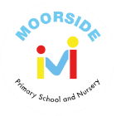
Dear Parents and Carers of children in Year 5,
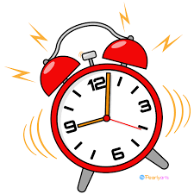
We are delighted to welcome the children back to school for the start of the Summer Term. As the weather is now getting warmer (fingers crossed), please ensure children come to school with sun hats and sun cream applied before school. Below, you will find all the important information you need for the term ahead. You will also be sent this term’s knowledge mat, including the key knowledge and vocabulary that the children will be learning, along with key texts and important diary dates. As always, if you have any questions or queries, please do contact us via the admin office and we will contact you as soon as possible. Thank you for your continued support, Miss Padbury Hunt
The School Day
- Doors open 8.50 am.
- Registers close 9.00 am.
- School finishes 3.20 pm.
If another person will be collecting your child or you are running late, please ensure that the school office is notified.
Please email any messages to admin@moorside-pri.n-yorks.sch.uk so that teacher can prioritise settling the children and supporting with their morning tasks.

What to bring EVERY DAY
- Reading Book
- Reading Record
- Spelling book
- Waterproof coat
- Water bottle
- Sun hat / cap
PLEASE ENSURE ALL ITEMS BROUGHT INTO SCHOOL ARE LABELLED
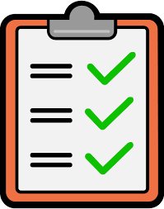

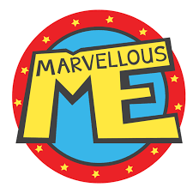


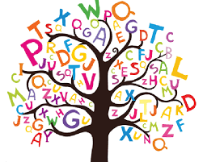
Marvellous Me
We love to share positive messages and reminders with you via the Marvellous Me app so please keep checking your notifications.
Homework Challenges
A homework mat will be sent home this week, packed with a variety of exciting tasks for the children to enjoy at home. We love sharing the children’s amazing work to inspire others and celebrate their creativity and effort!

Your child will continue to choose from our recommended reading selection for their year group. Please support them in becoming a High 5 Reader by listening to them read regularly and discussing their book to build understanding and enjoyment.
In addition, please encourage your child to use Reading Plus at least twice a week. These sessions can also be recorded and count towards their High 5 Reads.
Children who do not have 5 reads recorded will attend additional catch up reading sessions at lunchtime.
What to wear
Monday – PE kit
Tuesday – School Uniform
Wednesday – Forest School kit
Thursday – School Uniform
Friday – School Uniform
Please ensure that long hair is tied back. Earrings are studs only and your child must be able to remove them themselves on PE days.
https://www.moorsideschools.org.uk/policies/school-uniform-policy-2022-2025/#
Spellings
Your child will continue to receive their weekly spellings each Monday in their blue spelling book. Please support them in practising these across the week. They will then complete their spelling check the following Monday.
Spelling lists https://www.moorsideschools.org.uk/home-learning-and-websites/

