Friends of Moorside - All My Own Work

It's that time of year when we start our Christmas fundraising! Each year the children create lovely pictures, which we can send away to ‘All My Own Work’, where the pictures they have drawn can be featured on any of the items listed below. These make excellent Christmas presents and are lovely mementos of the children’s work. In the past this has been completed in school and parents were invited in to view the artwork. Due to Covid restrictions, we are making appropriate adjustments and are offering the opportunity for you to complete the artwork with your children over half term. The artwork doesn’t need to be Christmas related if you don't wish to purchase Christmas cards. PLEASE FOLLOW THE INSTRUCTIONS ON THE TEMPLATE CAREFULLY. We would need artwork, order forms and payment by Wednesday the 4th November. Exact money or Cheques made payable to ‘Friends of Moorside School’ in a named envelope. PLEASE DO NOT FOLD THE ARTWORK.

ITEM REQUIRED | PRICE | QUANTITY | TOTAL
Mug | £6.00
Coaster 4 Pack | £10.00
Fridge Magnet | £4.00
Hanging Decoration | £4.00
Water Bottle | £7.50
CHRISTMAS CARDS
Pack of 12, size A6 | £6.00
Christmas Coaster on a card | £4.00
 |  | ORDER TOTAL

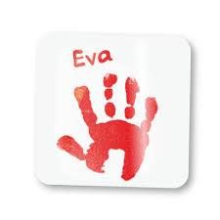 | 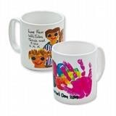
Fridge Magnet | Mug
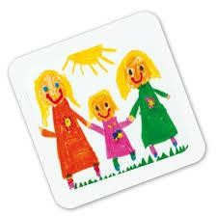 | 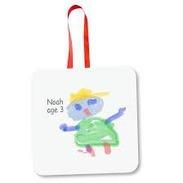
Coaster | Hanging Decoration

Childs name……………………………………………………………………. Class……………………………….

