Nursery Home Learning 13-7-20

Reading
Read a book with your child every day – the more often the better!
We will also be putting a story on YouTube and Facebook every day for you to enjoy at home.
Try these fun reading challenges this week;

Can you read outside? Can you read upside down? Can you read in bed?

Can you read a book that is linked to
a TV programme? Can you read whilst moving?

Can you read a rhyming story? Can you listen to a story in the bath?

Writing
Ask your child to trace the summer patterns on page 2. Encourage them to use different colours and attempt it more than once.

Remember to help your child to practice writing their name every day. Start with the first letter and practice that until they can do it beautifully! Then move onto the second letter etc.

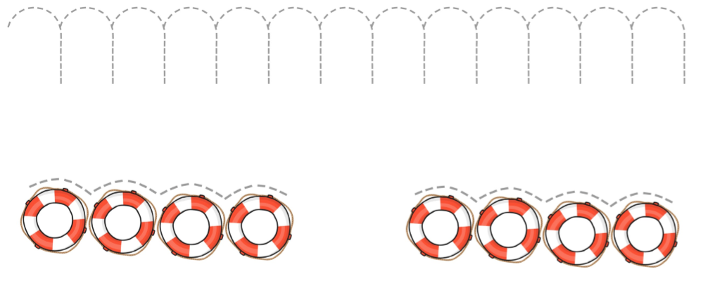
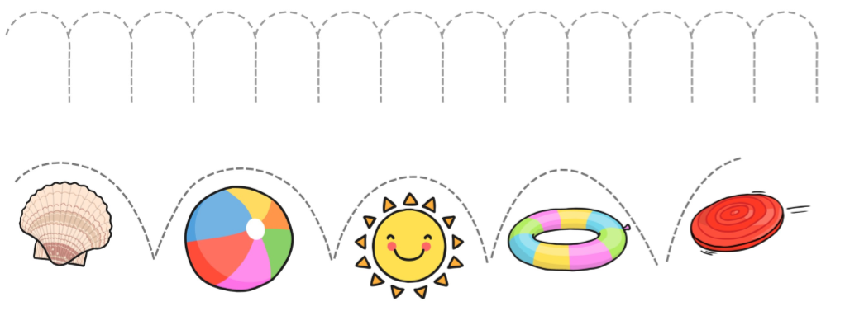

Phonics

Try the following activities with your family. Can you use your body to make lots of different sounds?

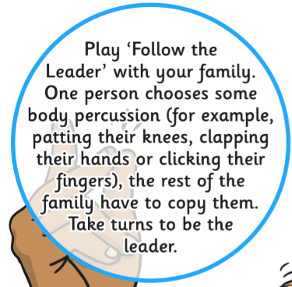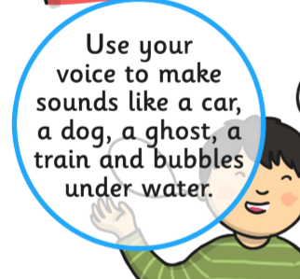

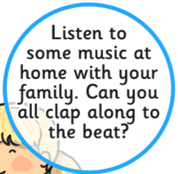

The Wheels on the Bus
Sing this song together as a family.

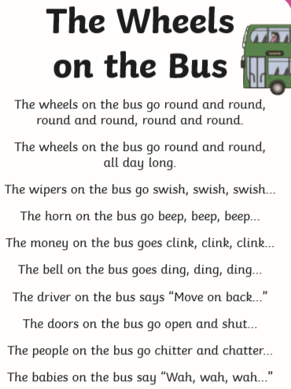

Can you make up some actions to go with the song?
Search ‘Singing Hands - The Wheels on the Bus’ on youtube and practice the Makaton signs.

Maths
This week we are thinking about patterns. If you have any beads or lego at home, you could try and make your own repeating pattern – or you could try and use something else; you can use anything!
Now try the following activities at home…
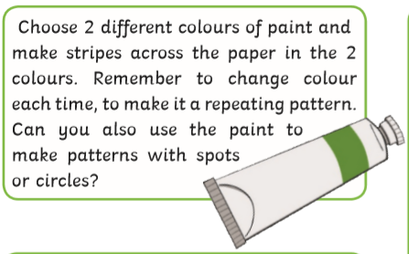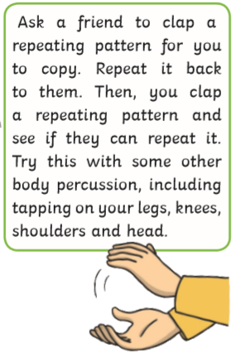

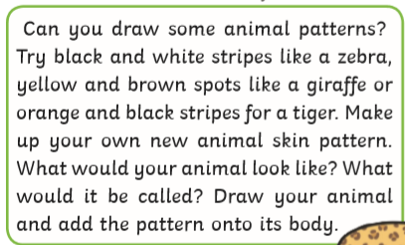

Topic – Moorside’s Got Talent!
This week we will be learning a new talent every day!
Monday
Learn the song ‘You are my Sunshine, my only Sunshine’ – watch it on
https://www.youtube.com/watch?v=dh7LJDHFaqA
‘You are my Sunshine, my only Sunshine
You make me happy when skies are grey
You’ll never know dear,
How much I love you,
Please don’t take my Sunshine away’
Can you sing it for a friend? Can you sing it for your family?

Tuesday
Can you throw and catch a ball? Practice with a grown up or a friend. Start off 2m apart and practice carefully.

Wednesday
Watch this Pinkfong ‘Go Bananas’ dance on youtube https://www.youtube.com/watch?v=PKyuJhHQCfI
Practice the dance until you know it off by heart – then show it to your family or friends! Can they join in? Can they teach you?

Thursday
What do you know lots about? Trains? Animals? Dinosaurs? Can you tell someone something REALLY interesting about your favourite subject? Or draw a picture about it?

Friday
Bake something delicious with your grown up! Can you make some yummy biscuits? Or a scrumptious cake?

