Year 2 Home Learning for 6.7.20
Maths
Your maths this week is all about mass. We will be measuring mass in grams and kilograms as well as comparing volume. Start each day by watching the videos on the White Rose website (Summer Term Week 10, 29th June). Then complete the sheets in your pack.
https://whiterosemaths.com/homelearning/year-2/
Spend time at home with some weighing scales and measuring jugs exploring the different weights and volume of objects and liquids at home. Maybe you could help with some exciting baking!
Play this game on Top Marks. Click on ‘answers in steps of 10 grams.’
https://www.ictgames.com/mobilePage/mostlyPostie/index.html

Monday – Measuring mass in grams.

Tuesday – Measuring mass in kilograms.

Wednesday – Comparing volume.

Thursday – Millilitres.

Friday – I have put a selection of mass challenges in your pack. Choose some fun ones to do. Then choose a selection of things at home to weigh. Can you order the objects you have chosen? Remember to keep playing on ‘Times Tables Rockstars,’ as this will really help you.
Monday part 1
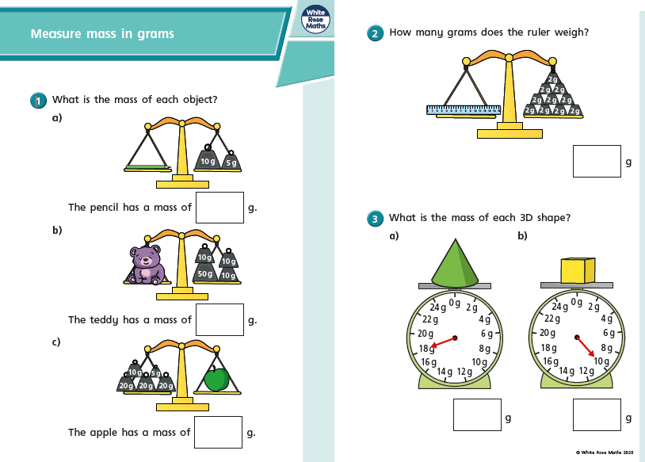

Monday part 2
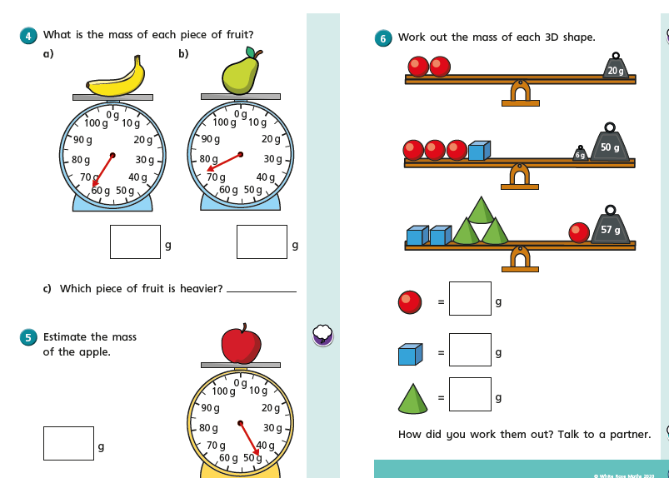

Tuesday part 1
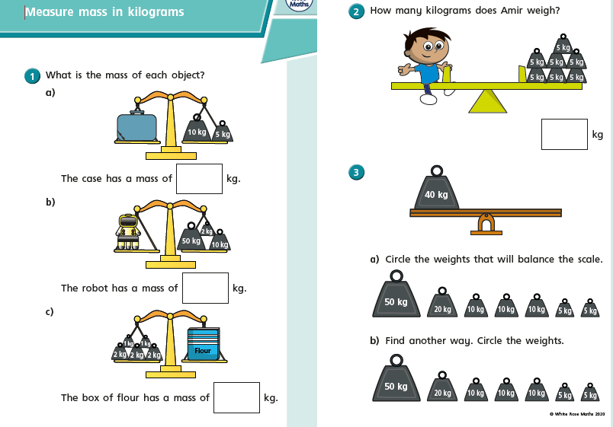

Tuesday part 2
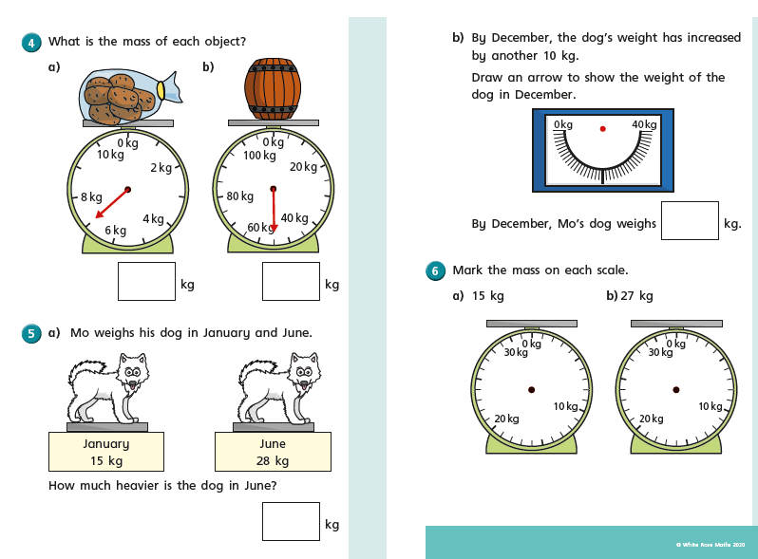

Wednesday part 1
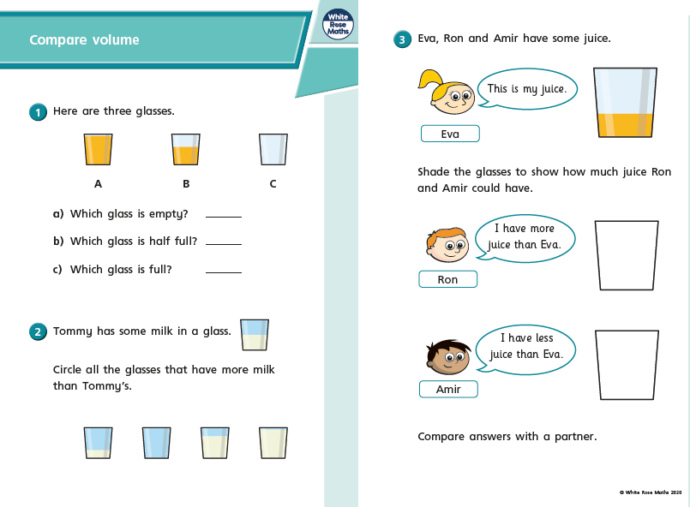

Wednesday part 2
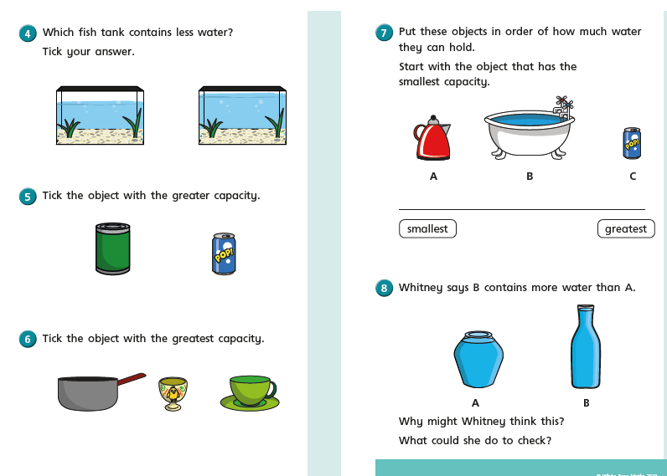

Thursday part 1
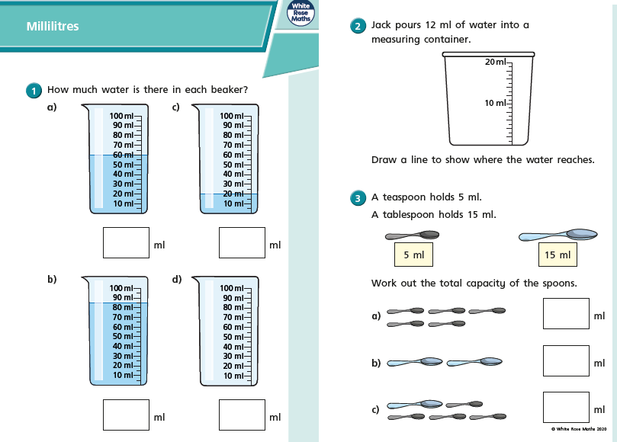

Thursday part 2
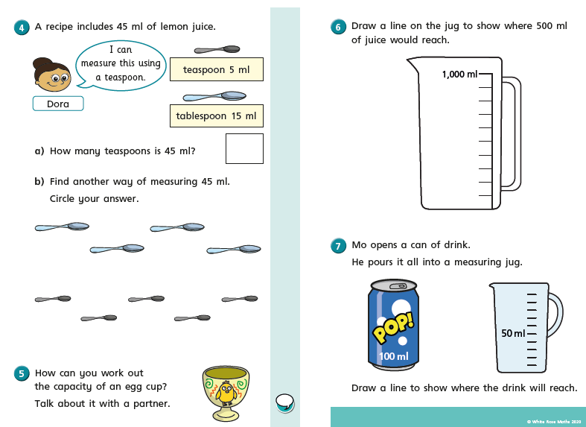

Friday
Friday
Friday
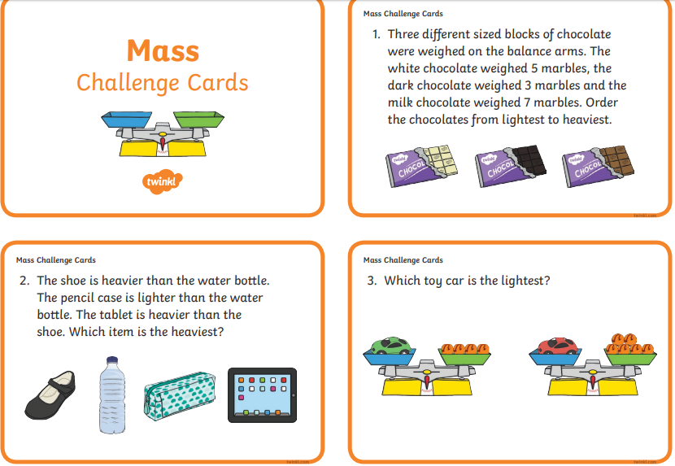

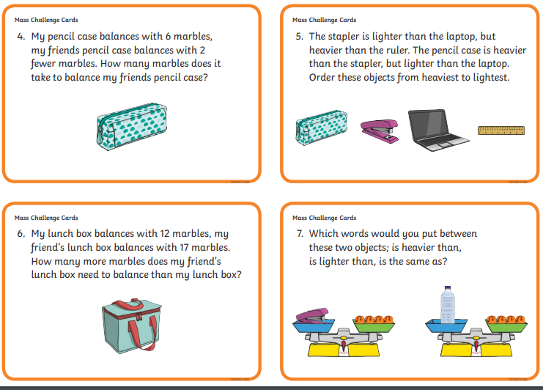

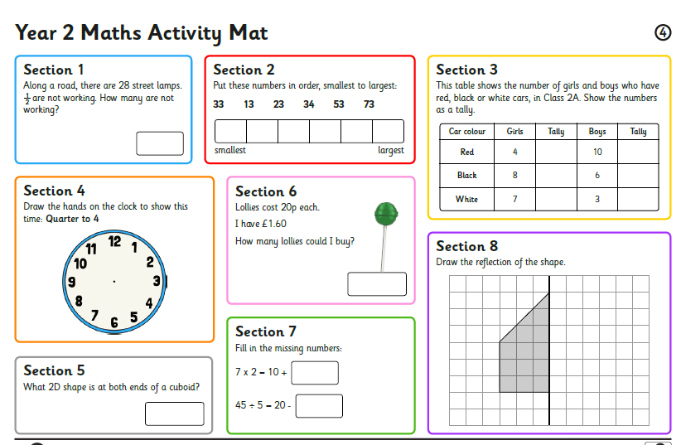

I am looking forward to seeing all your exciting learning!
Take Care,
Mrs Burland

