Year 2 Home Learning for 13.7.20
Maths
Your maths this week is all about mass. We will complete the work started on measures from last week and finish by looking at time on clocks. Start each day by watching the videos on the White Rose website (Summer Term Week 11, 6th July). Then complete the sheets in your pack.
https://whiterosemaths.com/homelearning/year-2/
Keep checking the time at home and telling an adult what the time is!
If you fancy getting fit whilst telling the time, follow this dance routine on BBC Supermovers:
https://www.bbc.co.uk/teach/supermovers/ks1-maths-telling-the-time/zk4t8xs

Play this game on Maths Frame. Click on games 1, 2 or 3.
https://mathsframe.co.uk/en/resources/resource/117/telling_the_time_in_words#
Monday – Measuring in litres.

Tuesday – Temperature.

Wednesday – O’clock and half past.

Thursday – Quarter past and Quarter to.

Friday – I have put a telling the time game in your pack. Then have a go at the mastery challenge.

Monday part 1
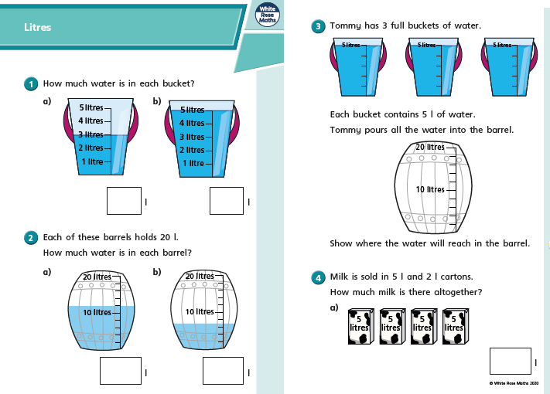

Monday part 2
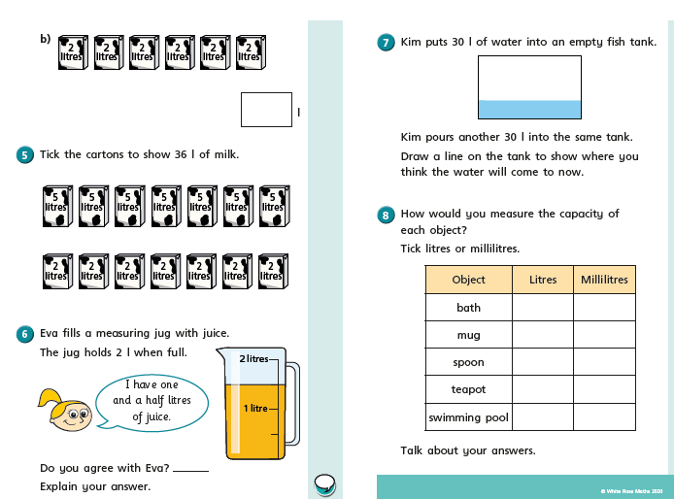

Tuesday part 1
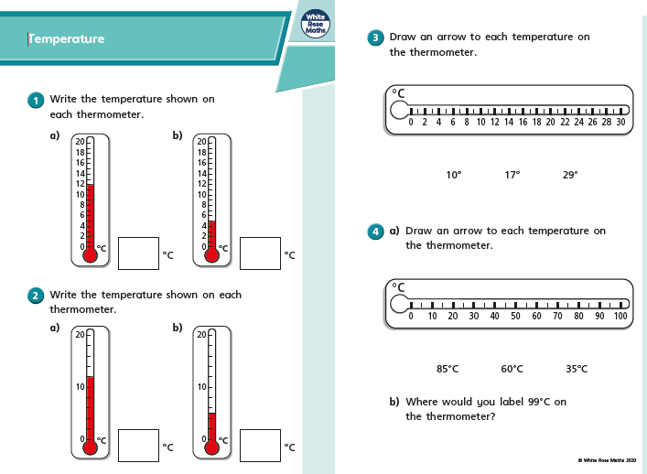

Tuesday part 2
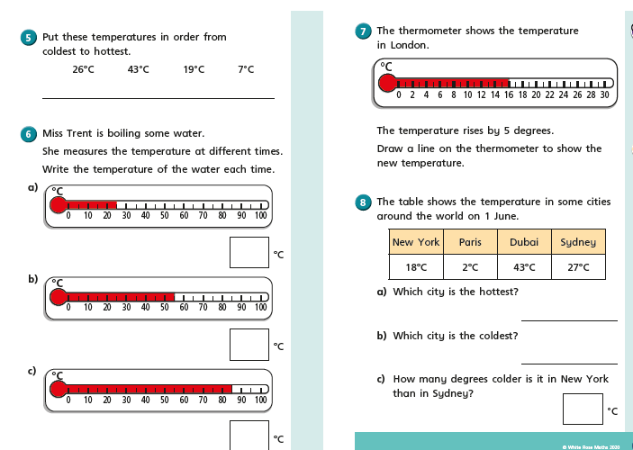

Wednesday part 1
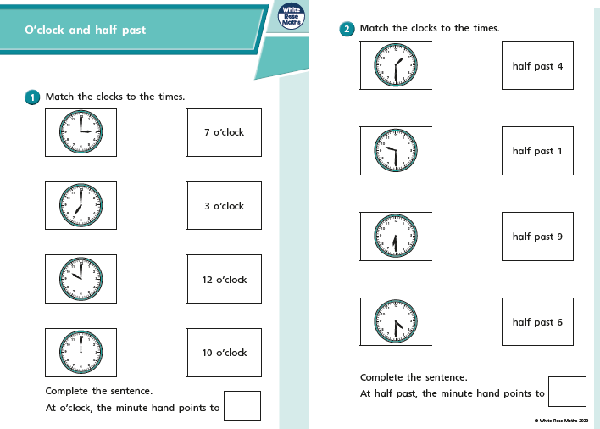

Wednesday part 2
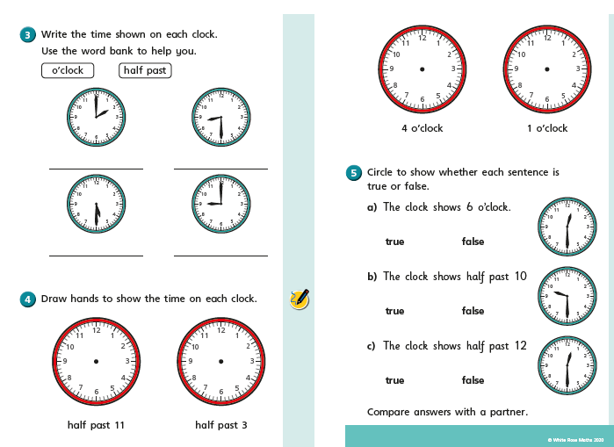

Thursday part 1
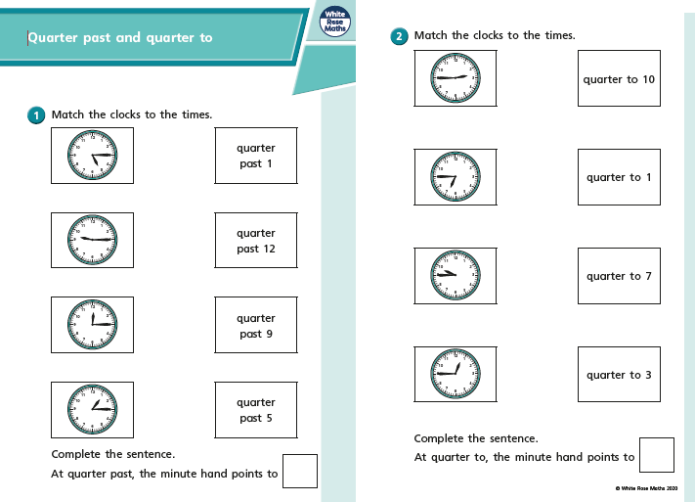

Thursday part 2
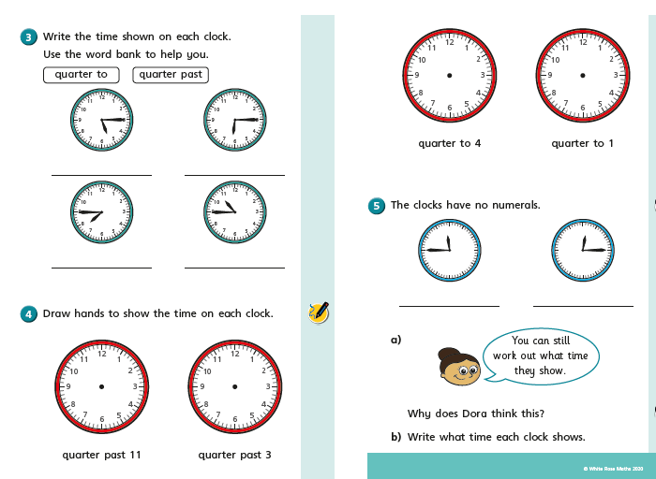

Friday
Friday
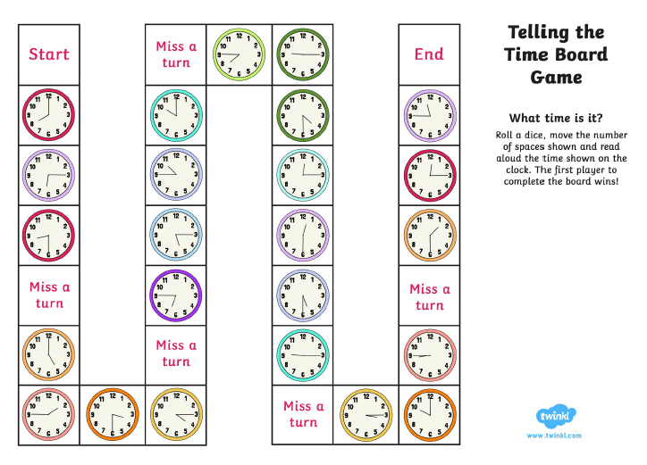

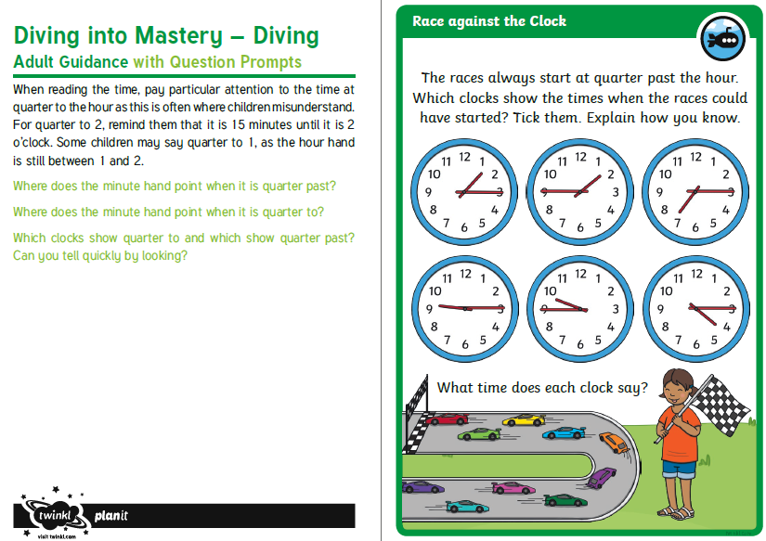

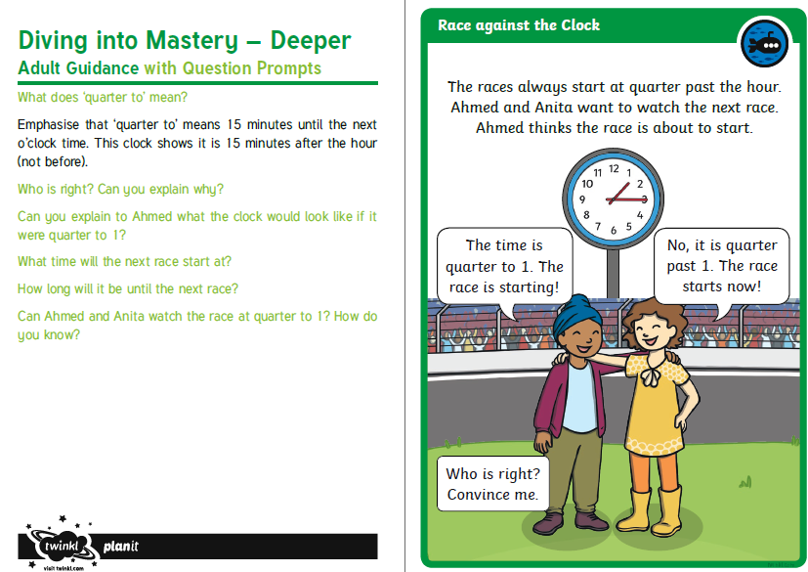

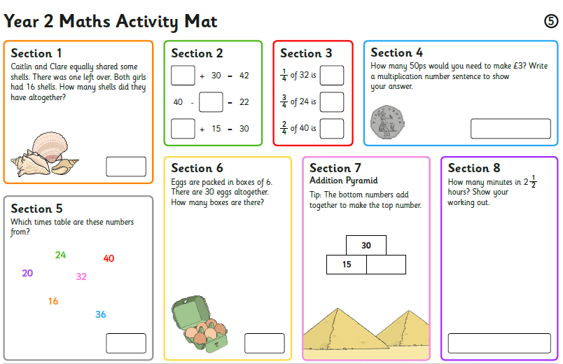

I am looking forward to seeing all your exciting learning!
Take Care,
Mrs Burland

