Answers
Maths Year 5
Recap of Year 5 w/c 13.07.20

Monday 13th July and Tuesday 14th July – Number and Place Value

Underline the thousands digit in 2769.
Underline the hundred thousands digit in 347, 053.
Underline the tens digit in 209, 740.

Here is a sequence counting up in 7s.
7, 14, 21, 28, 35, 42, 49, 56, 63, 70, 77, 84
Continue these sequences:
4, 8, 12, 16, 20, 24, 28, 32 ,36 , 40
25, 50, 75, 100, 125, 150, 175, 225, 275, 325
900, 890, 880, 870, 860, 850, 840, 830, 820
7382, 8382, 9382, 10382, 11382, 12382, 13382
6, 5, 4, 3, 2, 1, 0, -1, -2, -3, -4, -5, -6, -7

What is 10 more than 816? 916
What is 100 less than 1902? 1802
What is 1000 more than 3249? 4249

Write a number so that each sentence makes sense:
14,425 > 14, 237 this could be any number less than 14,425
15,645 = 15, 645
19,567 < 20, 440 this could be any number greater than 19, 567

Order these numbers:
1850 1058 1085 1805 1850
Smallest Greatest

What number is shown?

1000 + 100 + 100 + 100 + 100
= 1400
What number is shown?

1000 + 100 + 100 + 100 + 100 + 10 + 10 +10 +10 + 10 = 1450

Can you crack the code?
A | B | C | D | E | F | G | H | I | J | K | L | M
200 | 130 | 20 | 50 | 70 | 170 | 80 | 10 | 3000 | 60 | 30 | 1000 | 100
N | O | P | Q | R | S | T | U | V | W | X | Y | Z
400 | 900 | 130 | 140 | 2000 | 590 | 120 | 90 | 1500 | 110 | 40 | 7000 | 300

 | Answer | Letter
Round 14 to the nearest 10? | 10 | H
Round 223 to the nearest 100? | 200 | A
Round 1468 to the nearest 100? | 1500 | V
Round 68 to the nearest 10? | 70 | E
Round 204 to the nearest 10? | 200 | A
Round 1234 to the nearest 1000? | 1000 | L
Round 886 to the nearest 100? | 900 | 0
Round 1542 to the nearest 100? | 1500 | V
Round 73 to the nearest 10? | 70 | E
Round 698 to the nearest 1000? | 1000 | L
Round 7290 to the nearest 1000? | 7000 | Y
Round 591 to the nearest 10? | 590 | S
Round 91 to the nearest 10? | 90 | U
Round 99 to the nearest 10? | 100 | M
Round 147 to the nearest 100? | 100 | M
Round 65 to the nearest 10? | 70 | E
Round 1502 to the nearest 1000? | 2000 | R

Complete the table

Numerals | Words
345, 285 | Three-hundred and forty-four thousand, two hundred and eighty-five
855,102 | Eight hundred and fifty-five thousand, one hundred and two
622, 916 | Six hundred and twenty-two thousand, nine hundred and sixteen
120,563 | One hundred and twenty thousand, five hundred and sixty three

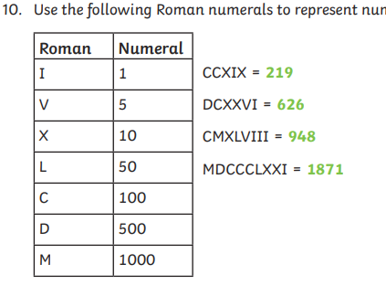

Wednesday 15th July – Addition and subtraction

Can you solve these calculations using mental methods?
- 376 + 3 = 379
- 376 + 40 = 416
- 376 + 200 = 576
- 15 672 – 3200 = 12472

Can you describe the mental methods that you used?

- Adding to the ones column
- Adding to the tens column and bridging through a hundred
- Adding to the hundreds column
- Subtracting 3 thousand from the thousands column and subtracting 2 hundred from the tens column

3 5 4 4 8
7 2 5 1 2
1 3 4 2 6 0

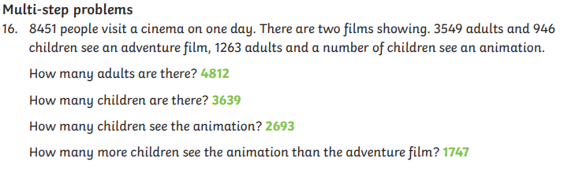
Thursday 16th July and Friday 17th July – Multiplication and division
Fill in the missing numbers
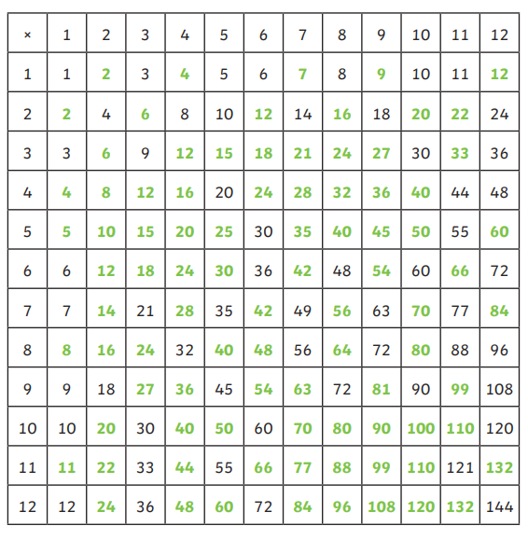
Use your knowledge of place value and related facts to solve these calculations
400 x 5 = 2 000
630 ÷ 7 = 90
450 ÷ 9 = 50
300 x 40 =12 000

Look back at your top tips for multiplying and dividing by 10, 100 and 1000. This web page will help remind you:
https://www.bbc.co.uk/bitesize/topics/z36tyrd/articles/z2fkwxs
Have a go at completing these calculations, then have a go at multiplying by 0 and 1 and dividing by 1.
45 x 10 = 450
6.7 x 100 = 670
902 x 1000 = 902 000
59 ÷ 10 = 5.9
4506 ÷ 100 = 45.06
382 ÷ 1000 = 0.382

285 x 1 = 285
285 x 0 = 0
285 ÷ 1 = 285

Here are the factors of 12
12
1
4
6
3
2
12

Can you find all the factors of 24? 1, 2, 3, 4, 6, 8, 12, 24
Can you find all the factors of 56? 1, 2, 4, 7, 8, 14, 28, 56
Use your factor pairs above to help you solve:
56 pencils are shared between 4 tables. How many pencils does each table receive? 14

List all the prime numbers up to 20 2, 3, 5, 7, 11, 13 17, 19
What is the first prime number after 100? 101

Write these numbers into the correct place in the table:
9, 144, 27, 4, 1, 8, 100, 81, 125, 16, 25, 64, 121.
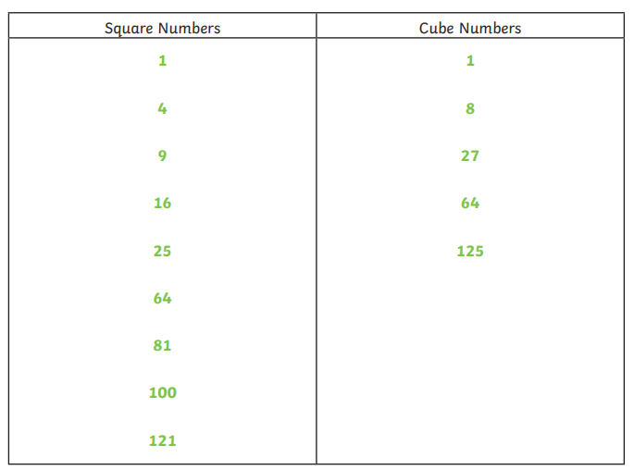

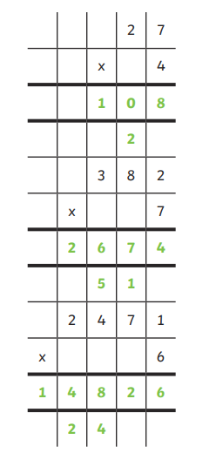
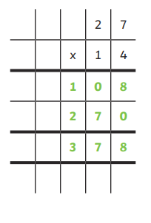

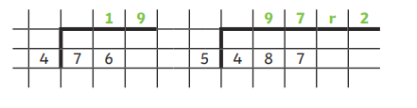
A teacher has four new boxes of pencils, each with 12 pencils and a tray with 37 pencils. The teacher shares equally all the pencils between 5 tables. How many pencils does each table receive? Show your working out below.

4 x 12 = 48 new pencils
48 + 37 = 85 pencils in total
85 ÷ 5 = 17 pencils per table

