Maths Year 5
Rounding w/c 06.07.20

Tuesday 7th July

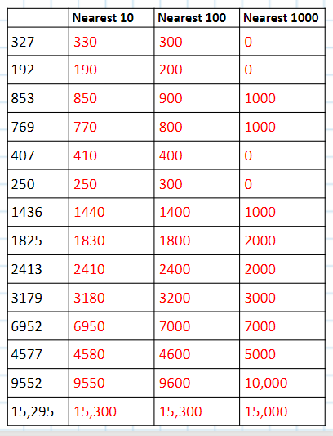

Wednesday 8th July

Have a go at completing this challenge by rounding the numbers to the nearest, 10, 100 and 1000. The first one has been done for you as an example.

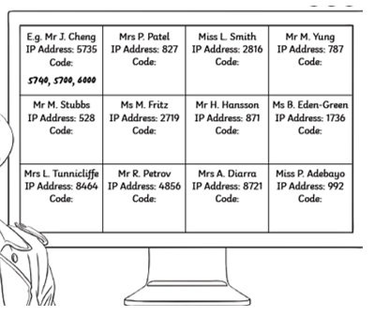
990, 990, 1000
8720, 8700, 9000
4860, 4900, 5000
8460, 8500, 8000
1740, 1700, 2000
870, 900, 1000
2710, 2700, 3000
520, 500, 1000
780, 800, 1000
2810, 2800, 3000
830, 800, 1000

Can you create a challenge for a friend? Send it in and I can share it with the rest of the class.

Thursday 9th July
Now have a go at rounding these to the nearest whole number
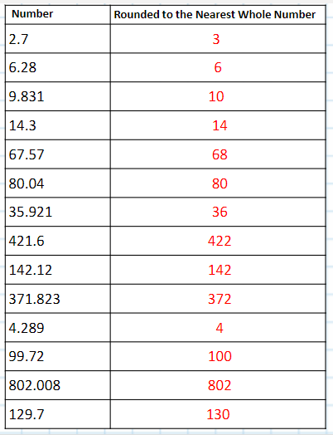

Friday 9th July
Write some top tips for rounding a decimal to the nearest whole number.

Have a go at matching up these sentences

