Year 2 Writing for 6.7.20
Monday
Phonics – This week we will look at how to spell words when they are in the plural. Tell a grown up what a plural is.
Can you remember the rules?
Rule – For lots of words we just add the letter ‘s’ to the end.
For example:
cat cats pencil pencils lamp lamps
However!!
If a word ends with one of the following sounds, then we add ‘es.’
sh, ch, ss, s, x, z
For example:
bush bushes church churches glass glasses
bus buses fox foxes

What do you think happens when the words ends in ‘y?’ You change the y to an i and add es (ies). Beware of words like ‘boy’ which just adds an ‘s.’
For example:
baby babies penny pennies city cities
Change the words on the next page into plurals. The first one has been done for you.
Dog = dogs
Tree =
Puppy =
Beach =
Pillow =
Bunny =
Lady =
Fox =
Candle =
Fairy =
Dress =
Flag =
Bench =
Jelly =
Witch =
Use some of these words to create ‘silly sentences.’ Write them in your home learning book.

Look in a book at home. How many different plural words can you spot?
Play the game on the next page.
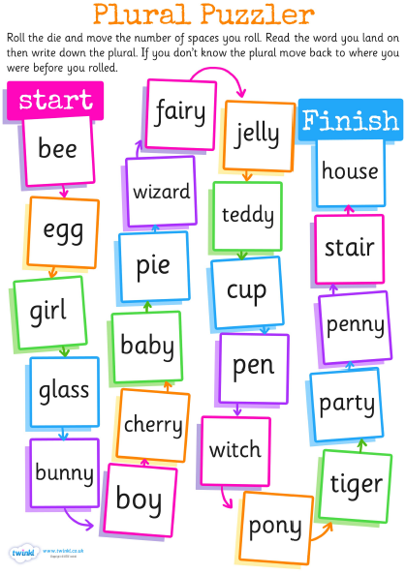

Then complete this spelling game on Classroom Secrets Kids:
https://kids.classroomsecrets.co.uk/resource/year-2-spelling-game-7/

Reading - Don’t forget to complete a reading eggs lesson.

Read a book at home or online and complete a book review.
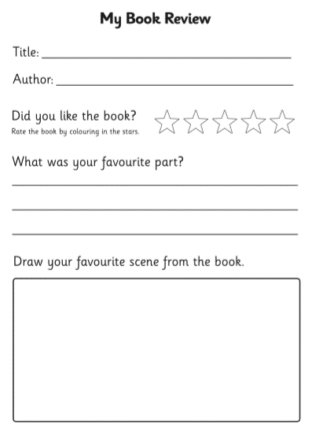

Tuesday

Complete the following comprehension about ‘Lighthouses.’
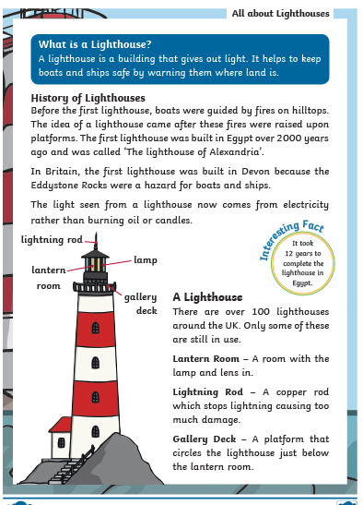
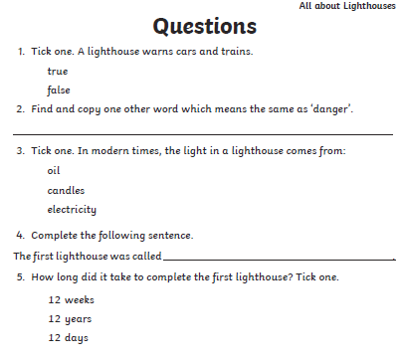
Make up 2 questions about lighthouses from what you have read.

1.

2.

Now complete the SPAG mat on page 8

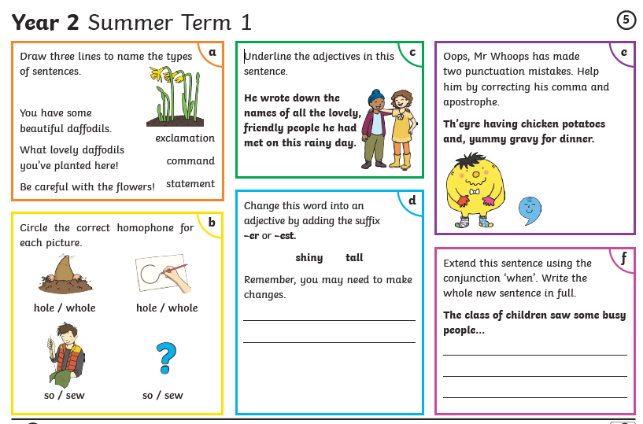
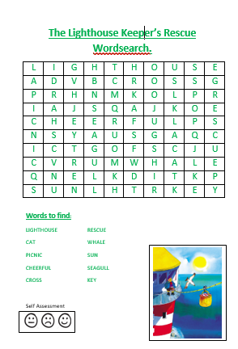
Complete the word search

Wednesday

This week we are looking at ‘The Lighthouse Keeper’s Lunch’ by Ronda and David Armitage.
You can watch and listen to the story on You Tube: https://www.youtube.com/watch?v=46wCRq50Wwg
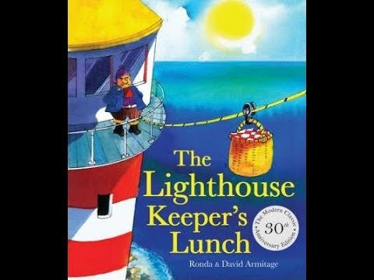

Think about the characters

In the story the characters are Mr Grinling, Mrs Grinling and the seagulls. On the next pages write some words (adjectives) to describe the characters around the picture, then use these words to write a character description. Remember to think about not just what the characters look like but their personality and the jobs they do in the story. There is a word mat on page 14 to help you.

Mr Grinling

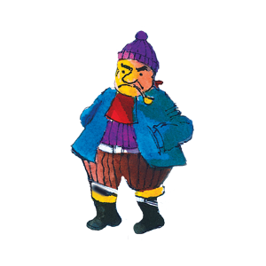

__________________________________________________________________________________________________________________________________________________________________________________________________________________________________________
_______________________________________

Mrs Grinling

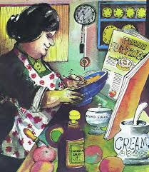

__________________________________________________________________________________________________________________________________________________________________________________________________________________________________________
_______________________________________

The Seagulls

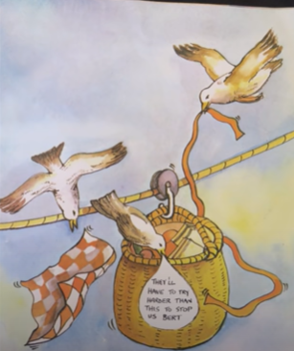

__________________________________________________________________________________________________________________________________________________________________________________________________________________________________________
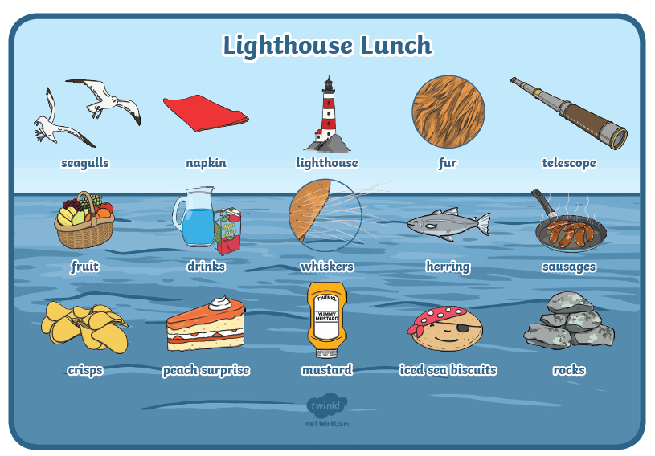
____________________________________
Thursday
Mrs Grinling makes a fantastic, yummy lunch for Mr Grinling at the beginning of the story.

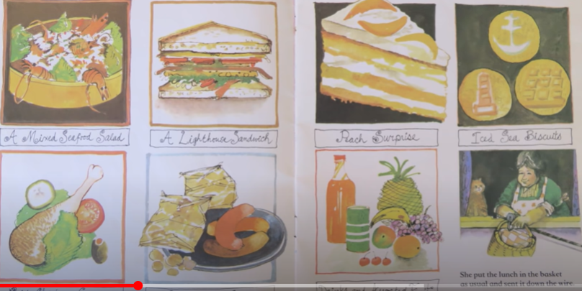

What would be in your yummy picnic lunch?

Create your amazing picnic on the next page.
Why not make your picnic and take photos of yourself enjoying it to send to school?

My amazing picnic

Friday

The seagulls have decided they like mustard snadwiches now, so Mrs Grinling needs your help to prepare a different disgusting picnic!
Think of some different disgusting sandwiches, cakes and drinks that Mrs Grinling could feed to the seagulls!

Sandwiches

snacks

dessert

Why not make your disgusting picnic and take photos? How bad can you make it so the seagulls will not want to eat it?

Handwriting
The handwriting sheet I am including each week will be recapping spellings we have already covered in Year 2. They will help you work towards a pen license!
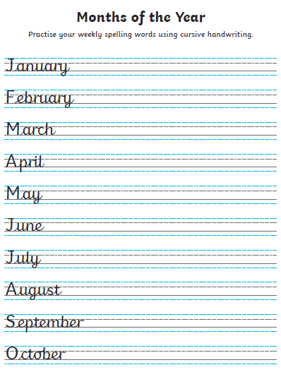
I can’t wait to hear all about your yummy and disgusting picnics!!
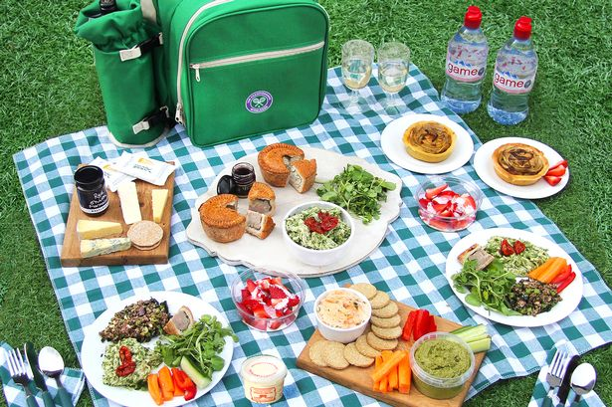

Happy Learning,

Mrs Burland

