Year 4 Writing
This week is slightly different. This week, we would like you to design and write instructions for your very own Sports Day! As we aren’t in school for a Moorside Sports Day, you will need to use your creative minds to make your own.

Task 1.
Click on the link below and look at some of the ideas that you could possibly use for your sports day at home.
https://www.bbcgoodfood.com/howto/guide/how-host-sports-day

Having had a look at this website, draft a list of activities you could do at home. These must be:
- Safe.
- Be accessible to everyone (don’t make them too hard or easy)

If you have equipment at home that you can use, then that is great! But only use it if it is safe to. You will need your parents help for this task.

Task 2.
On page 2, there is an example of what a Sports Day might look like. We’ve left the activities on as an example.
Use the sheet on page 3 for your plan for your Sports Day. This is key to being successful. We use something like this at school to help us when we plan our Sports Days.
You can use drawings to help you. Keep it neat and tidy and add any written instructions alongside.

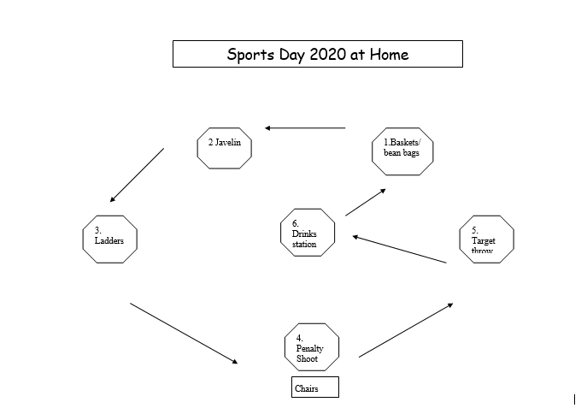
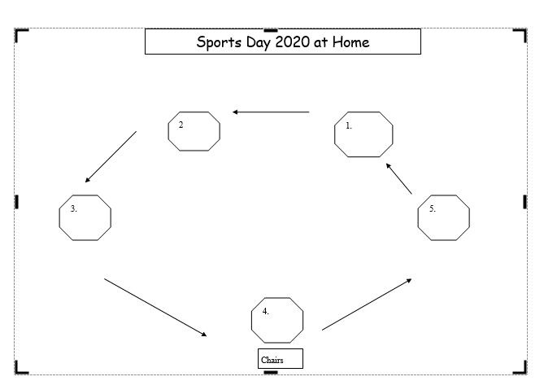

Task 3.
For each station you have, complete the template on pages 5, 6, 7, 8, and 9. Have no more than 5 activities for your Sports Day.
Complete the set of Instructions and Rules for each station. How will you score the activity?
The details need to be clear so that other people can understand it and have a go themselves.
Mums and Dads can also take part…..

Task 4.
Use the scorecard on page 10 to help you keep score. We like competition! Who will be your Home Sports Day Champion of 2020?

Task 5.
Please send photographs and videos of your work and how your Sports Day went. We will send certificates out to those whose photographs or videos we receive. Have fun!





