Year 3 Writing
For the final week of the year, I have given you some SPaG activities to do. We have looked at these before. You don’t have to do them all this week as you can do a few during the holidays to keep your brain ticking! Good luck. The answers are also on the school website. On page 8 and 9 is a glossary to help you. On page 10 are some spellings that we need to know too.
Monday.
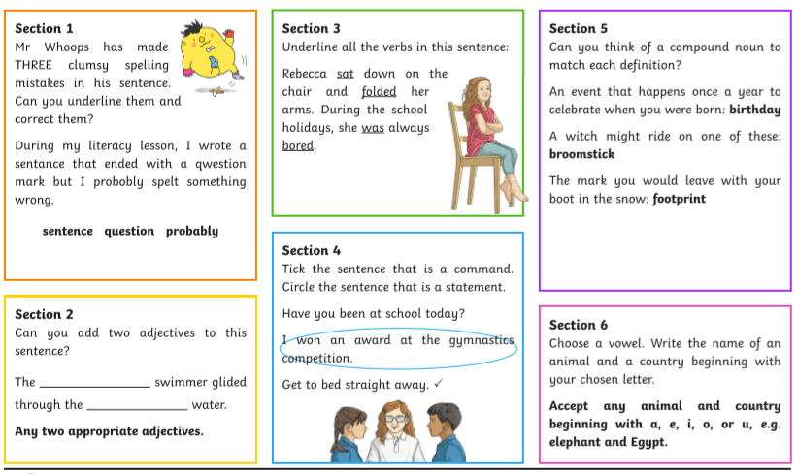
Tuesday:

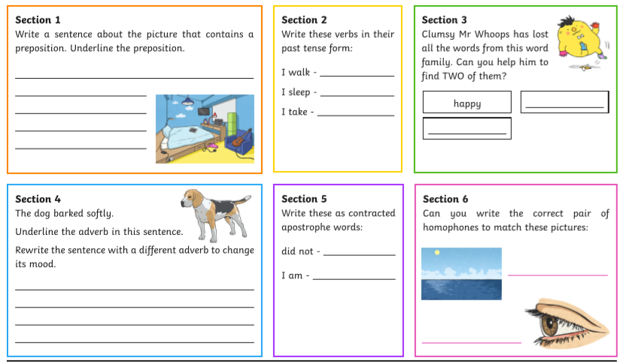
Wednesday:
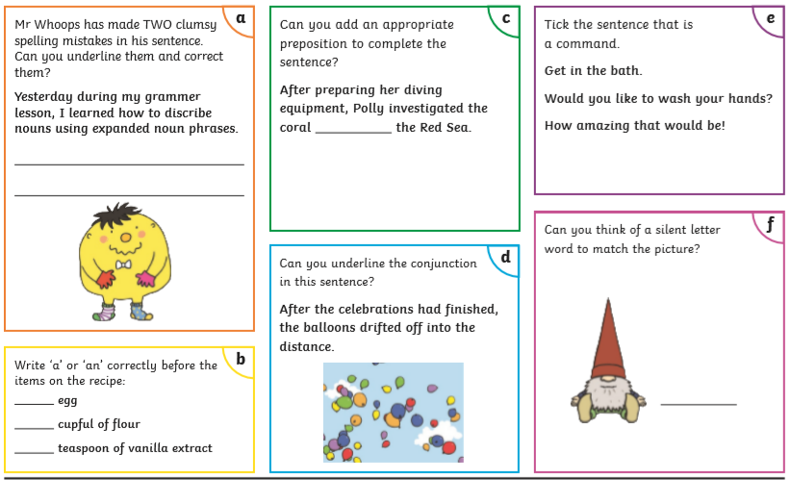
Thursday:
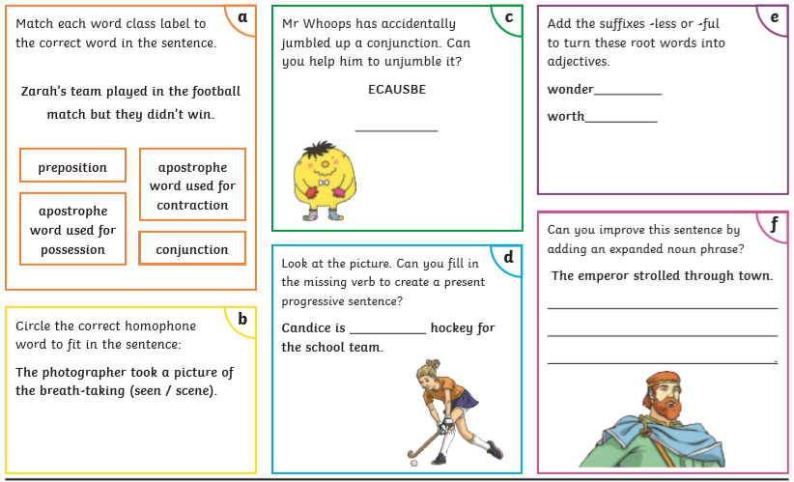
Friday:
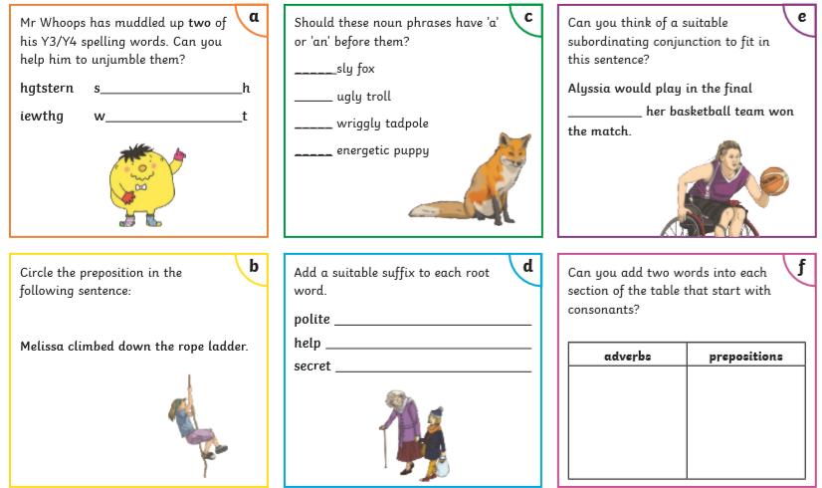
Summer holiday work! You are very welcome!
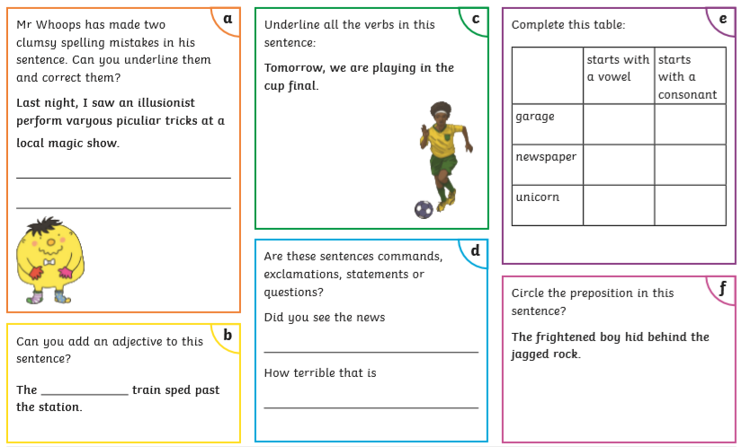
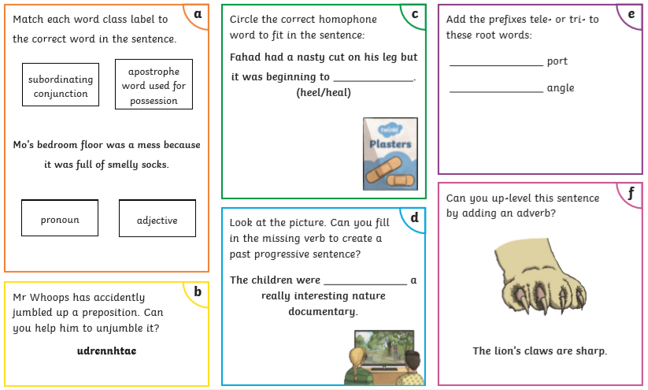
Year 3 Spelling, Grammar and Punctuation Glossary.
