Year 4 Writing
For the final week of the year, I have given you some SPaG activities to do. We have looked at these before. You don’t have to do them all this week as you can do a few during the holidays to keep your brain ticking! Good luck. The answers are also attached but only an adult can see them! On page 9 and 10 is a glossary to help you.
Monday.
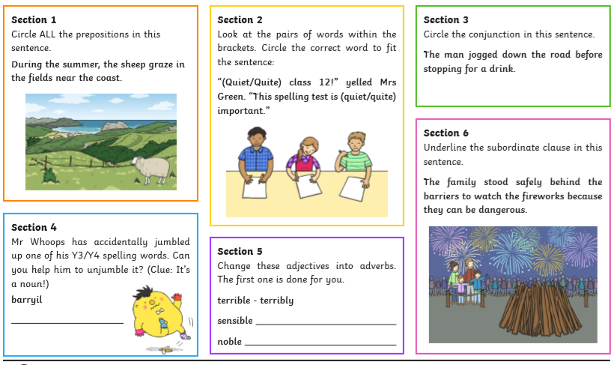
Tuesday:
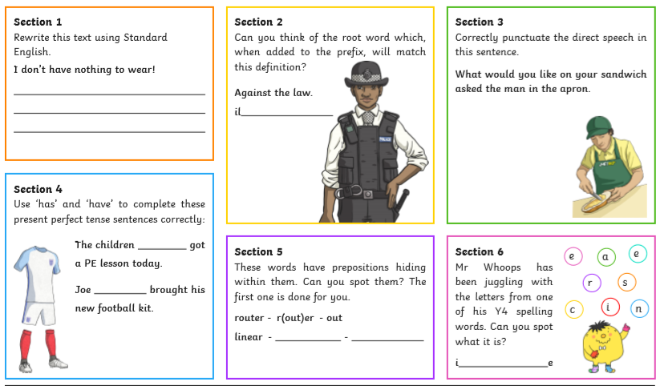
Wednesday:
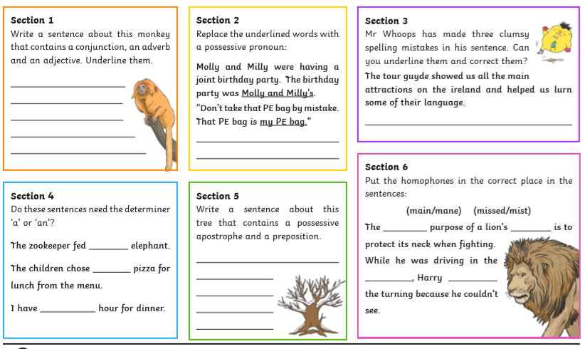
Thursday:
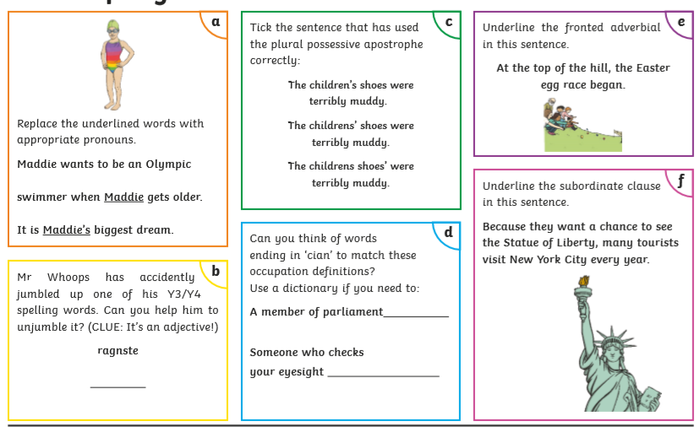
Friday:
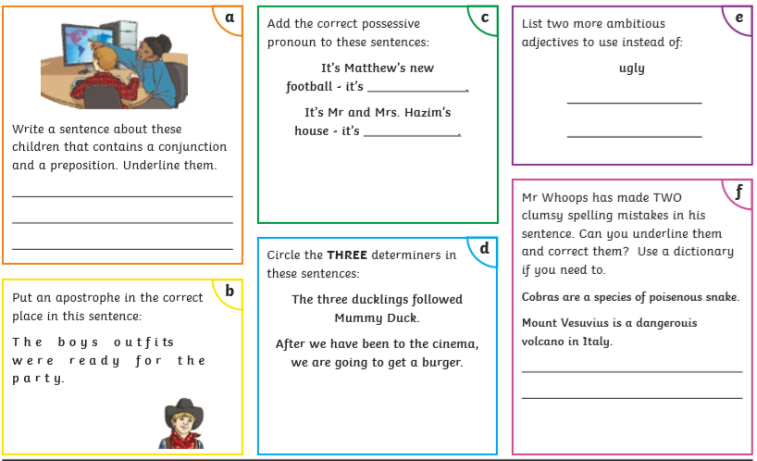
Summer holiday work! You are very welcome!
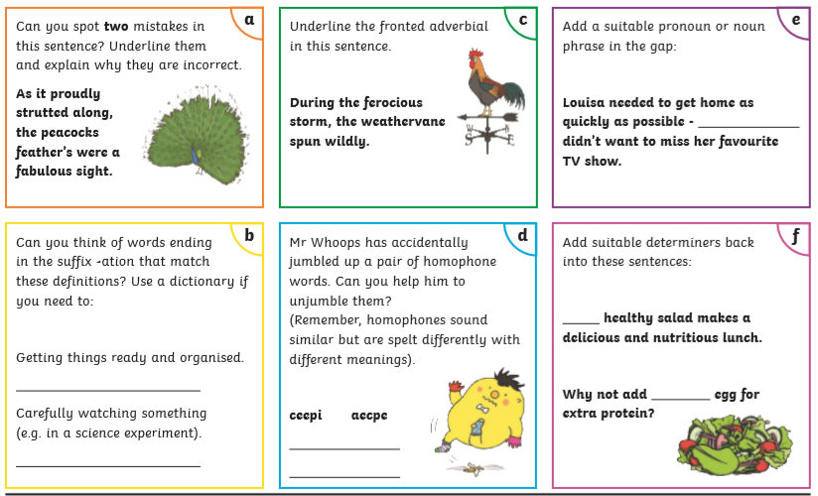
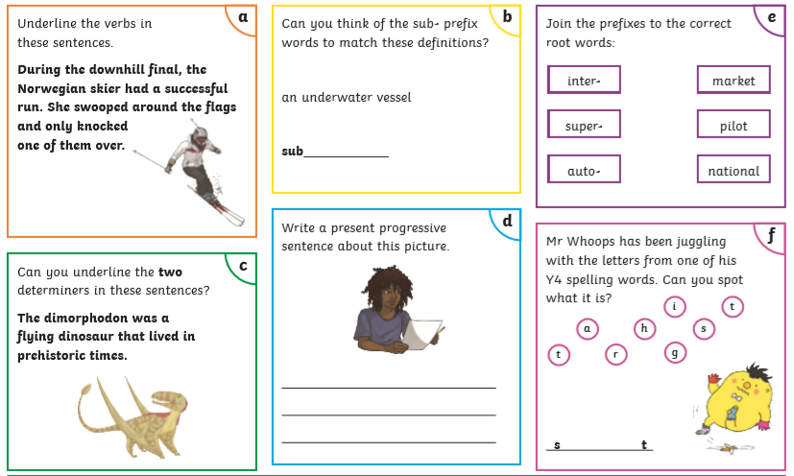
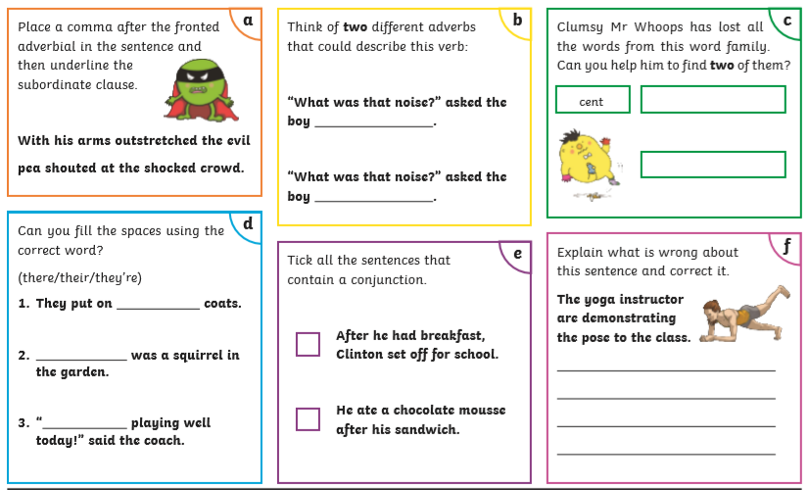
Year 4 Spelling, Grammar and Punctuation Glossary.
