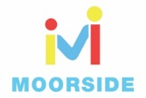
Year 3 and 4 Science Week Home Learning Challenges
Task 1  Create a poster or finger snapper using the 5 Finger facts below:  - I know that light from the sun can be dangerous and that there are ways we can protect our eyes.  - I know the benefits and dangers of the sun.  - I know about UV light and its dangers.  - I can describe ways to protect our eyes from the sun.  - I know how to protect myself from the sun. | Task 2. Benefits and dangers of the sun.  Have you ever been told not to look at the sun?  Is the sun good or bad?  The statements below (Page 2) are all things that the sun does.  For each statement, tick the statements that you think are positive 'Hero' and put a cross next to the negative statements. These are the 'Villain' statements.  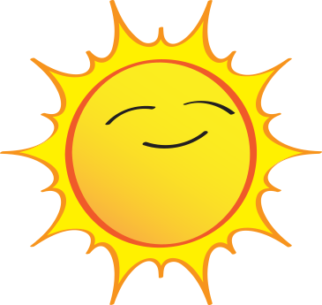 | Task 4. Sun Safety design.(Pages 3 and 4)  Your task is to design a pair of sunglasses or a hat that will protect someone's eyes from the harmful effects of the sun. You should also advertise your sun protection item!  Tell your customers why they need to buy your sunglasses or hat. Explain about the effects of the sun, and how your sunglasses or hat can help protect against them. You could even make your own sunglasses!  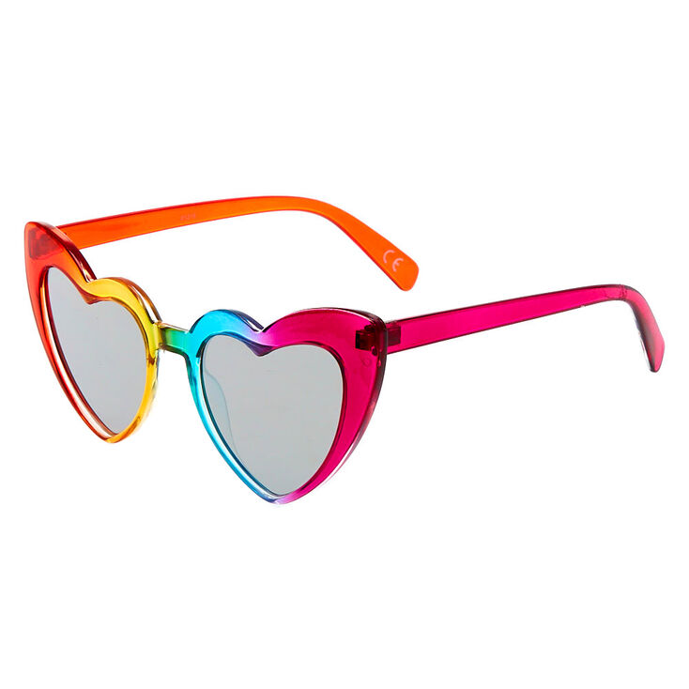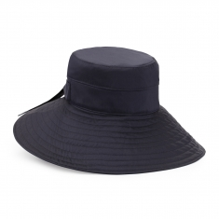
 | Task 3. Sun Safety.  Write a list of all the pieces of clothing that you should wear to help protect yourself from Ultra violet waves.  Use the poster on page 2 to help you understand how powerful Ultra violet waves can be.  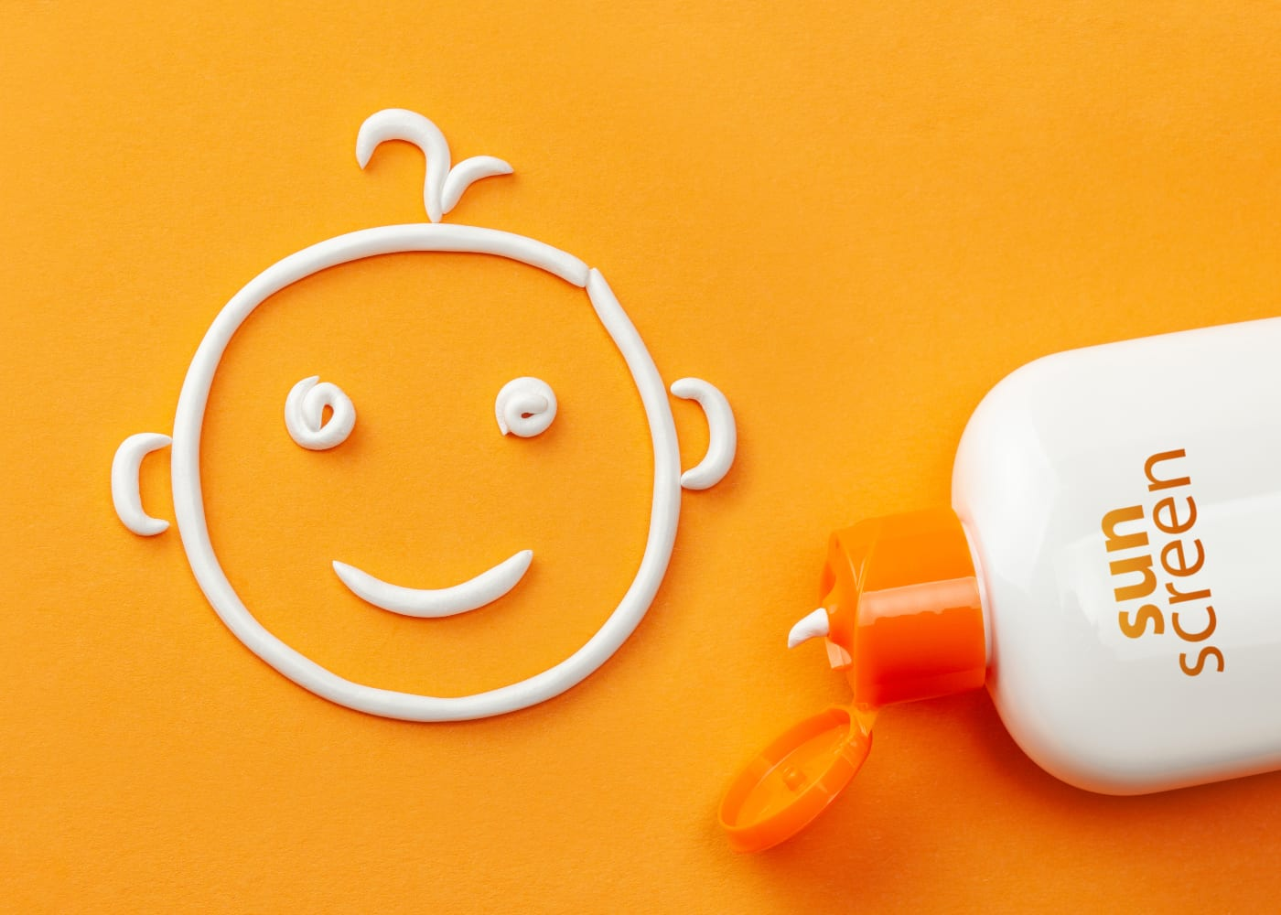 | Key Vocabulary  Ultra violet: these come from the Sun and are a form of radiation.  Sun: the star round which the earth orbits.  Solar Power: power obtained by harnessing the energy of the sun's rays.  Energy: power from a source to make something work.
How can we protect ourselves from the Sun?

