Year 3 Maths
This week our work is based around Angles and Lines.
The objectives we are working on are:
- recognise angles as a property of shape or a description of a turn.
- identify right angles, recognise that 2 right angles make a half-turn, 3 make three quarters of a turn and 4 a complete turn; identify whether angles are greater than or less than a right angle.
- identify horizontal and vertical lines and pairs of perpendicular and parallel lines.

All the lessons can be found on https://whiterosemaths.com/homelearning/year-3/
So, this week we are looking at angles and lines. We have touched on this but quite some time ago.
Tips:
A right angle is 90 degrees and is a quarter turn.
One full turn is 360 degrees.
In some of the shapes you see there maybe more than one right angle, so be careful.
It doesn’t matter if the right angle is on the left or right, it is still a right angle.

Use the videos very carefully this week. Good Luck!
Monday Task 1 . Watch this video first to help you.
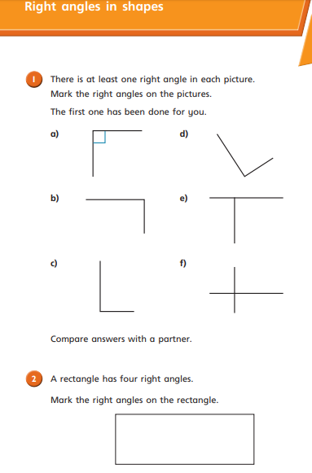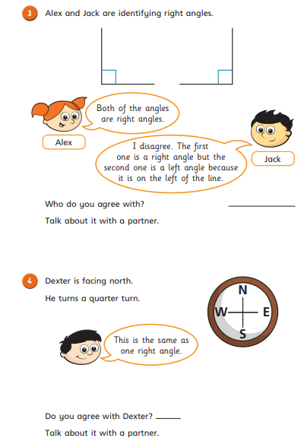
Monday Task 2
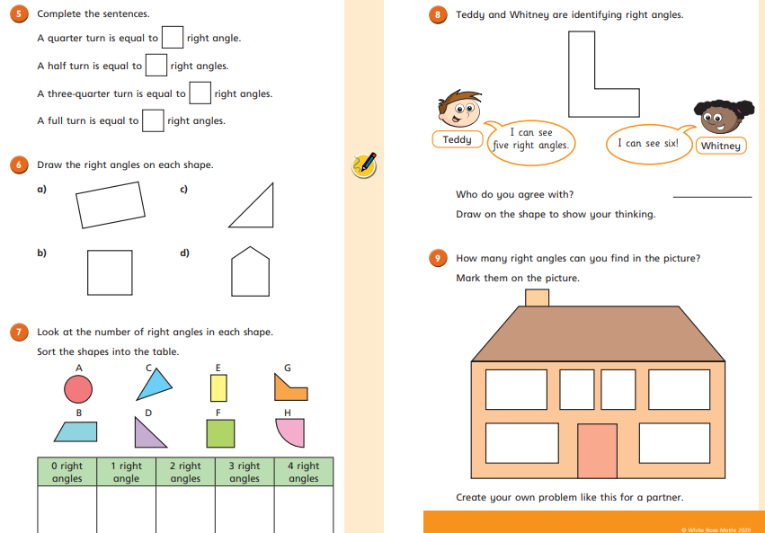
Tuesday Task 1. Watch this first:
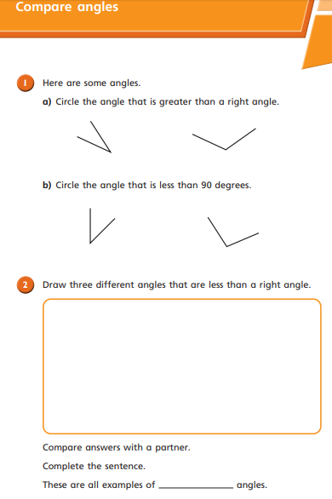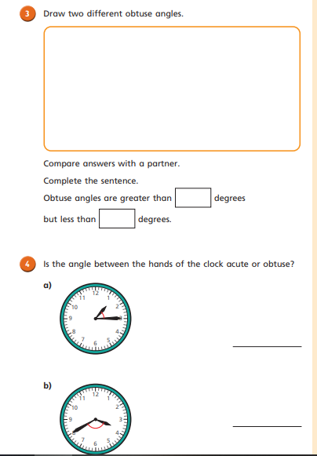
Tuesday Task 2.
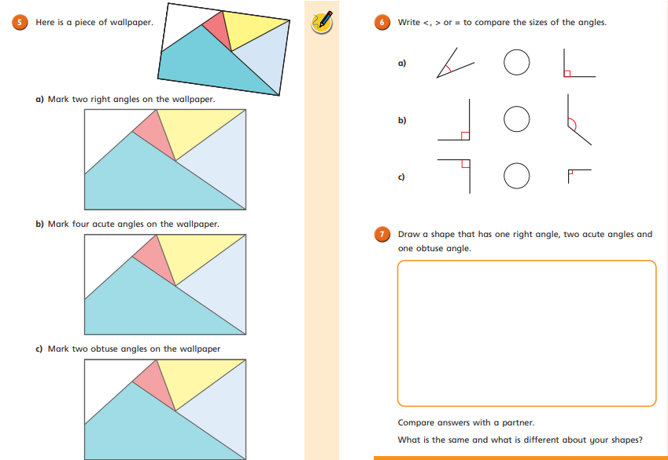
Wednesday Task 1. Watch this first:
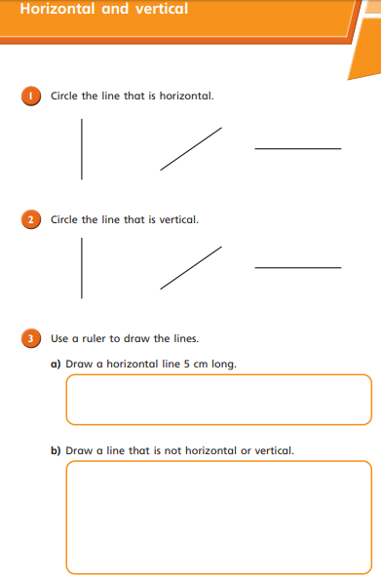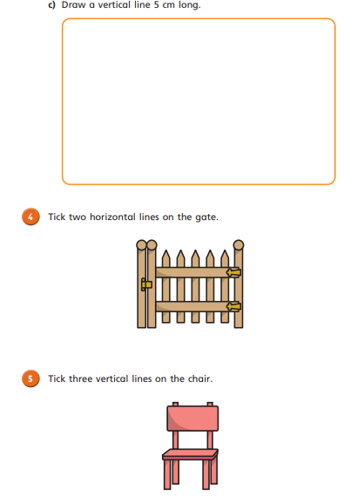

Wednesday Task 2
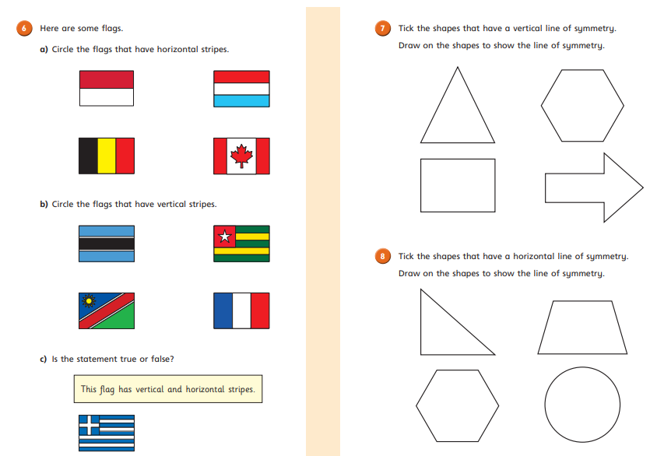
Thursday Task 1. Watch this video first:
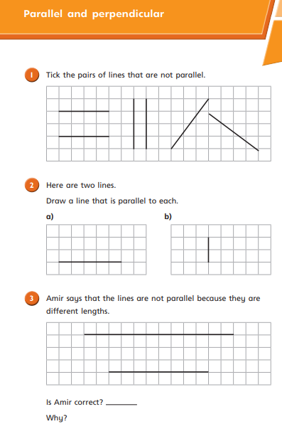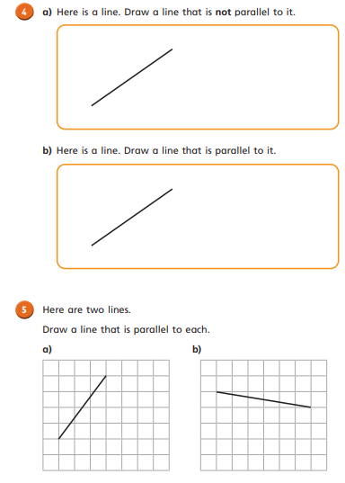
Friday Task 1.
