Maths Year 6
w/c 6.7.2020
The objectives we are working on in this week are:
- To recognise that shapes with the same area can have different perimeters and vice versa
- To calculate the area of parallelograms and triangles
- To calculate, estimate and compare volume of cubes and cuboids
This week you will be focussing on developing your knowledge and understanding of different measurements: area, perimeter and volume. On Monday, you will be calculating the area and perimeter of different shapes; then on Tuesday, you will be finding the area of triangles; on Wednesday, you will be finding the area of parallelograms; on Thursday, you will be finding the volume of cuboids and finally, on Friday, you can practise some of the skills you have learnt by having a go at an interactive activity using the following link: http://www.learnalberta.ca/content/me5l/html/math5.html?goLesson=12

Using the link below, click on Summer Term – Week 9 and each day (Monday – Thursday) watch the video and complete the accompanying task (these are printed in your pack). Lesson 1 – Monday, Lesson 2 – Tuesday, Lesson 3 – Wednesday, Lesson 4 – Thursday.

https://whiterosemaths.com/homelearning/year-6/

Monday (Part 1)
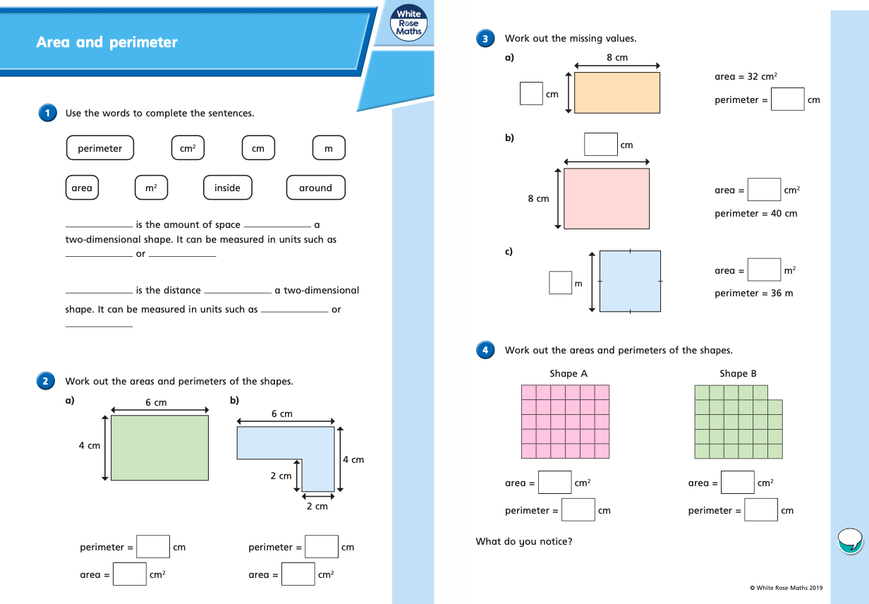
Monday (part 2)
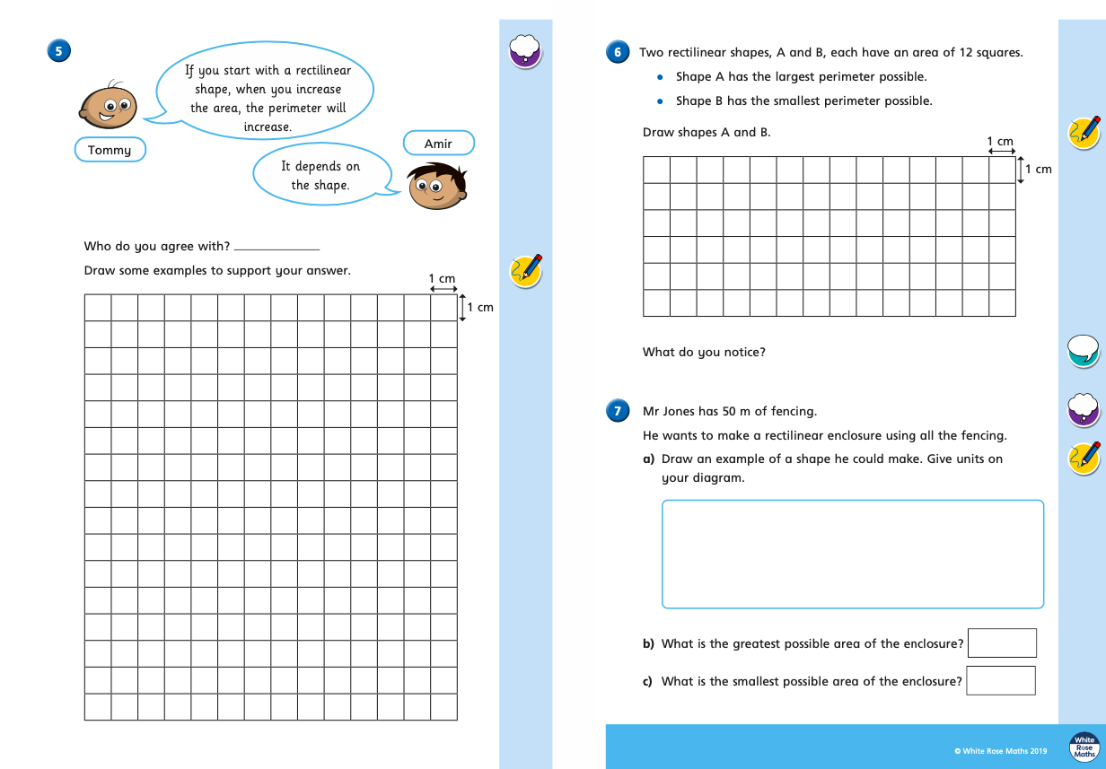
Tuesday (part 1)
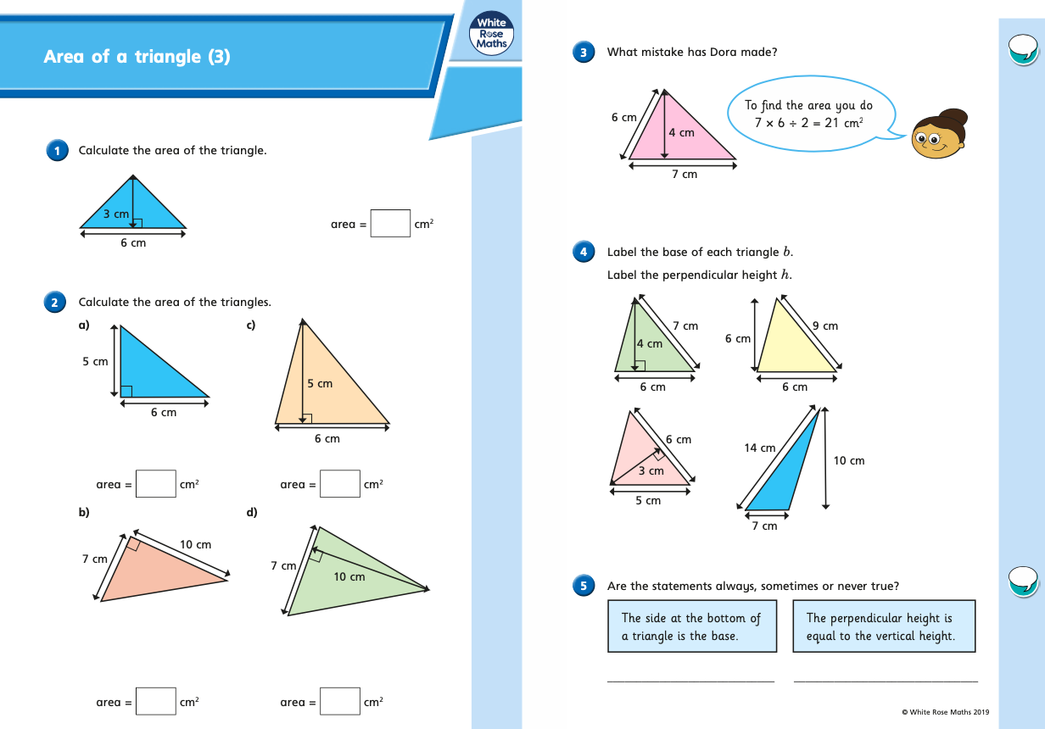
Tuesday (part 2)
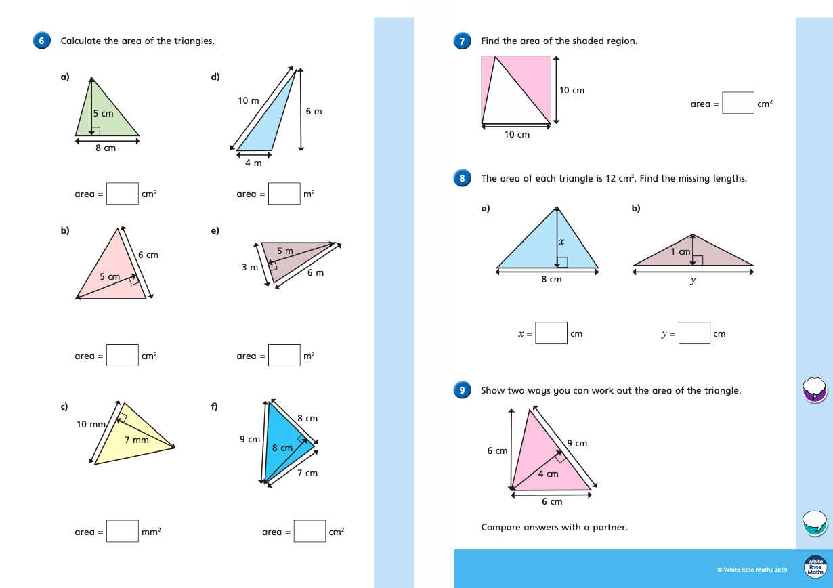
Wednesday (part 1)
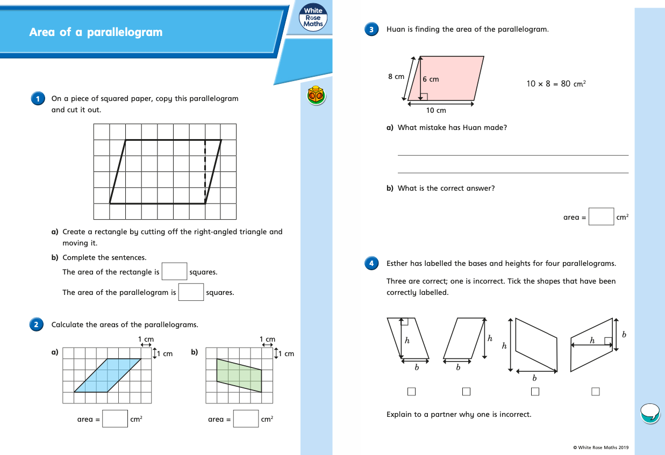
Wednesday (part 2)
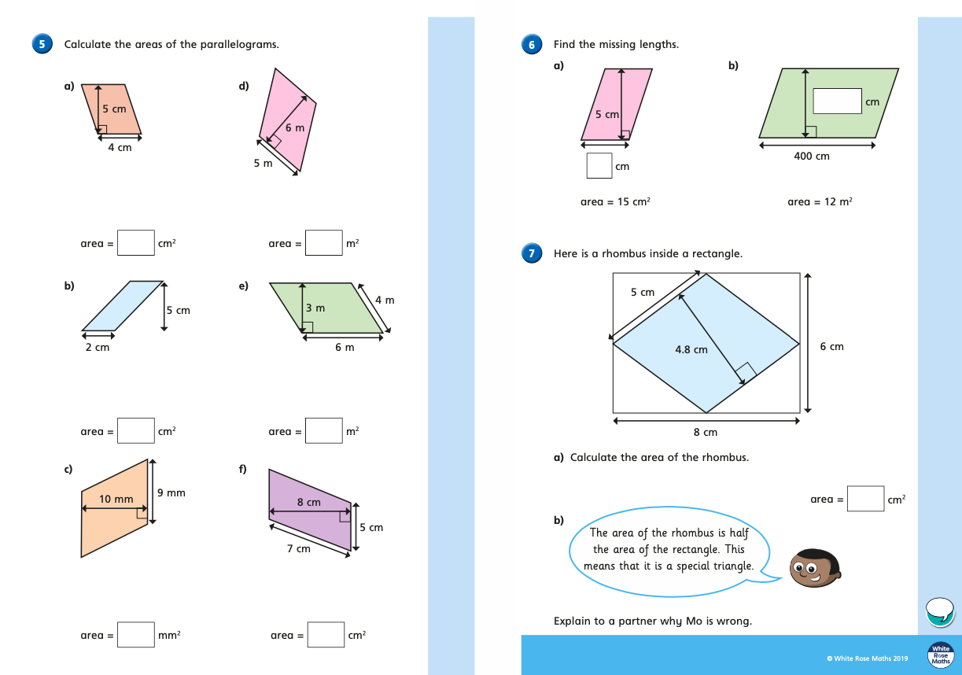
Thursday (part 1)
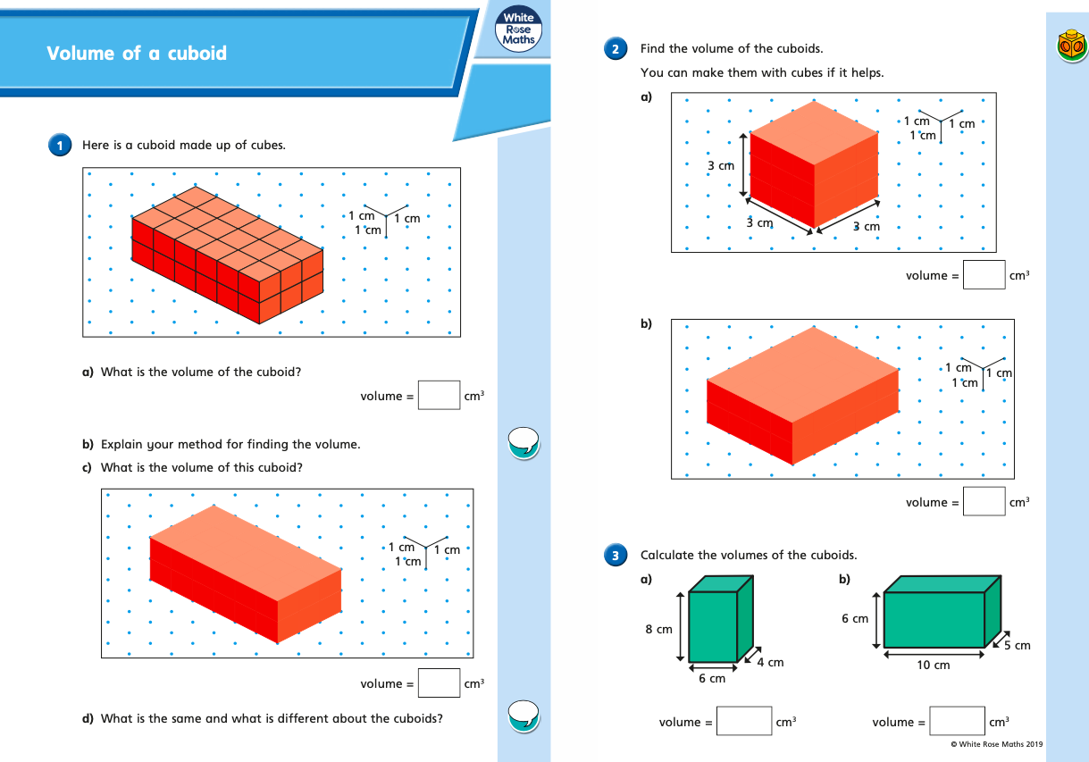
Thursday (part 2)
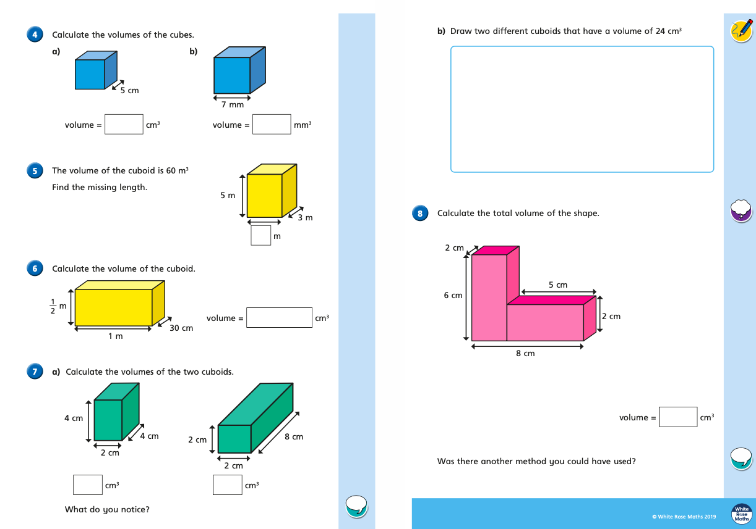

Friday
Click on the link below to have a go at some more perimeter and area activities to practise what you have learnt this week:
http://www.learnalberta.ca/content/me5l/html/math5.html?goLesson=12

