Year 3 Maths

This week is Word Problems week. There are several word problems to complete. Good luck!
You will need to persevere with these as the answer isn’t always as simple as it looks. Use the squared paper carefully and draw diagrams if required.
Make sure your answer is clear and in a number sentence.

Monday Task 1
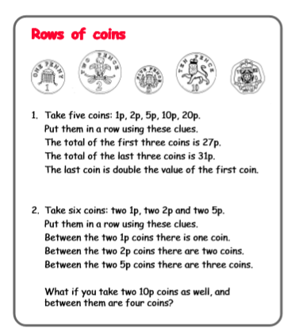

Monday Task 2.
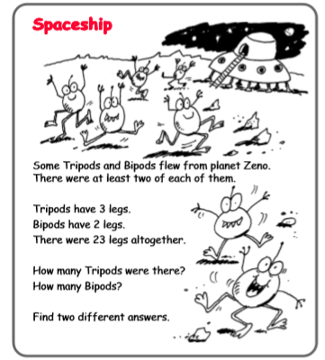

Tuesday Task 1.
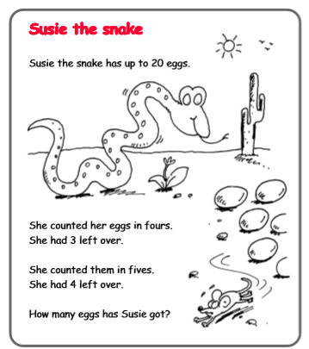
Tuesday Task 2.

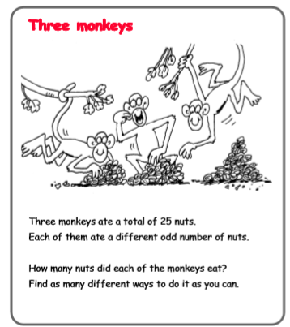

Wednesday Task 1.

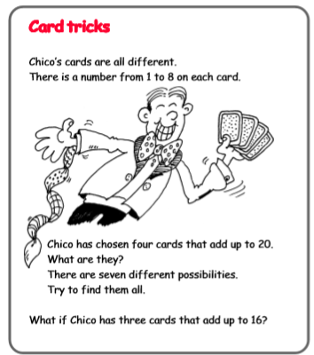

Wednesday Task 2.
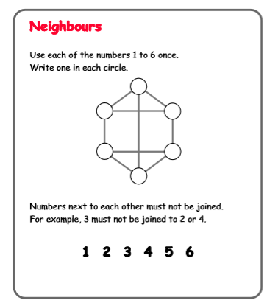

Thursday Task 1.
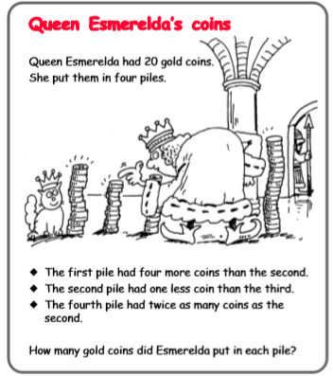
Friday Task 1.
