Maths Year 6
w/c 13.7.2020
The objectives we are working on in this week are:
- To recognise angles where they meet at a point, are on a straight line, or are vertically opposite, and find missing angles
- To find unknown angles in any triangles, quadrilaterals, and regular polygons

This week you will be focussing on developing your knowledge and understanding of angles. On Monday, you will be learning about vertically opposite angles; then on Tuesday, you will be calculating missing angles in triangles; on Wednesday, you will be calculating missing angles in special quadrilaterals; on Thursday, you will be calculating angles in regular polygons and finally, on Friday, you can practise some of the skills you have learnt by having a go some Classroom Secrets Kida activities using the following links:

https://kids.classroomsecrets.co.uk/resource/year-6-vertically-opposite-angles/
https://kids.classroomsecrets.co.uk/resource/year-6-introduce-angles-game/

Using the link below, click on Summer Term – Week 11 and each day (Monday – Thursday) watch the video and complete the accompanying task (these are printed in your pack). Lesson 1 – Monday, Lesson 2 – Tuesday, Lesson 3 – Wednesday, Lesson 4 – Thursday.

https://whiterosemaths.com/homelearning/year-6/

Monday (Part 1)
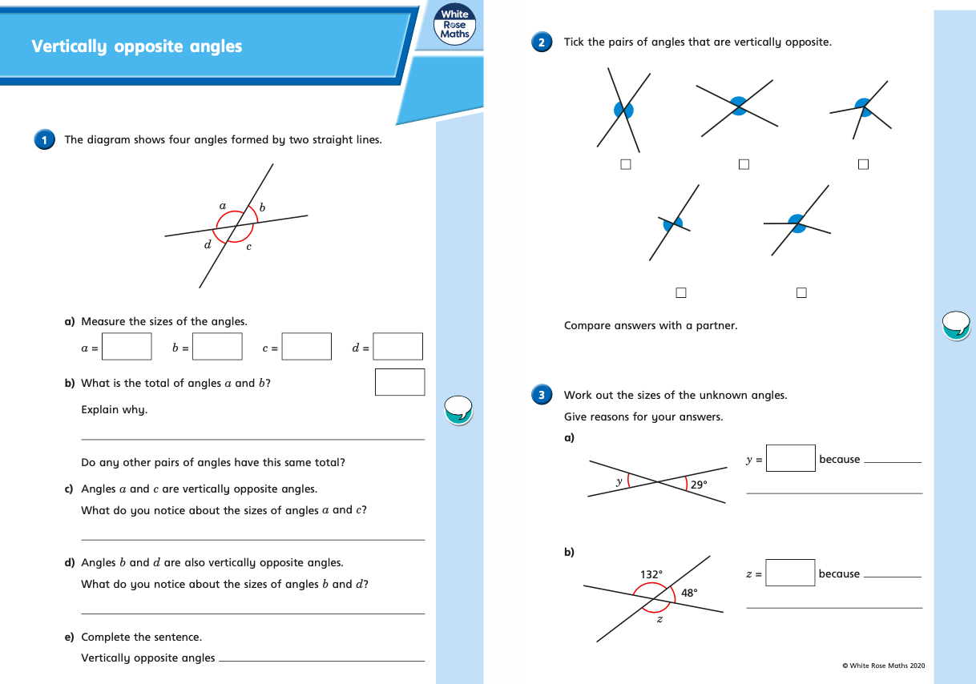
Monday (part 2)
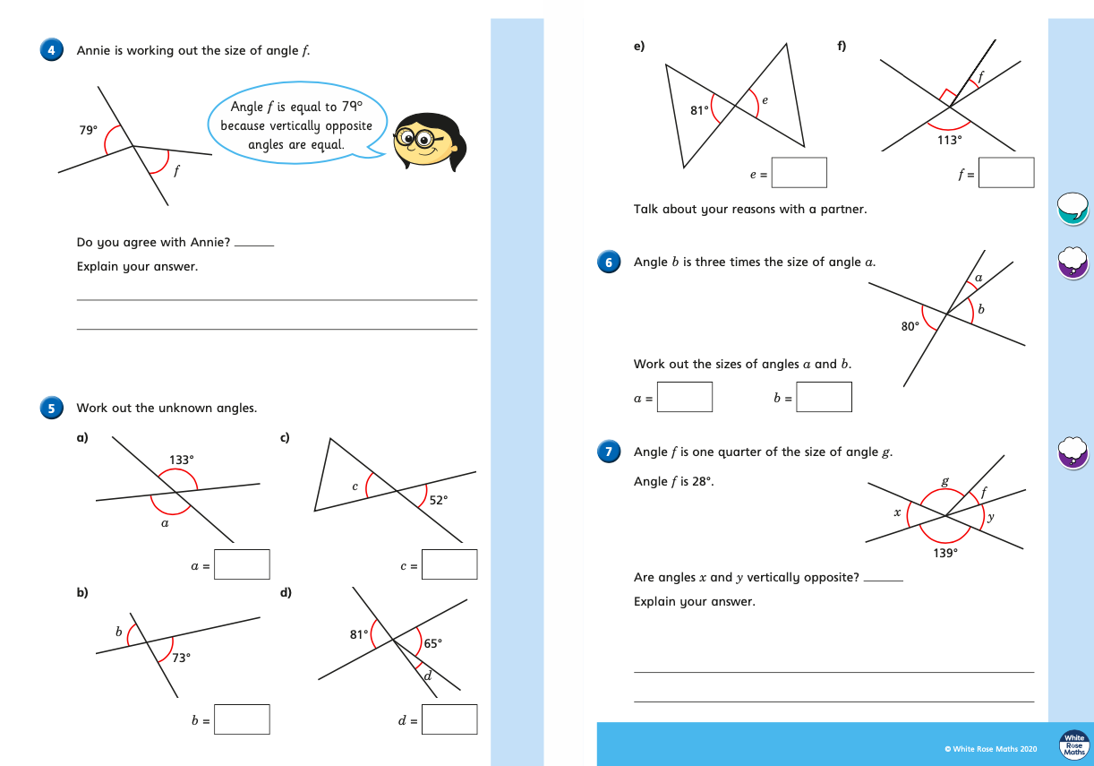
Tuesday (part 1)
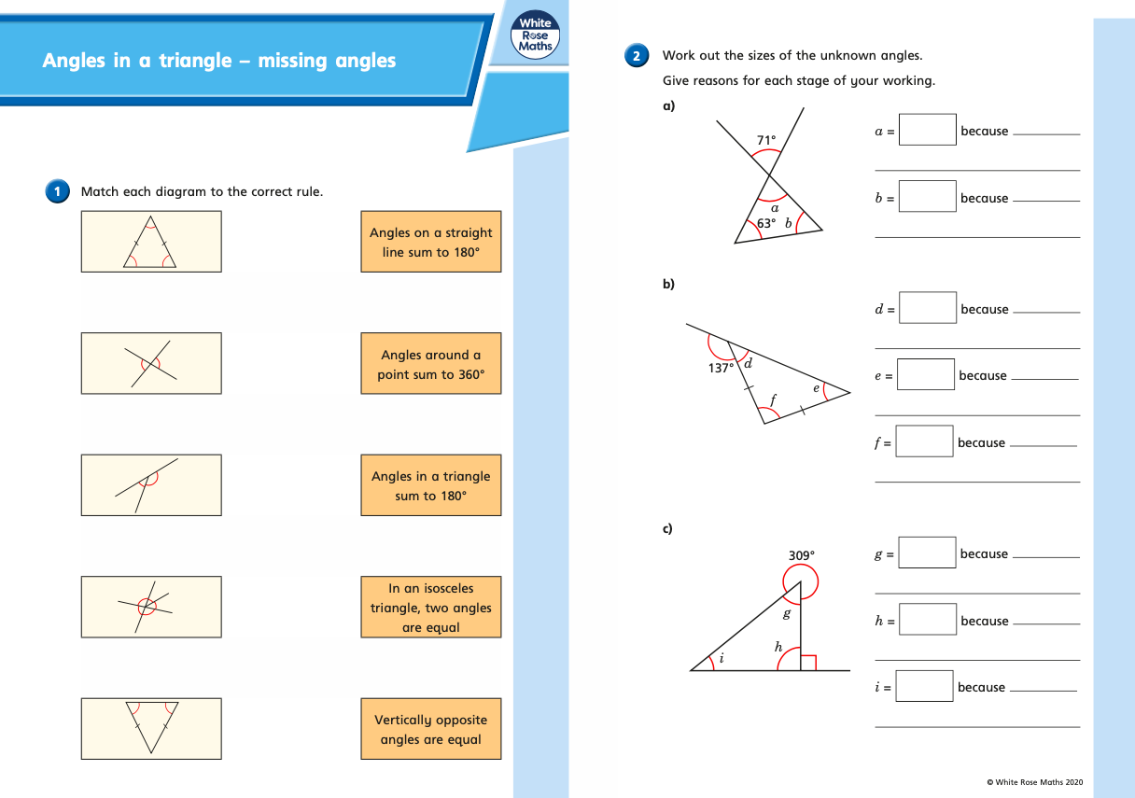

Tuesday (part 2)
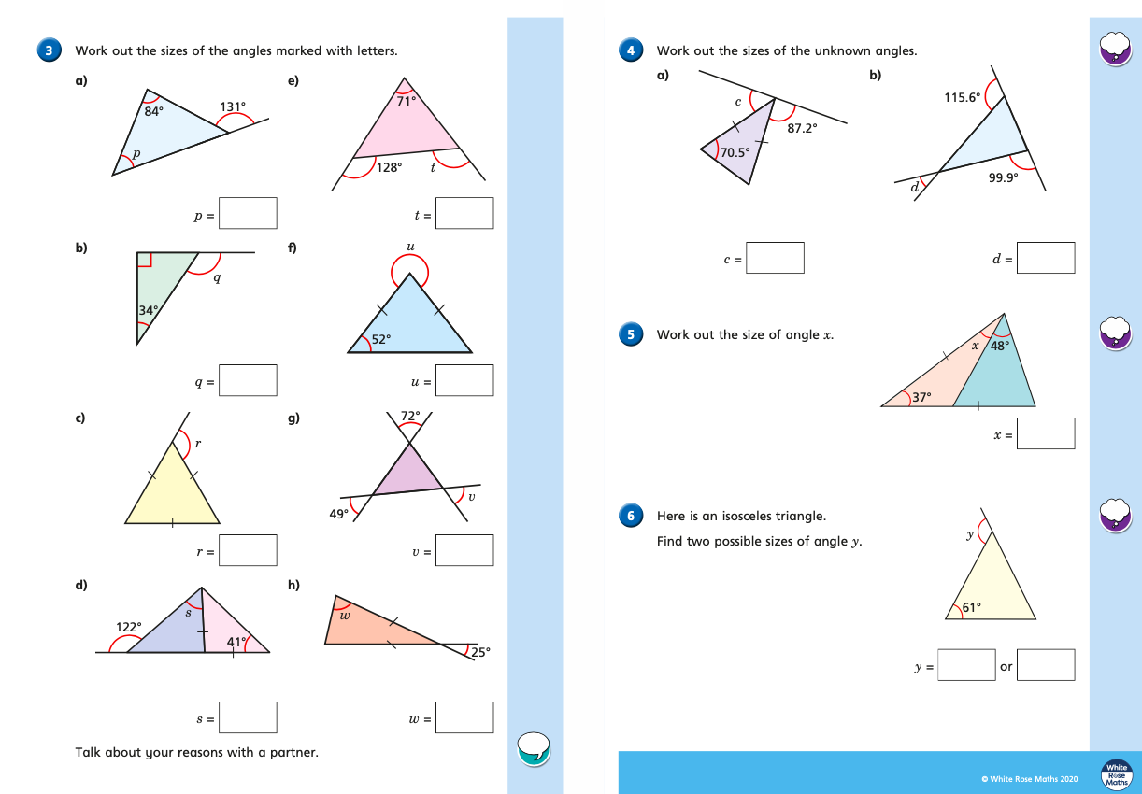

Wednesday (part 1)
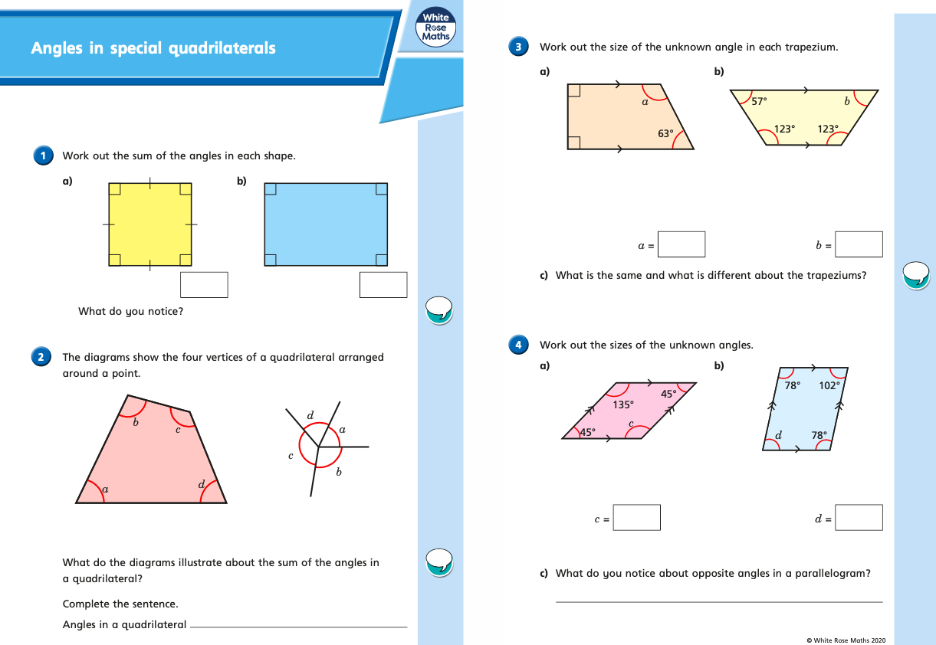
Wednesday (part 2)
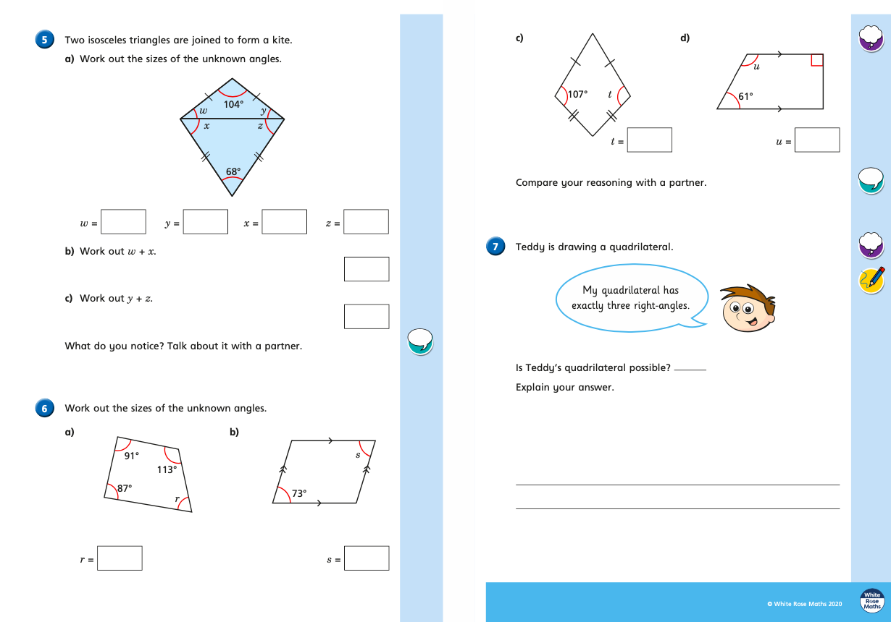
Thursday (part 1)
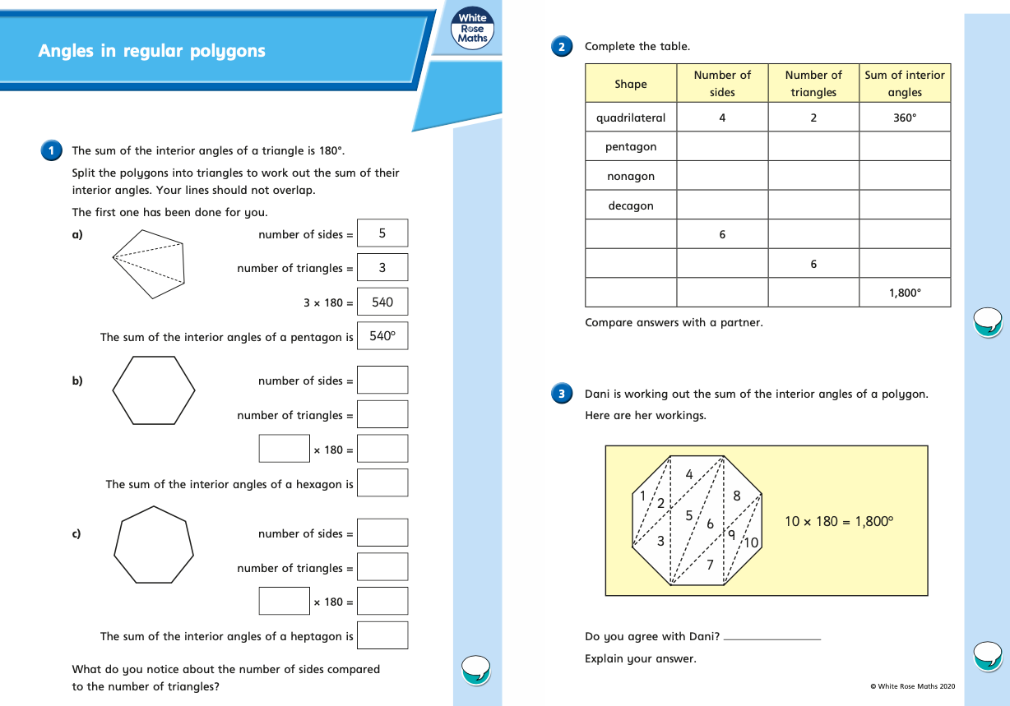
Thursday (part 2)
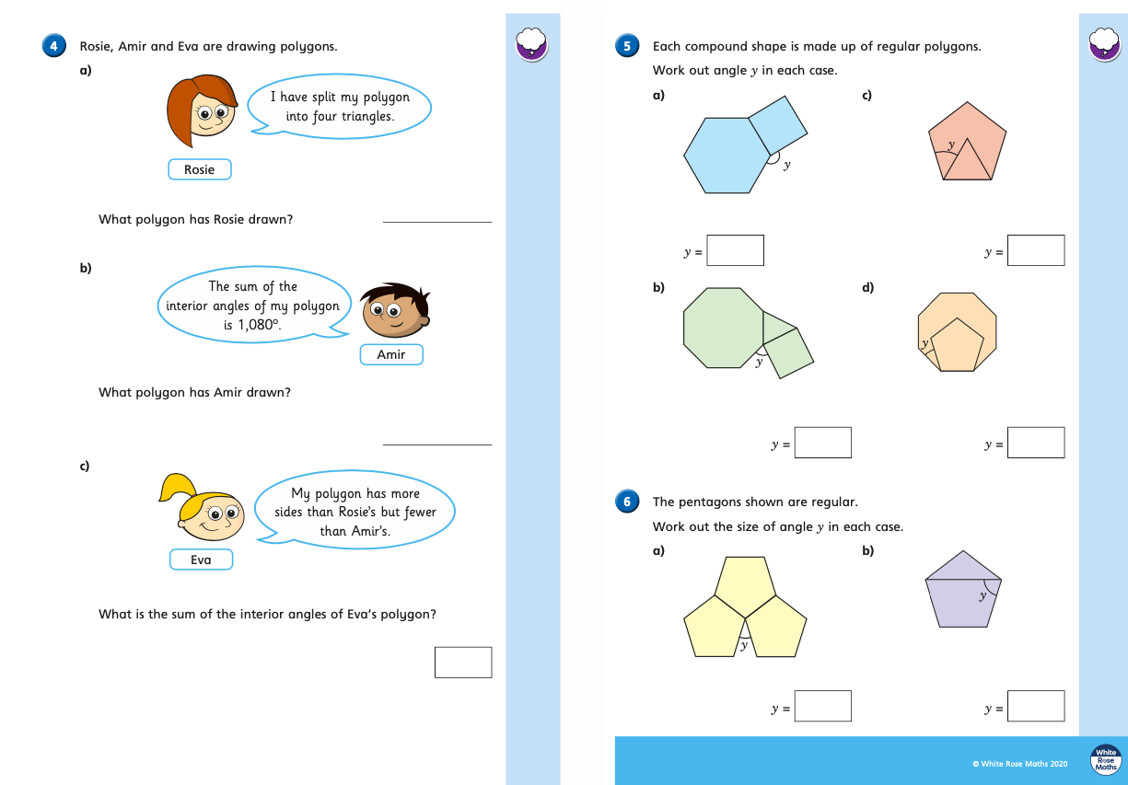

Friday
Click on the links below to have a go at some more angle activities to practise what you have learnt this week:

https://kids.classroomsecrets.co.uk/resource/year-6-vertically-opposite-angles/
https://kids.classroomsecrets.co.uk/resource/year-6-introduce-angles-game/

