Year 1 Home Learning for WC 13-7-20

Maths – White Rose Maths Home Learning – Summer term week 11 tasks
https://whiterosemaths.com/homelearning/year-1/
Monday - Lesson 1 – Find a half
Watch the video and answer these questions
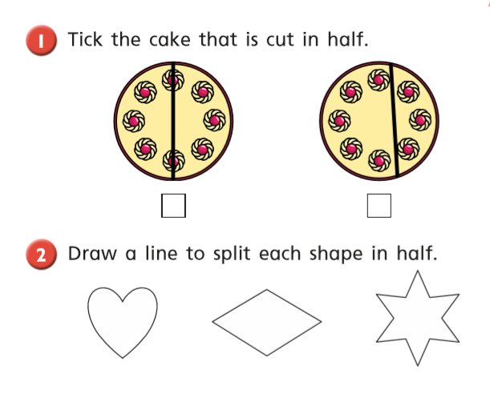
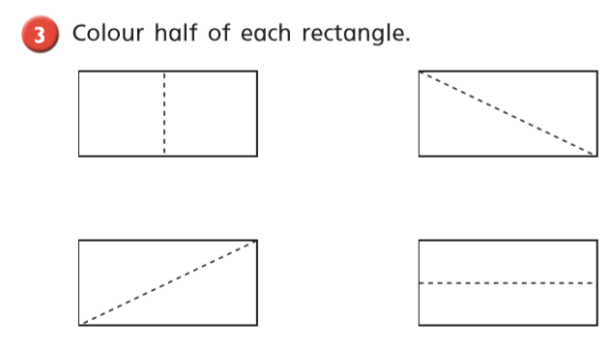
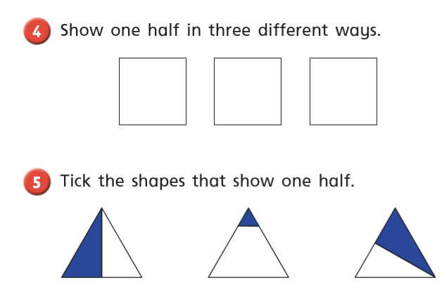
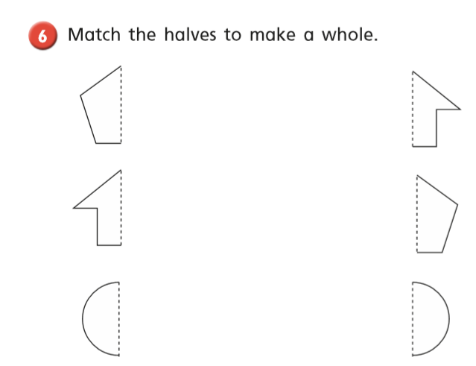

Tuesday - Warm up – Play ‘Halving a Quantity’ game on Classroom Secrets
https://kids.classroomsecrets.co.uk/resource/year-1-halving-a-quantity-game/
White Rose Lesson 2 – Find a half 2 Watch the video and then answer these questions
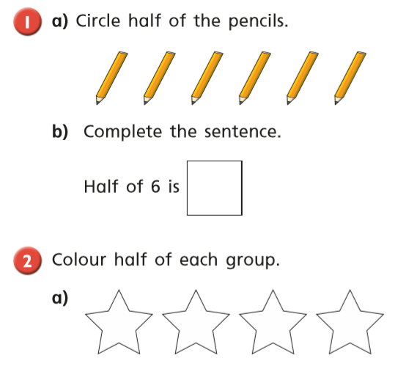
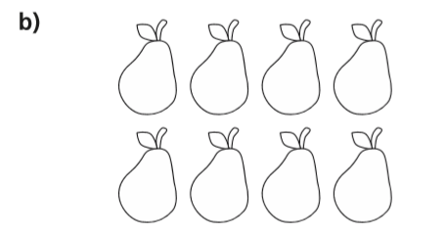

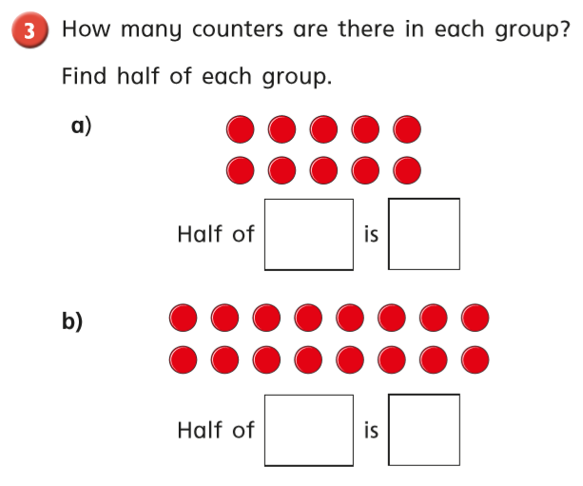
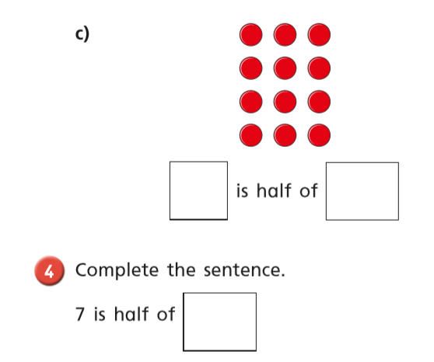
Wednesday - Warm up – Play ‘Find a Quarter of a Shape’ game on Classroom Secrets
https://kids.classroomsecrets.co.uk/resource/year-1-find-a-quarter-of-a-shape-game/
White Rose Lesson 3 – Find a quarter Watch the video and then answer these questions
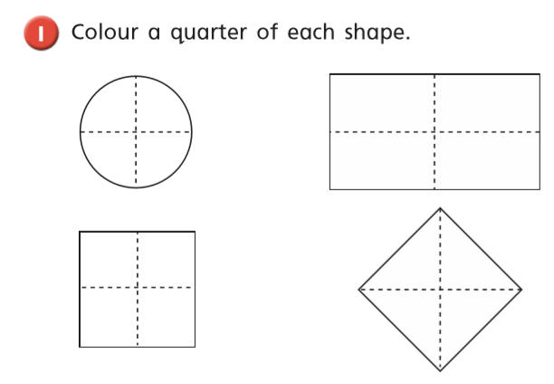
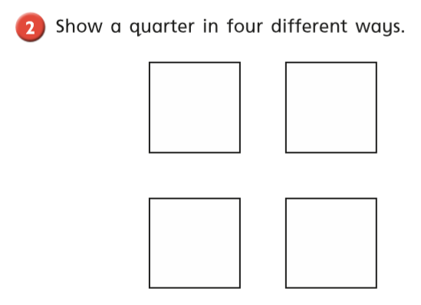
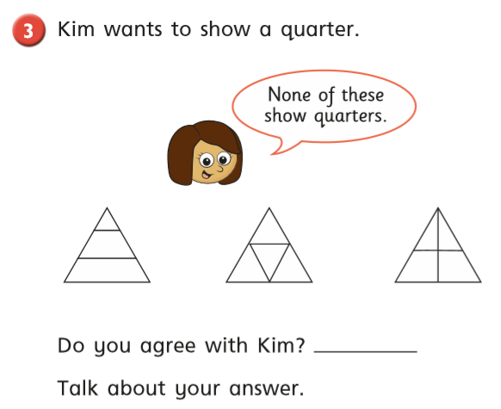
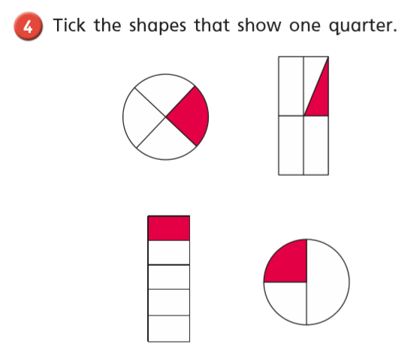
Thursday Warm up – Play ‘Pesky Pets’ on Abacus
White Rose Lesson 4 – Find a quarter 2
Watch the video and then answer these questions
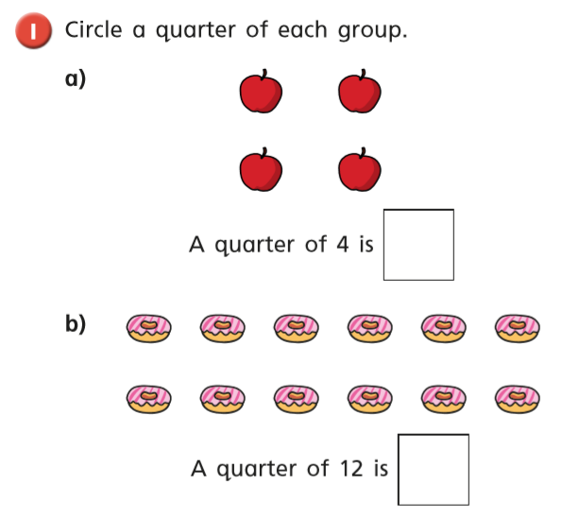
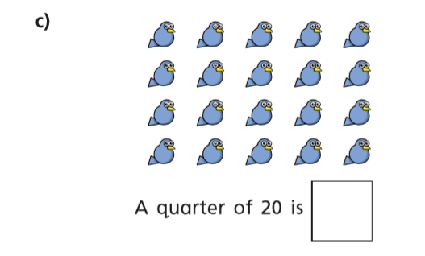
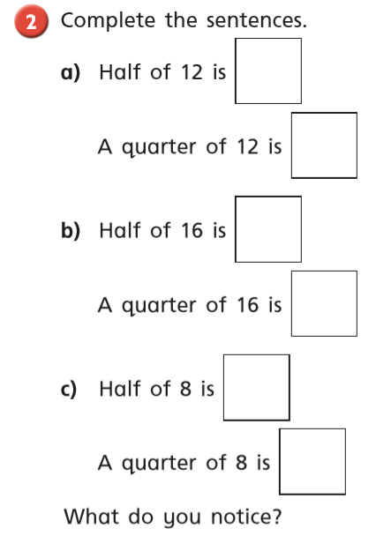
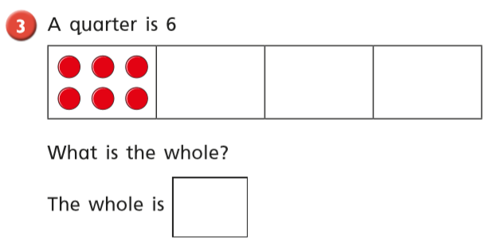

Friday – Warm up – play ‘x2 and x5’ on Topmarks - Hit the Button

