Reception Home Learning Challenges WC 13.07.20
Moorside’s Got Talent!
Moorside’s Got Talent  As it’s the last week, we would like to hold our very own talent contest! Moorside’s Got Talent!  Do you have a special talent? Maybe you can sing, dance, juggle or perform magic! Whatever it is we want to see it.  Take time this week to practice your skill then send your video into school! | Sport’s Day  One of our favourite afternoons in the summer term is Sport’s Day and it would be a shame to miss it this year. That’s why we are holding our own virtual sports day.  Create your own sports activities in your garden. This could be for yourself and your parents or brothers and sisters, or even for pets or toys.  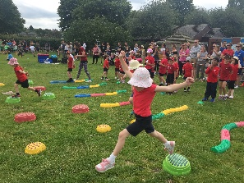  Draw a picture of the activities you have designed | Make your own certificate  After an amazing sports day design your own certificates and hand them out.  You can use the template on page 2 to help you.
Make your own dance  https://www.youtube.com/watch?v=o0wweS8P-tY  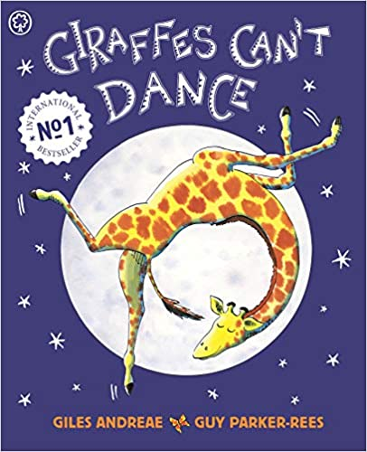  In the story ‘Giraffes Can’t Dance’ Gerald can’t dance at the beginning of the story.  Please can you help Gerald by  Making up your own dance to teach to Gerald or someone at home.  Get an adult to video your dance and send it to school. If you need some inspiration try Just Dance for Kids on YouTube. | Making summer plans  With summer approaching and hopefully nice weather there is so much that you can enjoy in the great outdoors. Look at the list on page 3. How many have you already done? Which ones do you think you might be able to do over summer? Can you send us some pictures of your amazing outdoor activities? | Learn a poem to perform  Learning things requires you to do things over and over again. Try to be a great learner and learn a poem to recite. To help you learn you could use pictures, objects, actions, break it into chunks or use voices. This is a bit like all the learning we do in school – we use things to help us remember.  Use parts of the poem from page 4 (or parts of it) or find your own.

