Maths Year 4
w/c 13.07.20
The objective we are working on in detail this week is:
add and subtract numbers with up to 4 digits using the formal written methods of columnar addition and subtraction where appropriate
Monday - subtracting two 4 digit numbers with no exchange - https://vimeo.com/427996624
Tuesday – subtracting two 4 digit numbers with one exchange - https://vimeo.com/428000196

Wednesday - subtracting two 4 digit numbers with more than one exchange - https://vimeo.com/428000367

Thursday – efficient subtraction –
https://vimeo.com/428003455

Friday – Challenges!

This week, I would like you all to make sure you have logged into Abacus and TTRockstars!

Monday
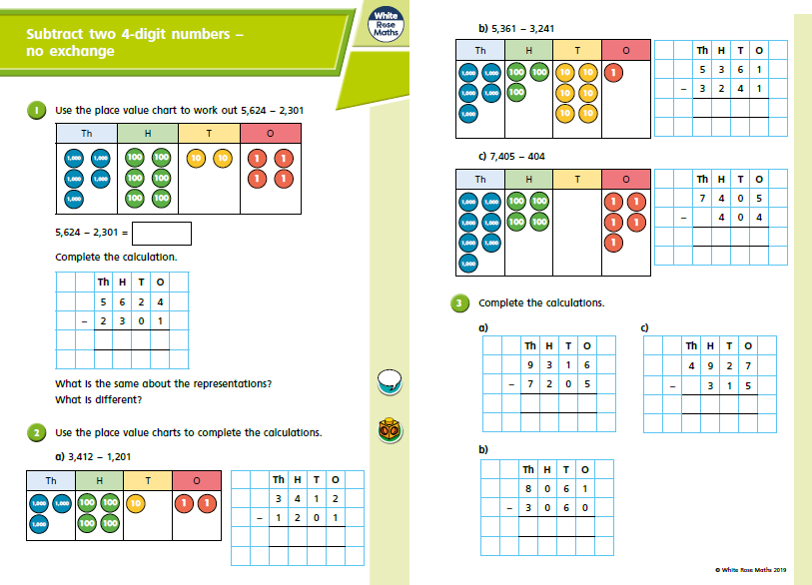

Monday
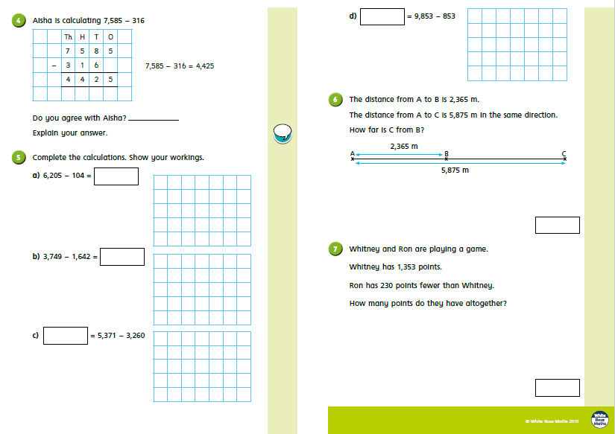

Tuesday
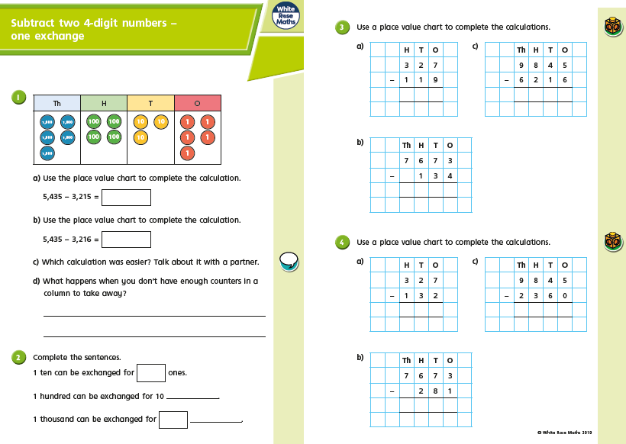

Tuesday
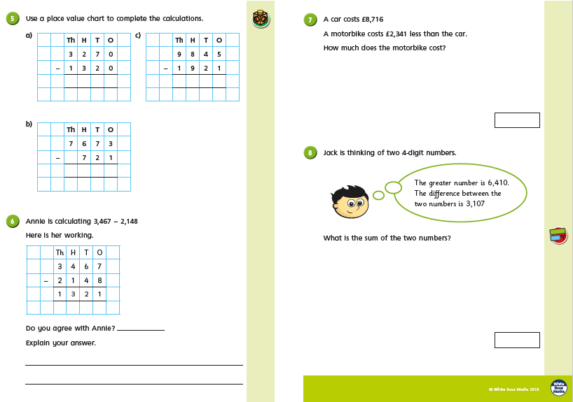
Wednesday
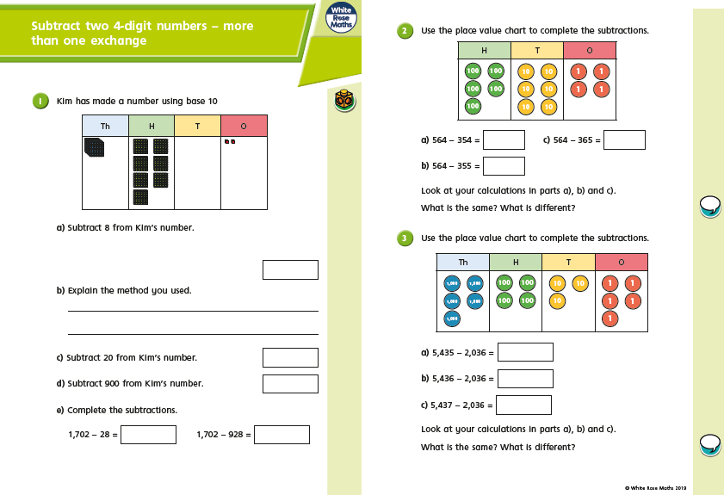
Wednesday
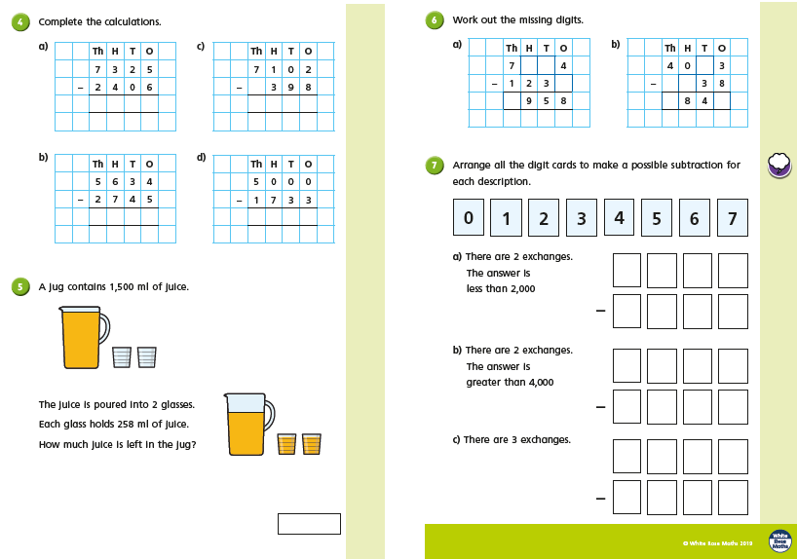
Thursday
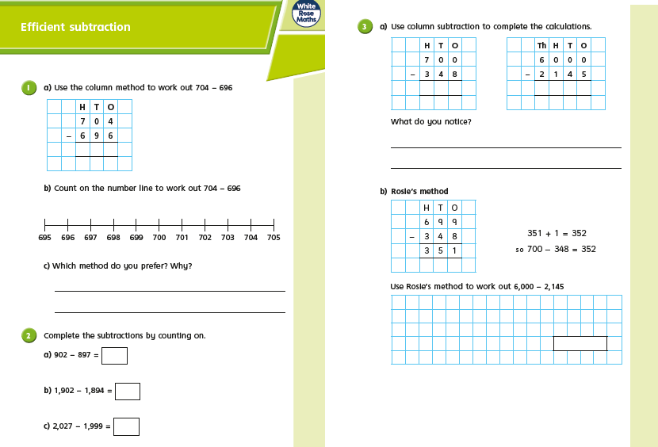
Thursday
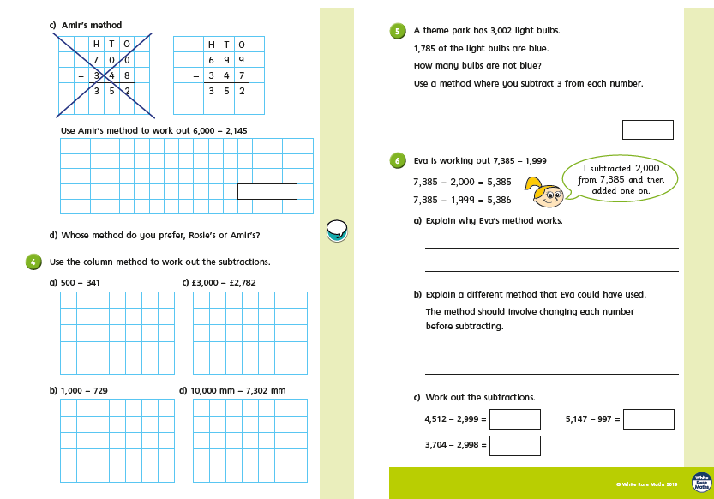
Friday Challenges
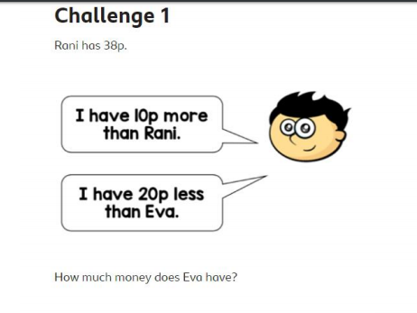
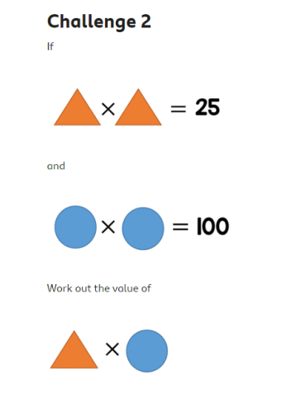

Friday Challenges
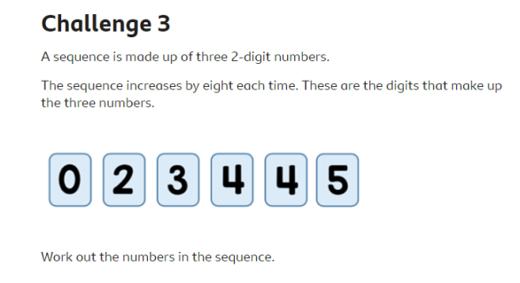

Friday Challenges

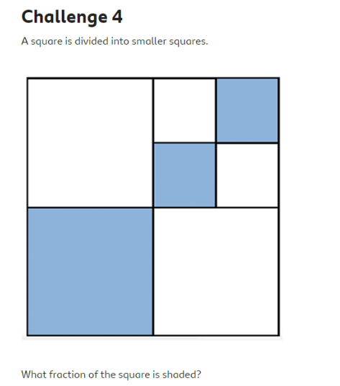

Friday Challenges
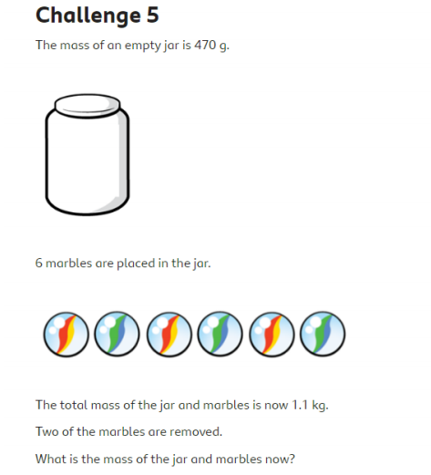

Friday Challenges
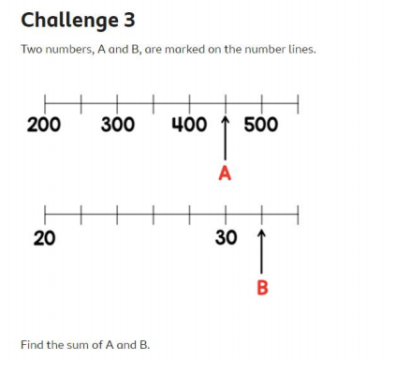

Friday Challenges
