Maths Year 4
w/c 06.07.20
The objective we are working on in detail this week is:
- add and subtract fractions with the same denominator
- solve problems involving increasingly harder fractions to calculate quantities, and fractions to divide quantities, including non-unit fractions where the answer is a whole number
This week on Monday, you will start by adding fractions with the same denominator. On Tuesday, you will be subtracting fractions with the same denominator. On Wednesday, you will be finding fractions of quantities. On Thursday, you will be calculating quantities and on Friday, you have maths challenges to complete!
Using the link below, click on Summer Term Week 6 and each day watch the video and complete the accompanying task (these are printed in your pack), recording the answers in your book. Lesson 1 – Monday, Lesson 2 – Tuesday, Lesson 3 – Wednesday, Lesson 4 – Thursday and Lesson 5 – Friday.
https://whiterosemaths.com/homelearning/year-4/

Have a go at this classroom secrets games to practise your skills!

https://kids.classroomsecrets.co.uk/resource/year-4-add-2-or-more-fractions-game/

https://kids.classroomsecrets.co.uk/resource/year-4-calculate-fractions-of-a-quantity-game/

Monday
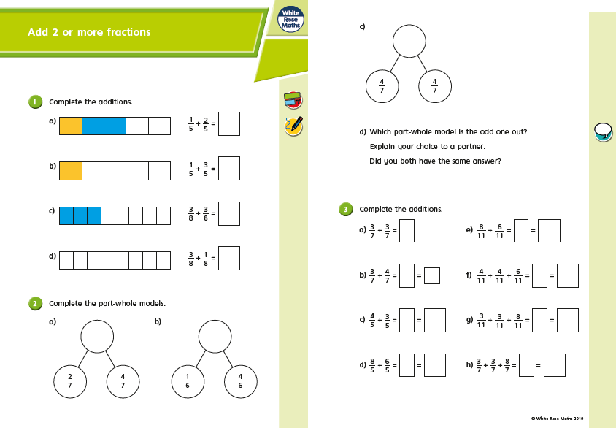
Monday
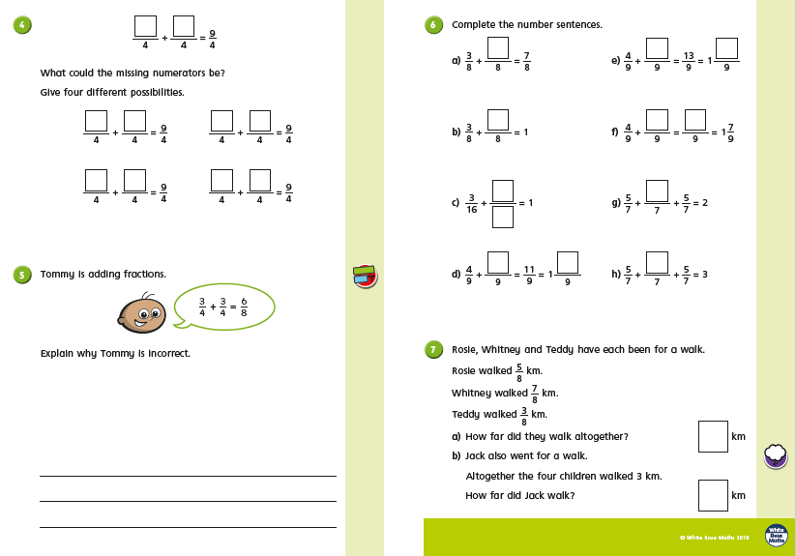
Tuesday
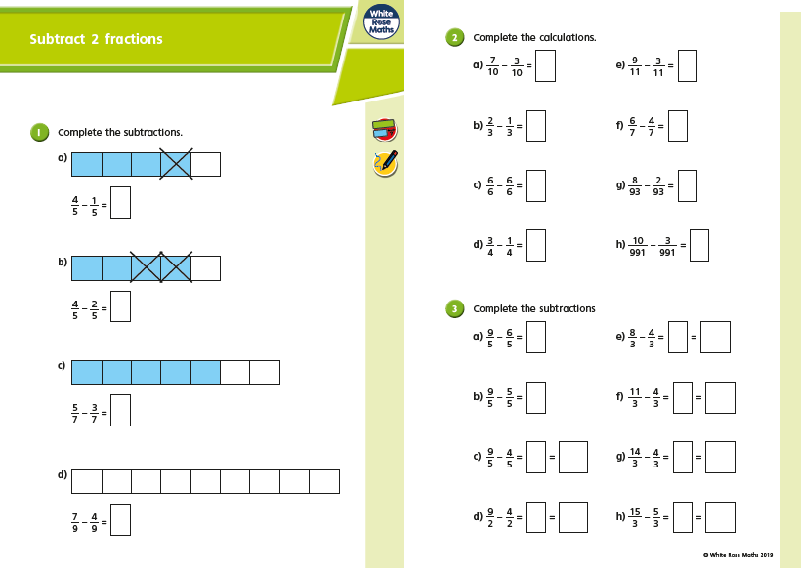
Tuesday
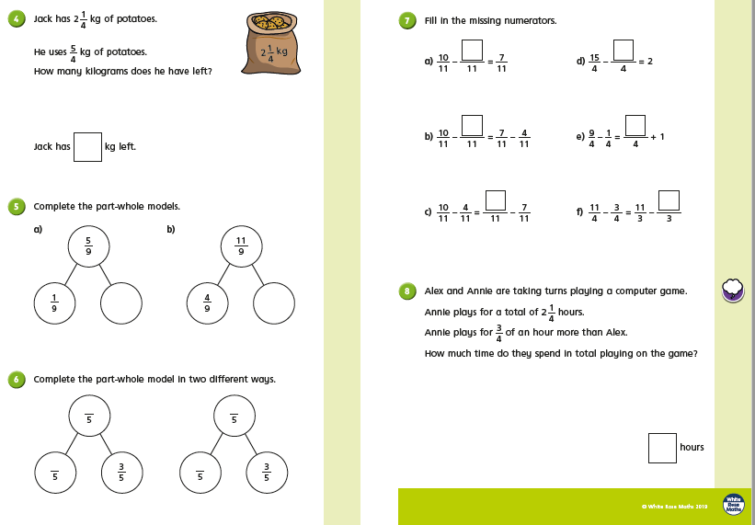
Wednesday
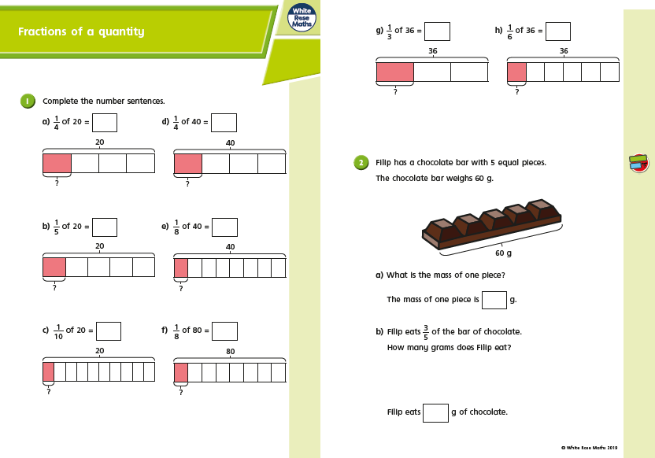
Wednesday
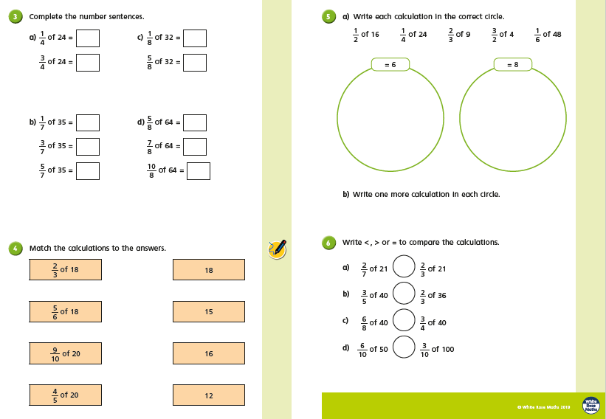
Thursday
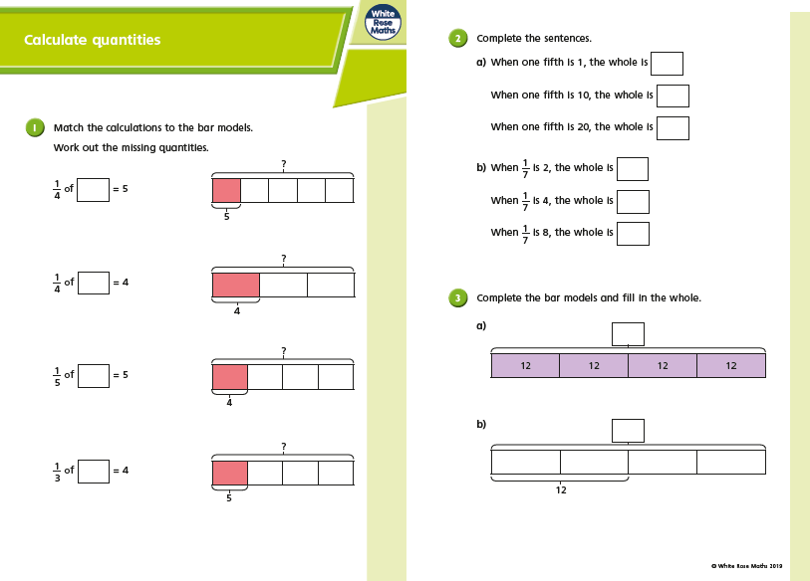
Thursday
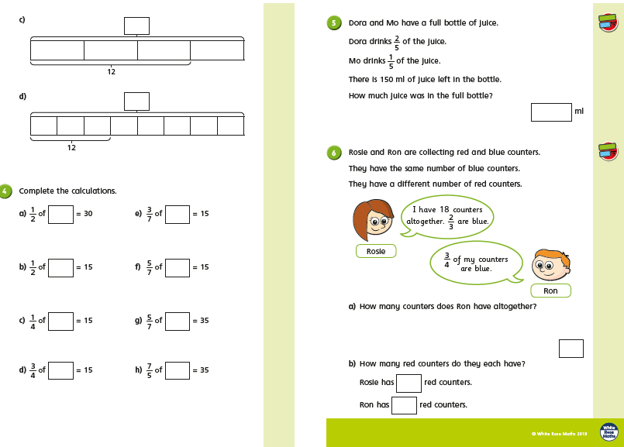
Friday Challenges
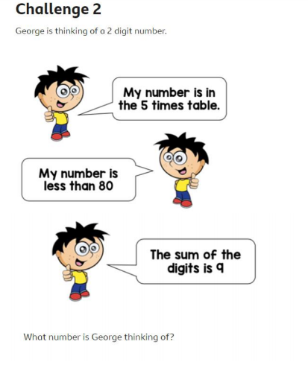
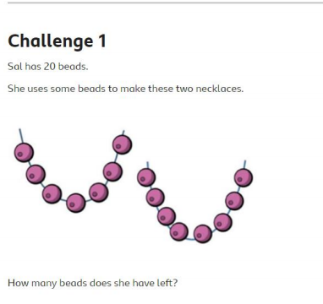

Friday Challenges
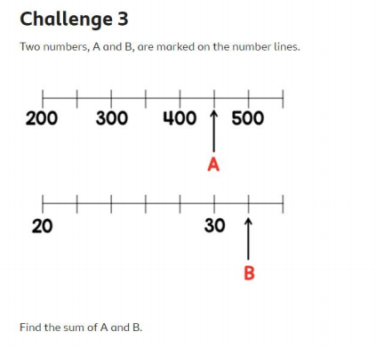

Friday Challenges
