Year 3 Writing
You are going to write a poem to describe an animal.
Monday
SPAG – Adverbs
Watch this clip to learn about Adverbs.
https://www.bbc.co.uk/bitesize/topics/zwwp8mn/articles/zgsgxfr
Adverbs.
An adverb is simply a word that describes a verb (an action or a doing word).
• He ate his breakfast quickly.
The word 'quickly' is an adverb as it tells us how he ate (the verb) his breakfast.
Where to place adverbs?
Adverbs can come before or after a verb.
• He 'quickly' ate his lunch.
• He ate his lunch 'quickly'.

Task:
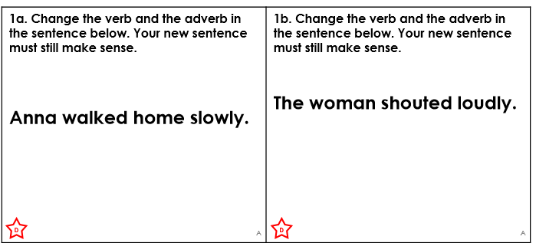
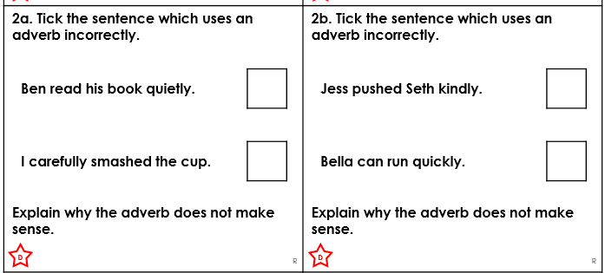
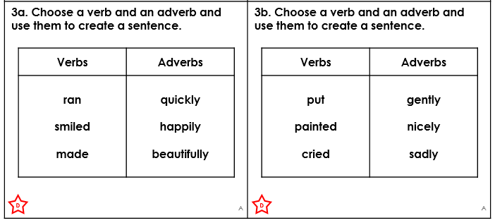
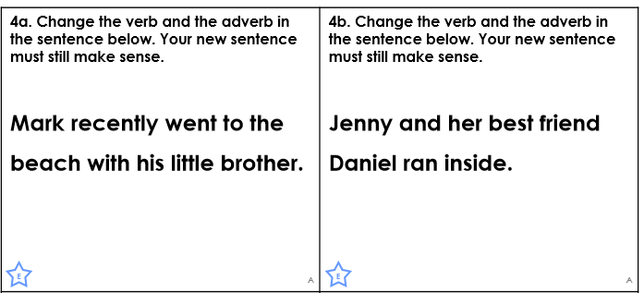
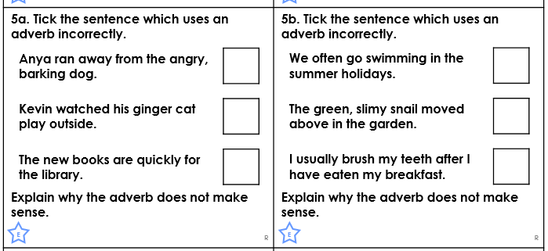
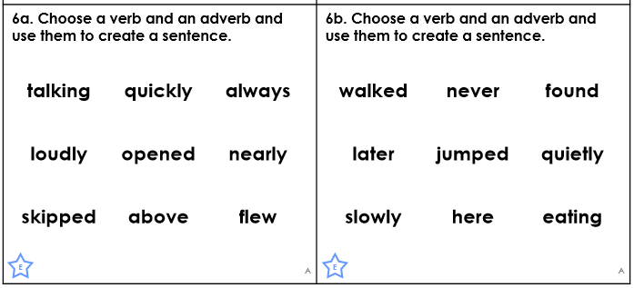

Tuesday:
Today, you are going to select two animals to write poems about. You can either pick two of the pictures below or use your own animals.

Once you have picked them, I would like you to think of adjectives (used previously) and adverbs to describe the animal. Think about how the animal moves and this will help with the use of adverbs. How they look will help with your use of adjectives.
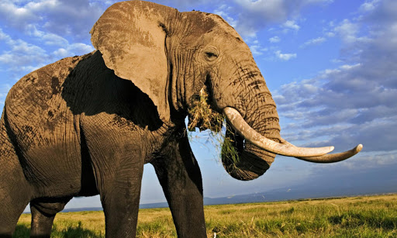
e.g

Body Part | Adverb | Adjective
Trunk | Gracefully, happily | Long, swaying, grey
Tusks | Angrily, wildly | Shining, sharp
Legs | Slowly, gently | Colossal, huge,
Ears | enthusiastically | enormous

Tuesday – Animal pictures.
Remember pick two animals to describe or come up with your own!
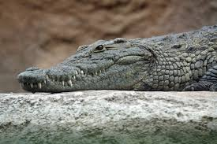
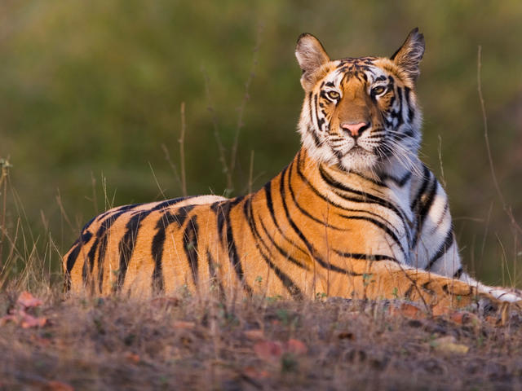

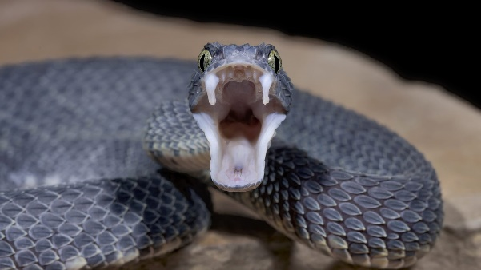
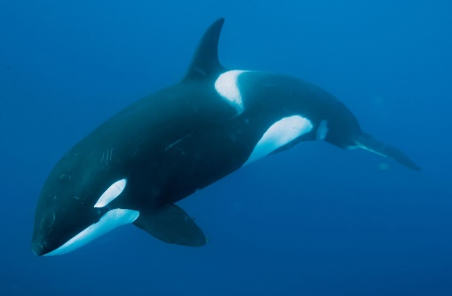
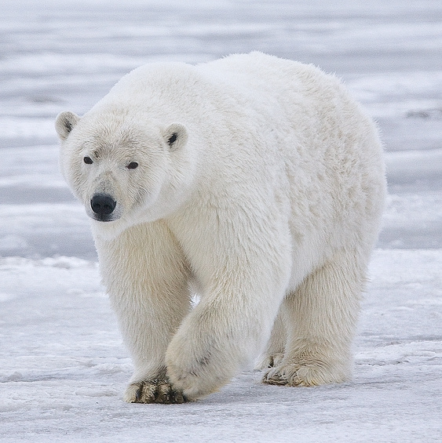
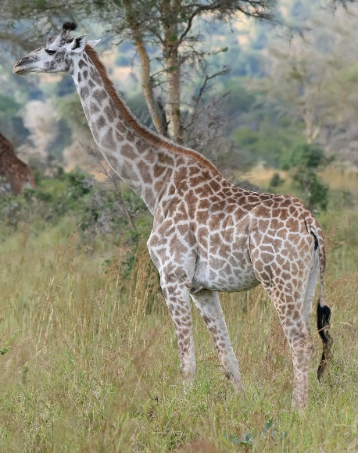

Adverbs word mat

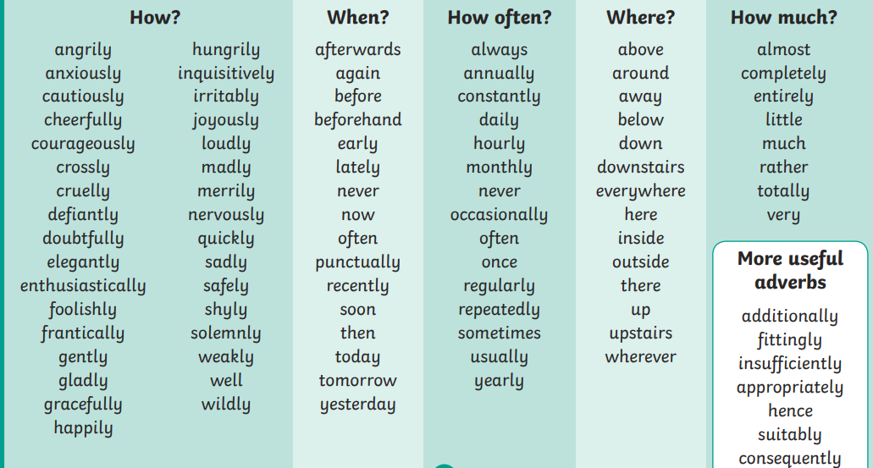

Adjectives word mat.
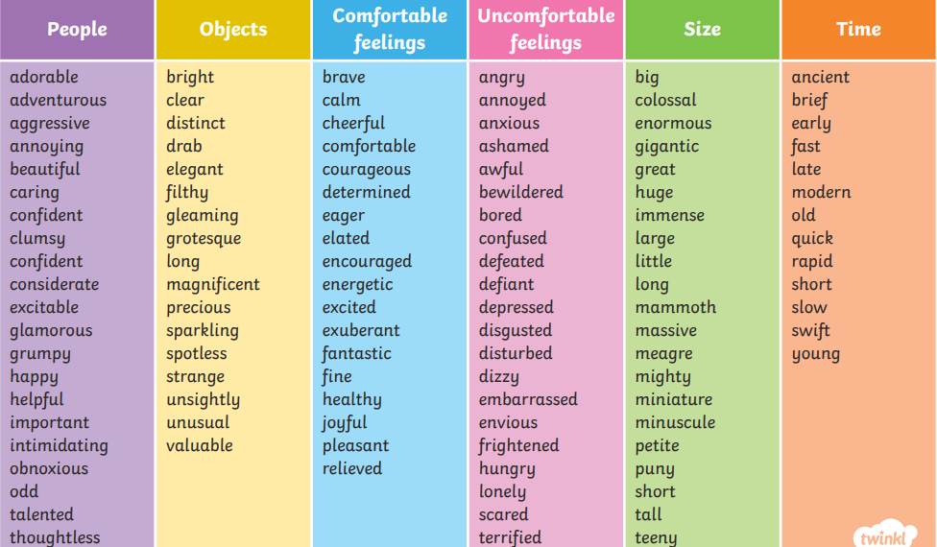

Wednesday
Read through the following poems. Can you highlight where the adverbs have been used?
Now, try highlighting where the adjectives have been used.
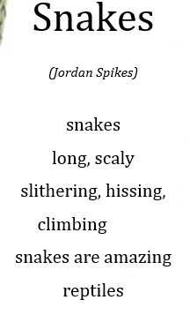
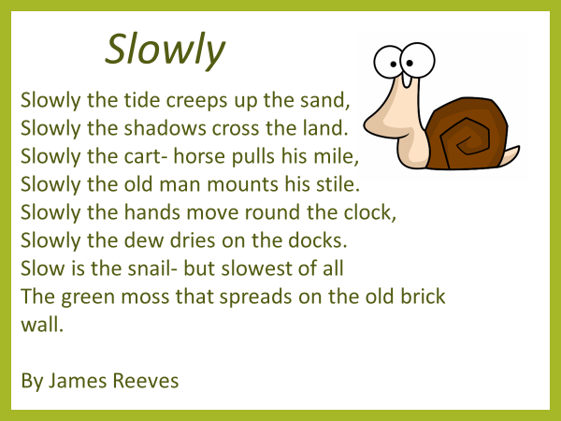

Once you have done this, go back to your work from yesterday... Are there any ideas you could borrow for your own writing?

Thursday
Today, you are going to try and write a poem about the animals you have chosen adverbs and adjectives for.
To start with, choose your first animal and have a go at writing out the adverbs and adjectives for each body part like I did on Tuesday.
Example
Body Part | Adverb | Adjective
Trunk | Gracefully, happily | Long, swaying, grey
Tusks | Angrily, wildly | Shining, sharp
Legs | Slowly, gently | Colossal, huge,
Ears | enthusiastically | enormous

You can use the word mats to make these words more spectacular! Think about how the animal moves. Below is my poem about the elephant. Can you make it better?
My final poem:

The Elephant is enormous and colossal,
He gracefully swings his trunk through the air,
The sun glistens on his sharp tusks,
As he trudges, slowly, through the forest,
His ears flap enthusiastically,
As he makes it home.

Task: can you find the adverbs and adjectives in this poem?

Then repeat the process for your other animal!

You could also try and acrostic poem, which looks like this:
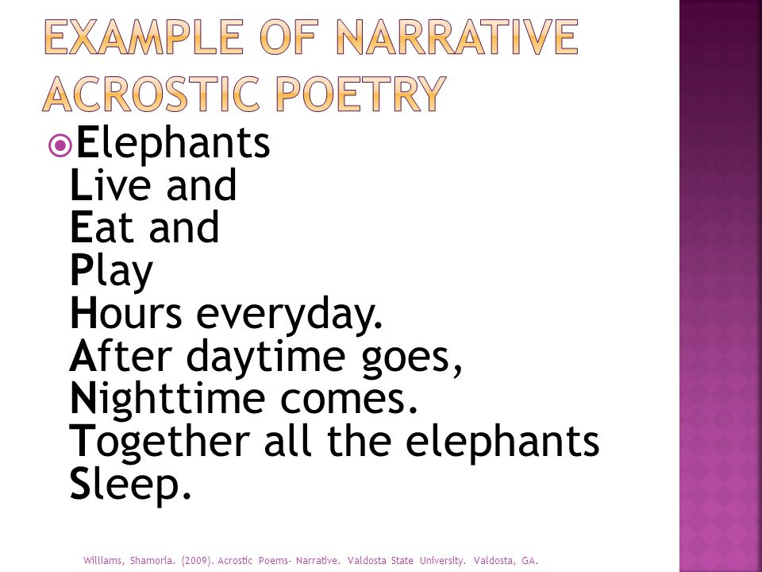

Friday
Select your favourite poem you have written. Make sure you have spelt the words correctly and can easily spot the verbs, adverbs and adjectives.
Use the page border on the next page to write the final draft of your poem neatly.
Have fun year 3!

Mr Price

