Nursery Home Learning WC 22-6-20

Reading
Read a book with your grown up every day – the more often the better!
We will also be putting a story on YouTube and Facebook every day for you to enjoy at home.
Choose a book from home to look at – try and choose one that your child is very familiar with.
- Ask them to read it to you!
- You could also read it to them and leave a word for them to fill in; A mouse saw the nut, and the nut was……..?
- Miss a word that starts with the first letter of their name and then discuss the letter and the sound - can they think of anything else that starts with the same sound?
- Choose a letter to hunt for in a story; how many ‘s’s can they find? Etc.

Writing
Practice tracing over the dotty lines on page 2. Keep your pencil on the lines very carefully!
Remember to help your child to practice writing their name every day. Start with the first letter and practice that until they can do it beautifully! Then move onto the second letter etc. Use the laminated name sheet to practice – if you use a whiteboard pen, you can rub it out and keep practicing.
Phonics
Use the rhyming pictures on page 3 to play ‘Silly Soup’. Cut out each strip of 4 pictures into separate images, so you have 4 bits of paper. You also need a bowl and a spoon. Your child has to find the picture that doesn’t belong (that doesn’t rhyme). Put the pictures in front of the bowl and say
‘I’m going to make some silly soup, I’m making soup that’s silly.
I’m going to cook it in the fridge, and make it nice and chilly.
I’m going to put in….. e.g. a jug, a cat, a rug and a slug.
Something doesn’t belong! Can you hear what is wrong?!’’
Rhyming is a tricky skill, and children need to hear lots and lots of rhyming words before they start to hear whether words rhyme or not. Reading lots of stories with rhyming words is a big help!

Check out ‘Learn with Timmy’ on youtube – some lovely videos to help with language.

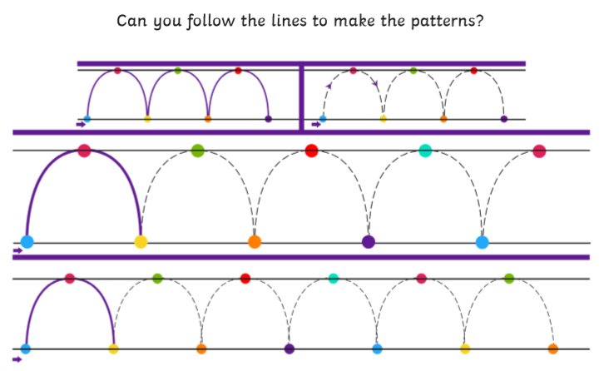
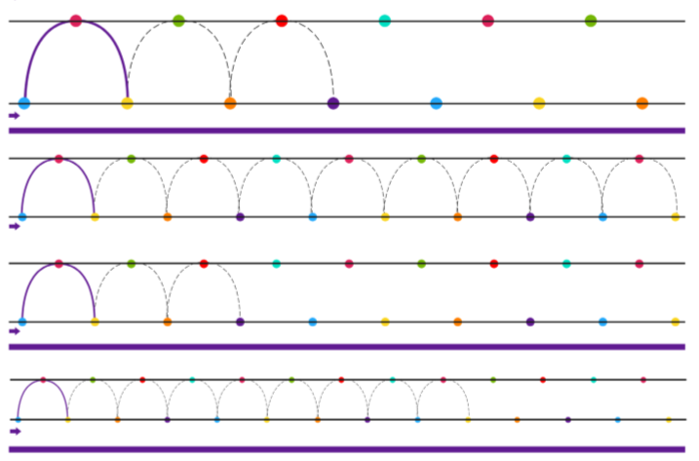
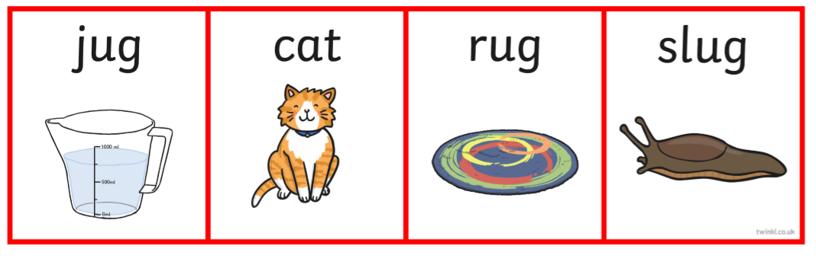
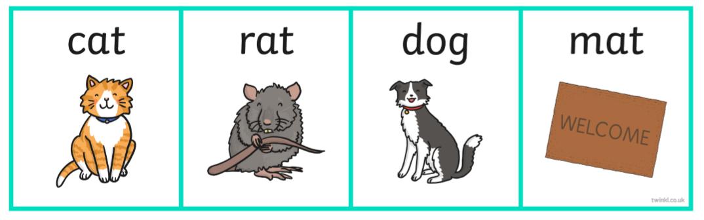
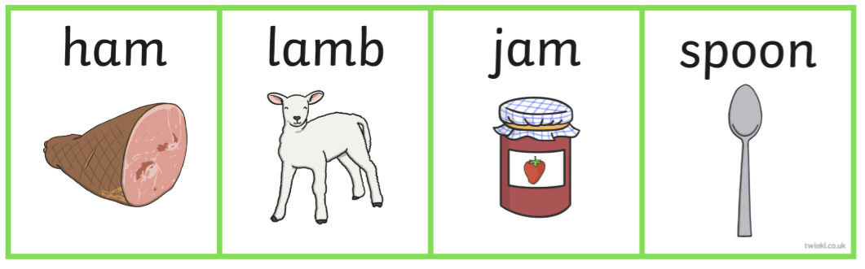
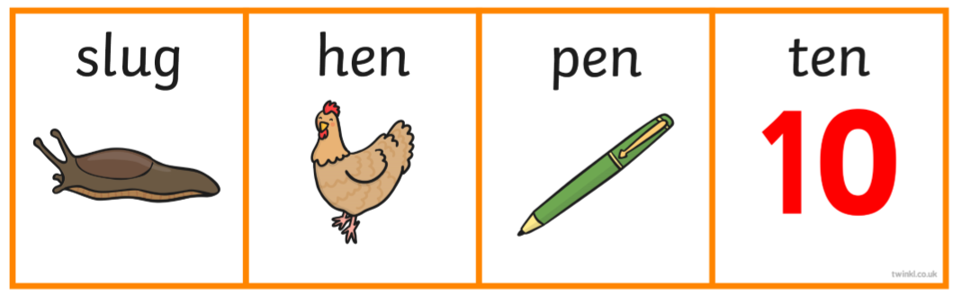

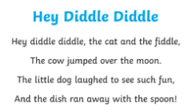

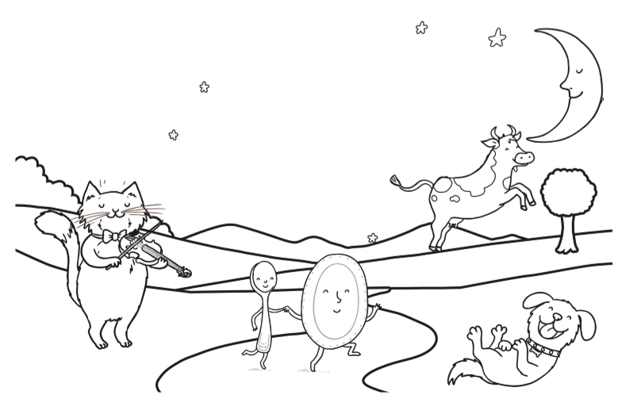

Maths
Practice counting and singing to 10.
https://www.youtube.com/watch?v=6RfIKqkvHTY

When you watch this one, pause the video to allow your child to count the objects on screen.
https://www.youtube.com/watch?v=diMJIlv-4N0

Adapt ’10 green bottles’ for whatever you have in your home; you could do ’10 shiny motorcars’, ’10 big dinosaurs’, ’10 shiny spoons’ etc. and use the items along with the song. Encourage your child to join in, counting on their fingers as you both sing. Emphasize the maths; ‘there were 10, we took one away, and now there are 9’ etc.

Squares
This is our ‘square’ song (to the tune of Frere Jacques)

Squares
Find 4 corners, find 4 corners,
Sides the same, sides the same,
Join them altogether, join them altogether,
Square’s my name, square’s my name.

Go on a ‘square hunt’ around your home – can you find a square in every room? Use page 6 to show me what you found…

What squares did you find…..

In the kitchen?

In your bedroom?

In the living room?

Topic – Transitions
All the children in nursery will face some changes in September; it might be their first time back to nursery for a long time, there might be different staff, there will be new children or the classroom might have changed round. We know how important it is for children to talk about changes that might happen and any worries they might have. It is also important for them to feel confident and secure – if children feel happy and safe, they are much better equipped to deal with changes and new situations. The following activities will help your child to deal with changes and their feelings about them.

Page 8 will let your child think about things that make them happy – talk about what they enjoy at nursery, and let them draw something in each bubble.

Page 9 is instructions to make a ‘well-being jar’ – you don’t have to make it as fancy as it says! This activity will allow you and your child to talk about things that you are both missing, and think about how much you are looking forward to doing them in the future.

Try some of the mindfulness activities on page 10 – these will teach your child some ways that they can keep calm if they feel worried.

We practice something called ‘finger breathing’ in school – we trace the outline of one of our hands with a finger on the other hand. We breathe in through our noses when we go up a finger, and out through our mouths when go down the finger. We do this very slowly and keep our eyes closed. This technique calms us down when we are feeling worried or cross. Try it at home and see!

