Nursery Home Learning WC 15-6-20

Reading
Read a book with your grown up every day – the more often the better!
We will also be putting a story on YouTube and Facebook every day for you to enjoy at home.
Choose one of your books from home to look at. Have a go at the activities below;

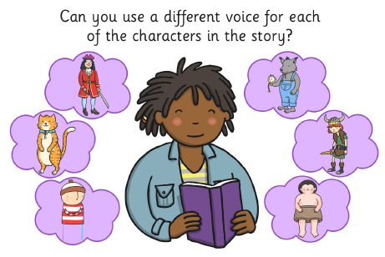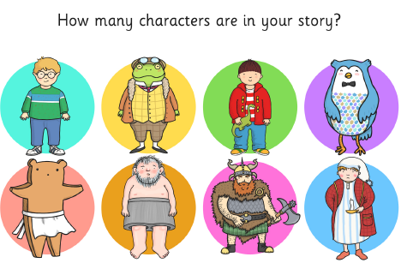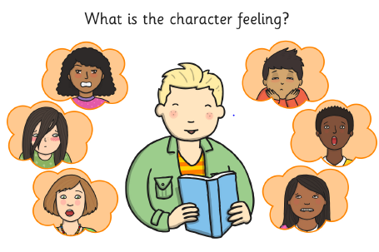
Writing
Practice tracing over the dotty zigzag lines on page 2. Keep your pencil on the lines very carefully!
Remember to help your child to practice writing their name every day. Start with the first letter and practice that until they can do it beautifully! Then move onto the second letter etc.
Phonics
Use the rhyming pictures on page 3 to play some rhyming games. You could turn the pictures face down and play a pairs game, or practice saying the names of the objects and see if your child can say ‘rhyme’ or ‘no rhyme’. Rhyming is a tricky skill, and children need to hear lots and lots of rhyming words before they start to hear whether words rhyme or not. Reading lots of stories with rhyming words is a big help!

Check out ‘Learn with Timmy’ on youtube – some lovely videos to help with language.

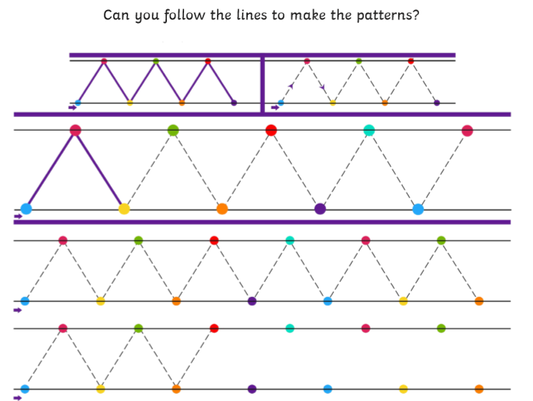

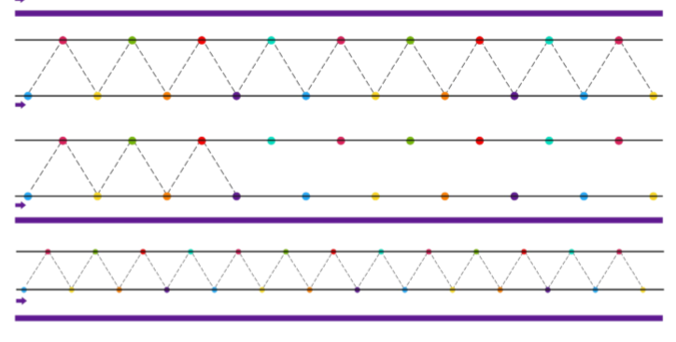
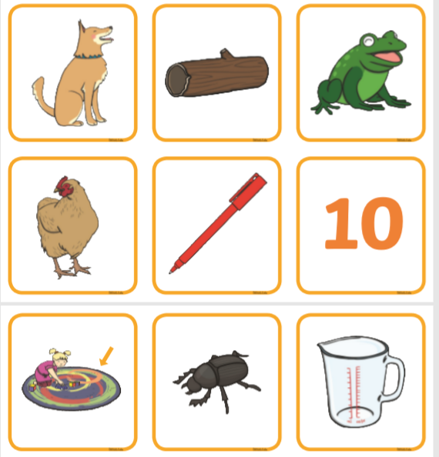

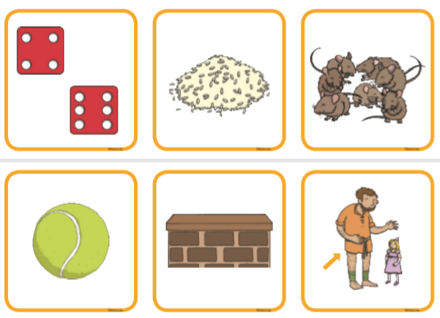

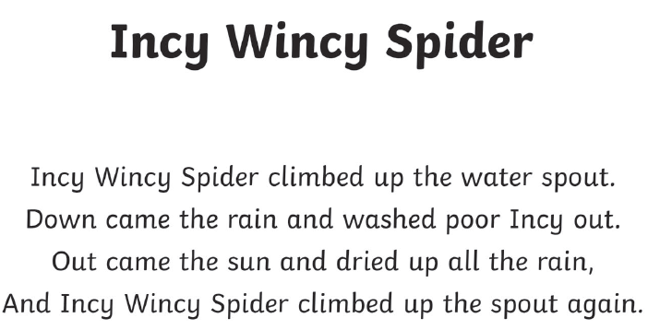

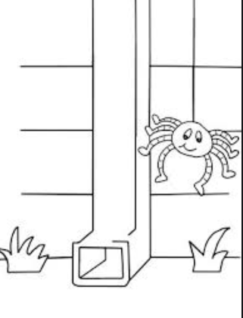

Maths
Practice singing…
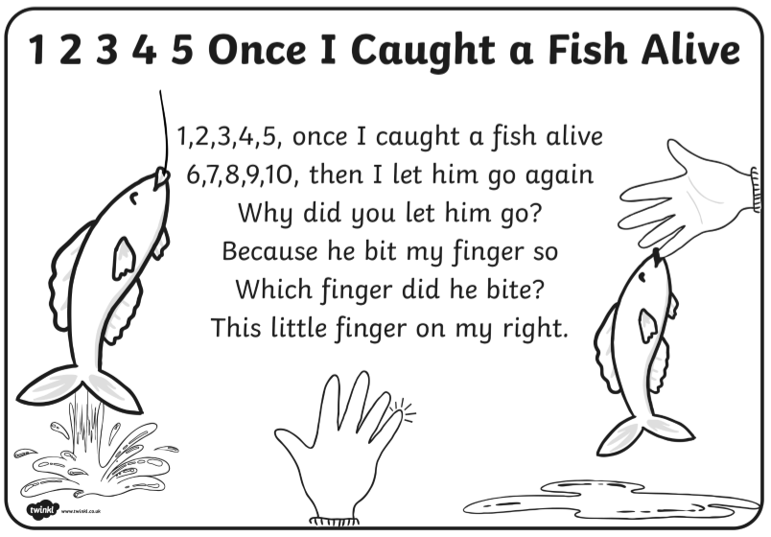

Cut out the fish on page 6, and use them to play a counting game. The adult writes a number on a piece of paper, and the child has to count out that number of fish. You could swap roles and get the child to check whether you have counted properly – make some mistakes and see if your child can help you!
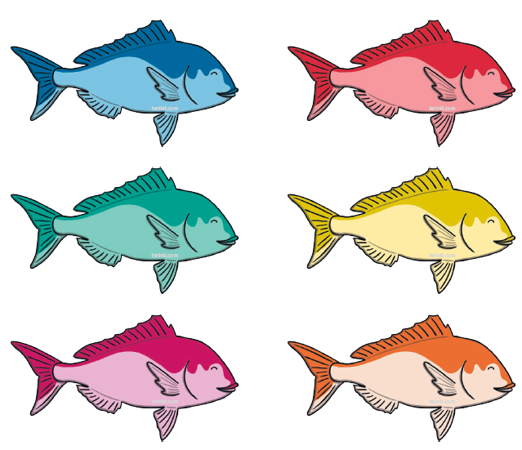
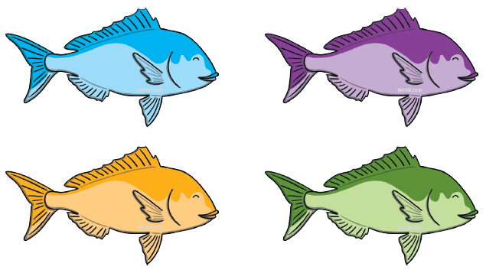
Rectangles and Oblongs
Use the sheet on page 8 to explore rectangles and oblongs. Don’t forget to sing the song!

Oblongs
(to the tune of Hickory Dickory Dock)
2 of my sides are short,
2 of my sides are long,
With corners 4, I’m like a door,
And my name is oblong.

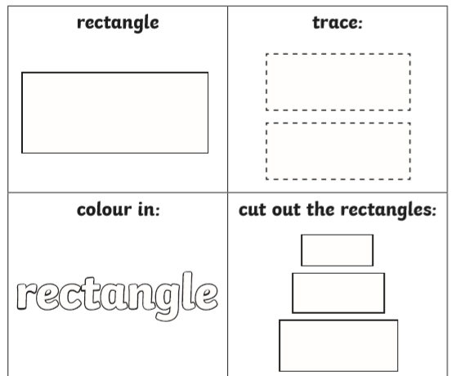
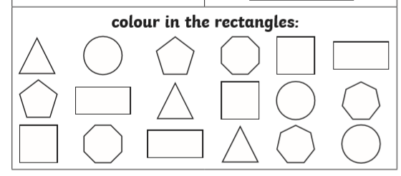

Topic – What does it mean to be ‘safe’?
Being safe means that you are being looked after, and you are unlikely to come to any harm.

There are lots of things that grown ups do to keep you safe – talk to your parents about what they do. Can you think of 5 things?

What things do you do to keep yourself safe? Think about when you go for a walk, go in your car or ride on your bike.

Sometimes people have to leave their homes and the country where they live because it isn’t safe for them, these people are called REFUGEES.

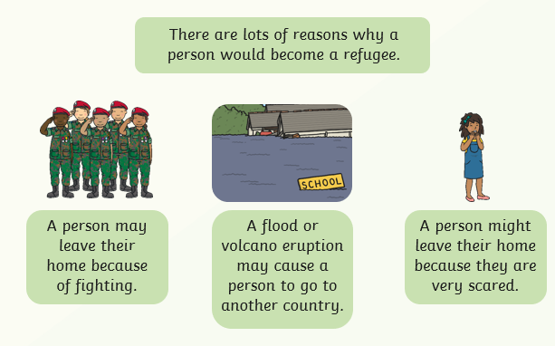

Sometimes refugees have to travel a very long way to find a new home where they are safe. If you had to leave your home, what special things would you take with you? Draw them in the suitcase on page 10.

