Year 2 Home Learning for 1.6.20
Maths
Your maths this week is all about multiplication. We will begin by creating number sentences linking addition to multiplication and move towards arrays and our times tables.
Start each day by watching the videos on the White Rose website (Summer Term Week 5, 18th May). Then complete the sheets in your pack.
https://whiterosemaths.com/homelearning/year-2/
I have included a link to the BBC Bitesize, which matches the lessons you are looking at:
https://www.bbc.co.uk/bitesize/articles/zbypscw

Monday – Creating a multiplication sentence using ‘x’ symbol.

Tuesday – Using Arrays.

Wednesday – The 2 times tables

Thursday – The 5 tables tables.

Friday – I have put a selection of times tables games in your pack. Remember to keep playing on ‘Times Tables Rockstars,’ as this will really help you.

Monday part 1
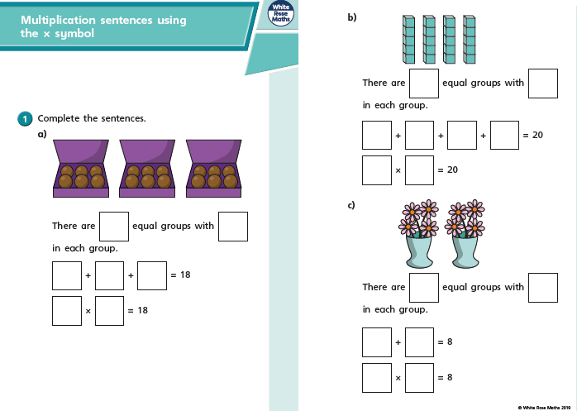

Monday part 2
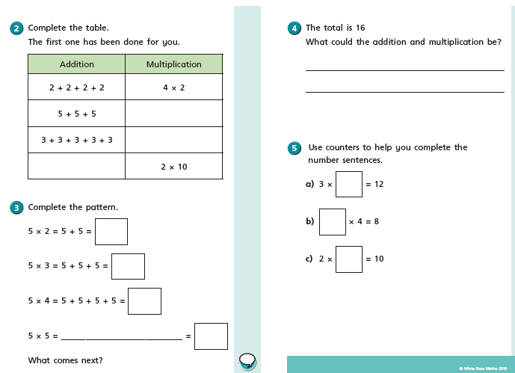

Tuesday part 1
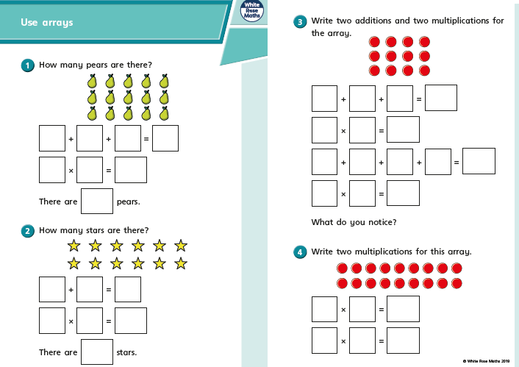

On Thursday and Friday, we are going to look at counting amounts of money in £ and p. In Year 2 we are brilliant at counting in 1s, 2s, 5s and 10s and this is going to help us.
Remember the coins and notes we use are:
1p, 2p, 5p, 10p, 20p, 50p, £1, £2, £5, £10, £20
Tuesday part 2
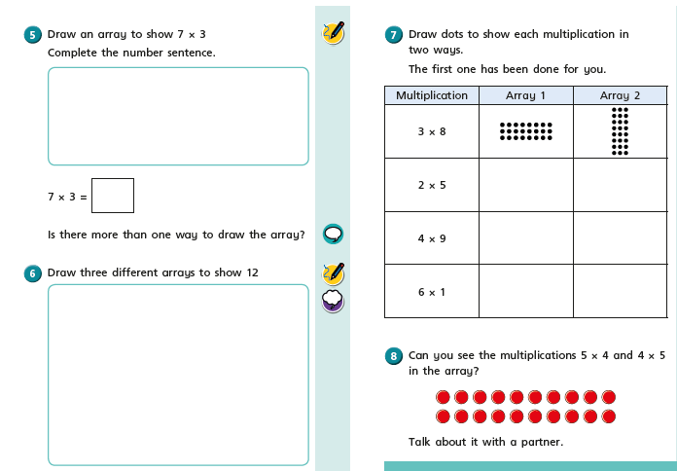

Wednesday part 1
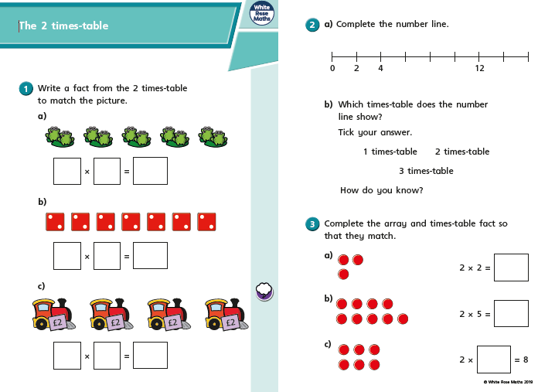

Wednesday part 2
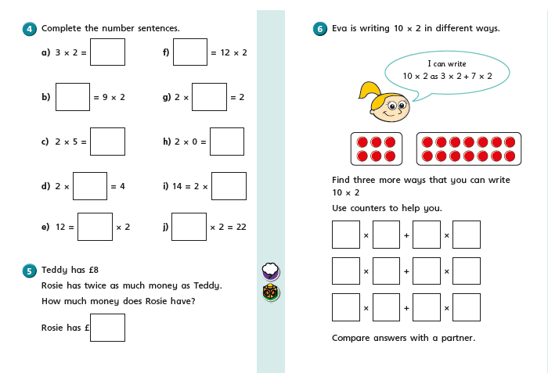

Thursday part 1
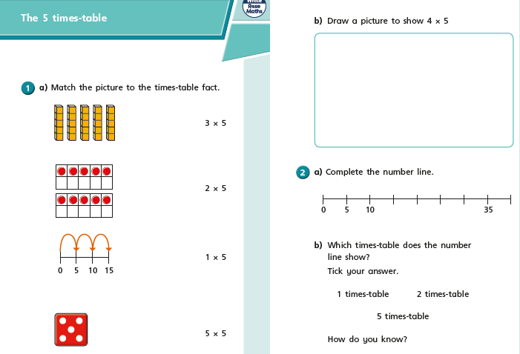

Thursday part 2
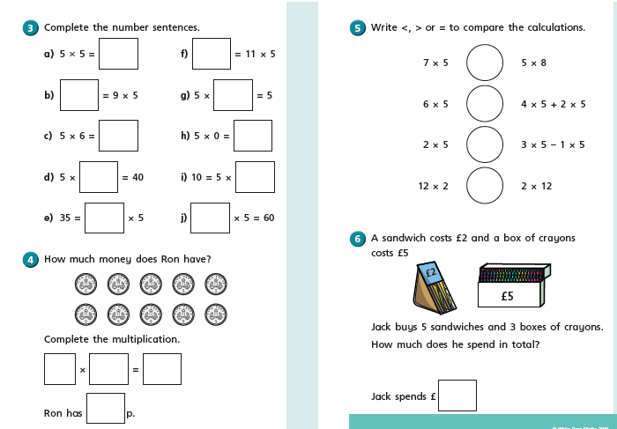

Friday
Friday

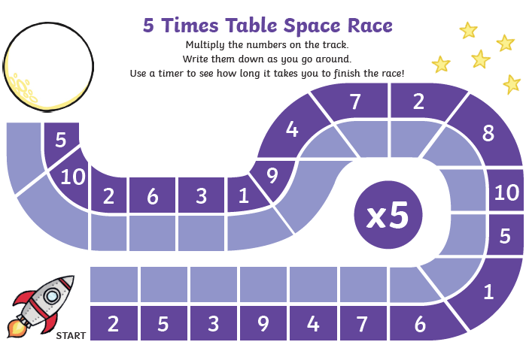
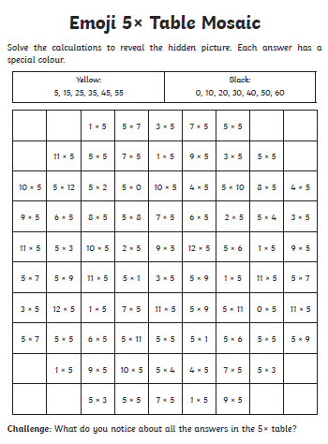
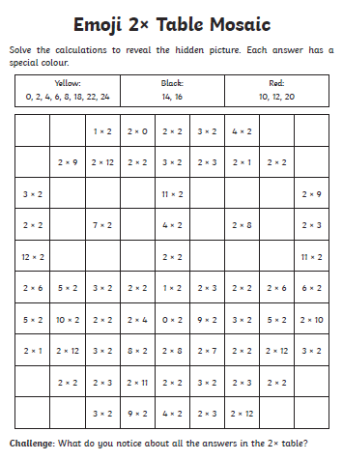
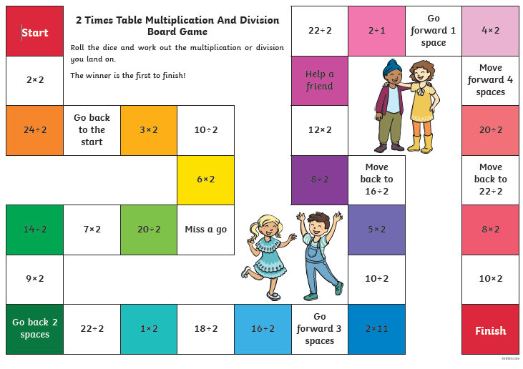

I am looking forward to seeing all your exciting learning!
Take Care,
Mrs Burland

