Year 2 Home Learning for 29.6.20
Maths
Your maths this week is all about length. We will be measuring and comparing lengths. Start each day by watching the videos on the White Rose website (Summer Term Week 9, 22nd June). Then complete the sheets in your pack. We have covered some length activities earlier in the term, so I have put some slightly different sheets in for Tuesday and Wednesday.
https://whiterosemaths.com/homelearning/year-2/
Here are some games on Classroom Secrets Kids which match our learning this week.
https://kids.classroomsecrets.co.uk/resource/year-2-four-operations-with-lengths/

https://kids.classroomsecrets.co.uk/resource/year-2-compare-lengths/
Monday – Measuring length.

Tuesday – Comparing length.

Wednesday – Four operations with length.

Thursday – Comparing mass.

Friday – I have put a selection of length challenges in your pack. Choose some fun ones to do. Remember to keep playing on ‘Times Tables Rockstars,’ as this will really help you.

Monday part 1
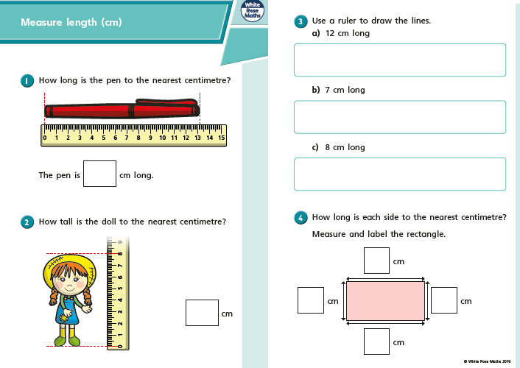

Monday part 2
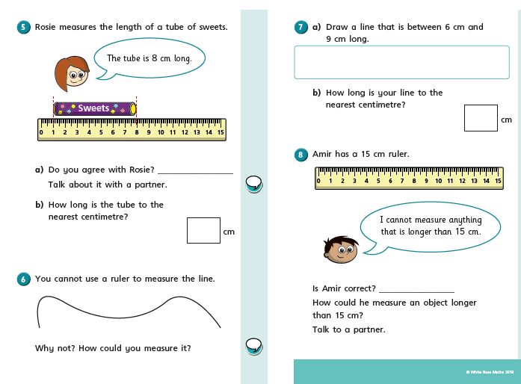

Tuesday part 1

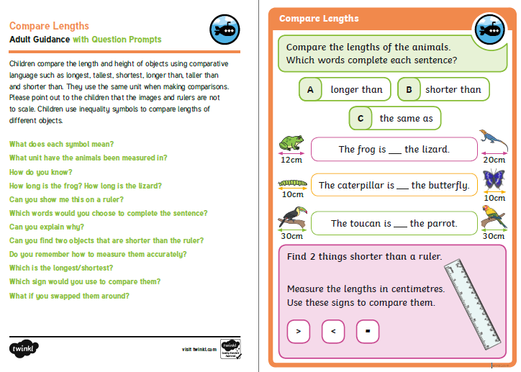

Tuesday part 2

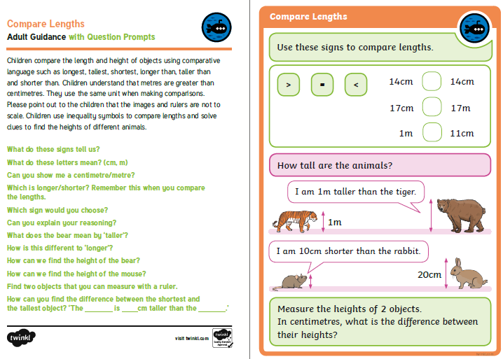

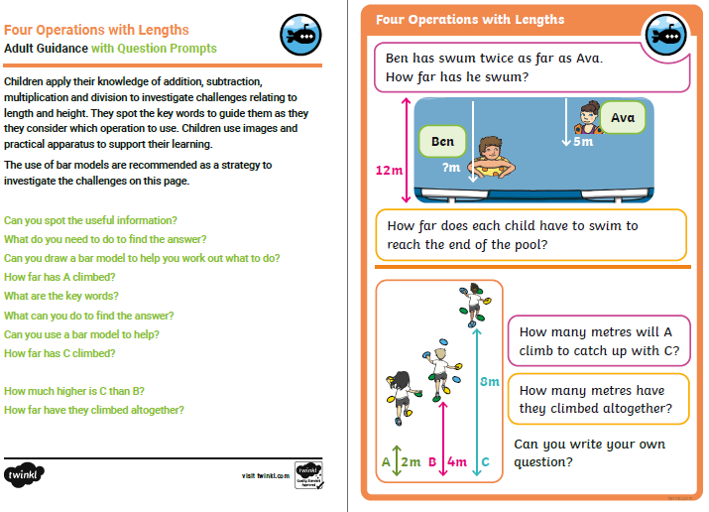
Wednesday part 1

Wednesday part 2

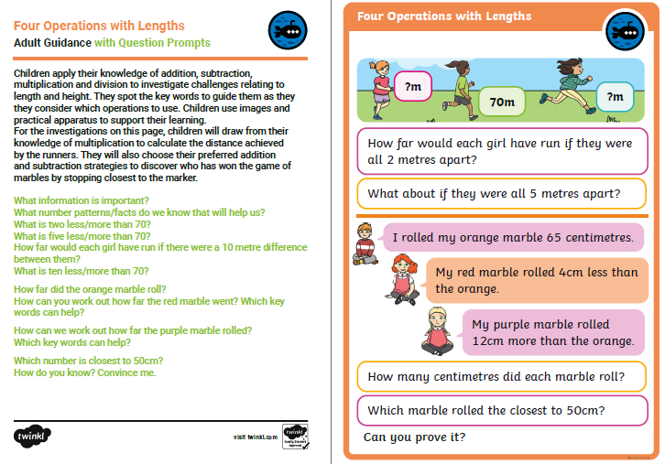

Thursday part 1
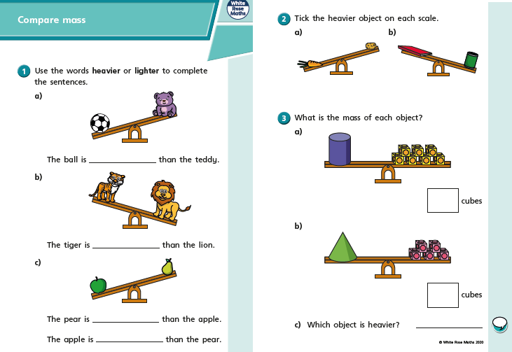

Thursday part 2
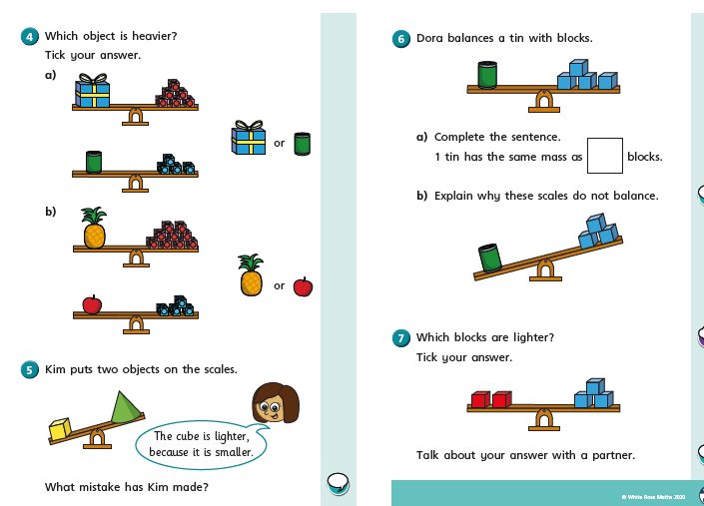

Friday
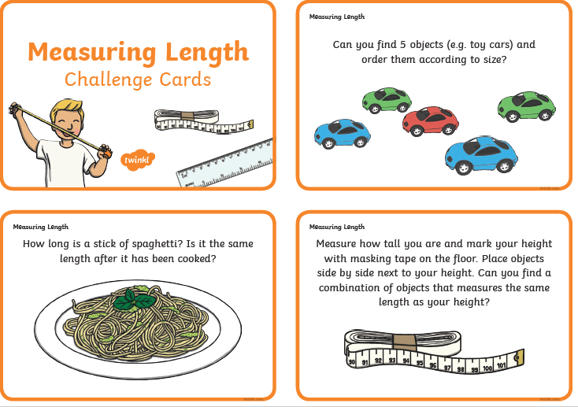
Friday
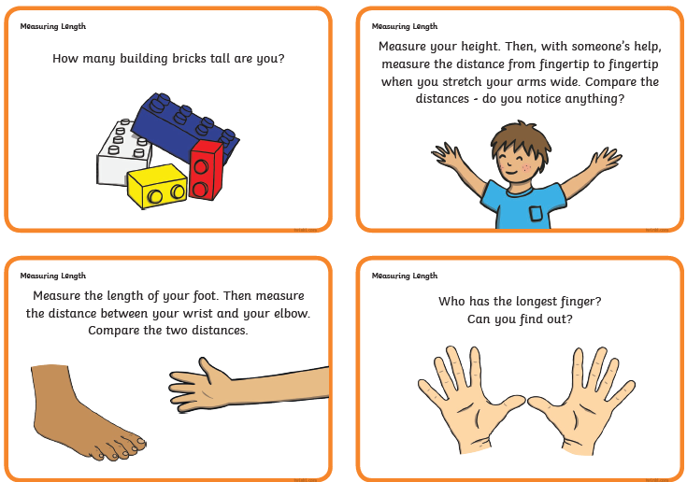
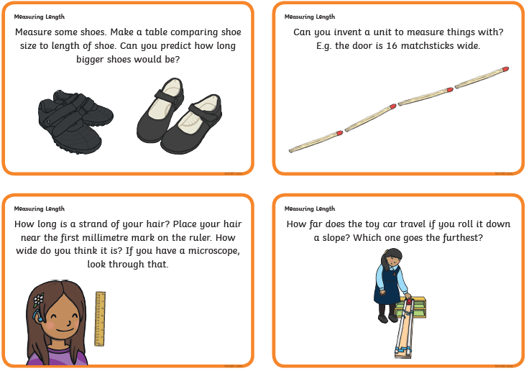
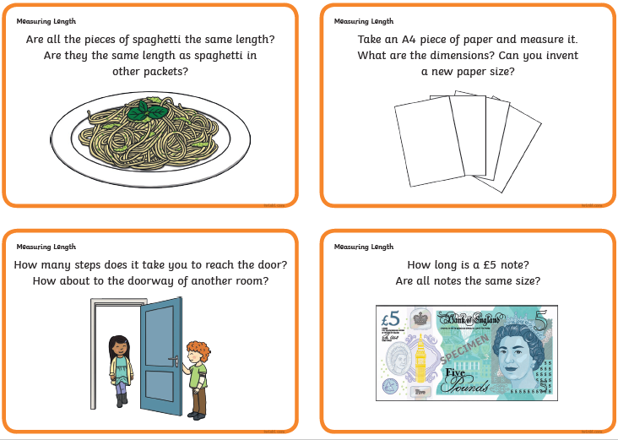

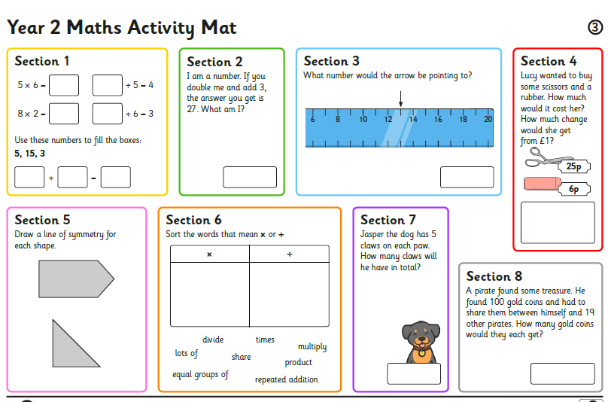

I am looking forward to seeing all your exciting learning!
Take Care,
Mrs Burland

