Year 2 Home Learning for 22.6.20
Maths
Your maths this week is all about shape. We are looking at 2D and 3D shapes this week. Start each day by watching the videos on the White Rose website (Summer Term Week 8, 15th June). Then complete the sheets in your pack.
https://whiterosemaths.com/homelearning/year-2/
Here are some games on Classroom Secrets Kids which match our learning this week.
https://kids.classroomsecrets.co.uk/resource/properties-of-3d-shapes-video-tutorial/

https://kids.classroomsecrets.co.uk/resource/year-2-making-patterns-with-shapes-game/

https://kids.classroomsecrets.co.uk/resource/year-2-making-patterns-with-shapes-reasoning-practice/

Monday – Counting sides and vertices.

Tuesday – Counting faces and edges.

Wednesday – Sorting 2D and 3D shapes.

Thursday – Merging 2D and 3D shapes.

Friday – I have put a selection of shape games in your pack. Remember to keep playing on ‘Times Tables Rockstars,’ as this will really help you.
Monday part 1
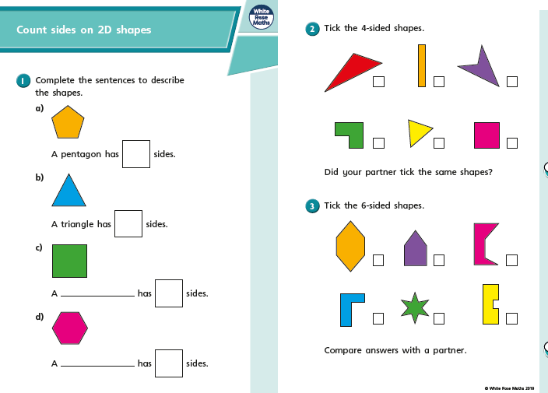

Monday part 2
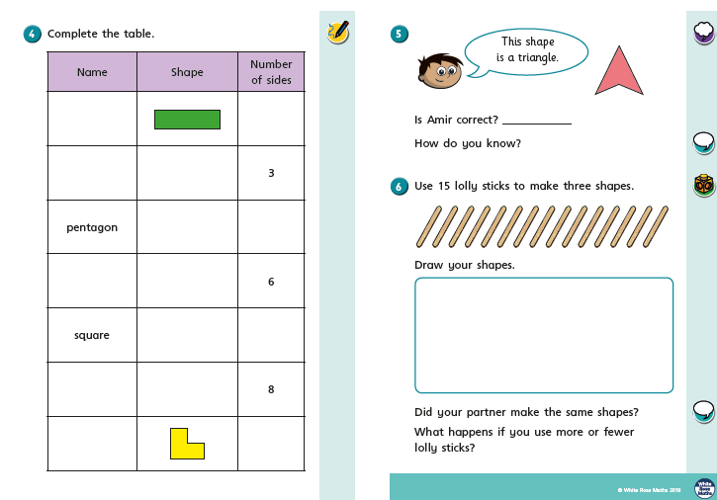

Monday part 3
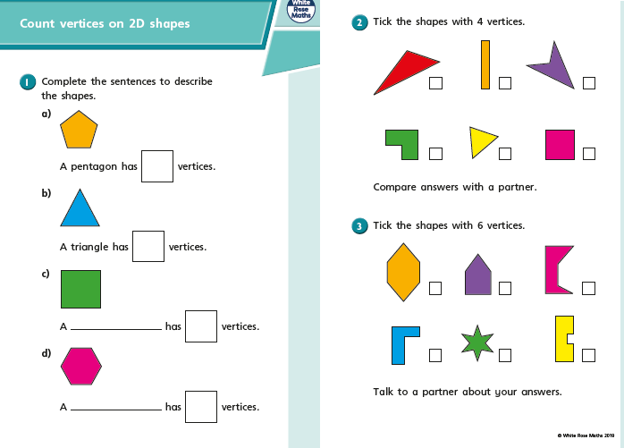

Monday part 4
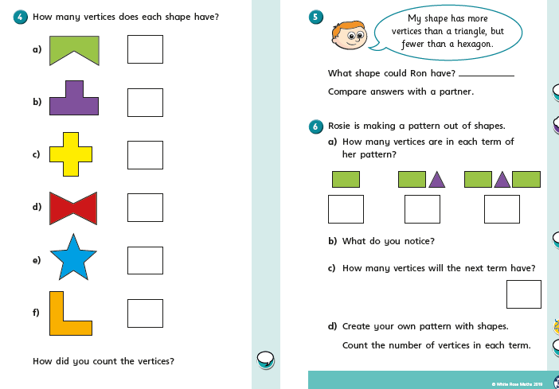

Tuesday part 1
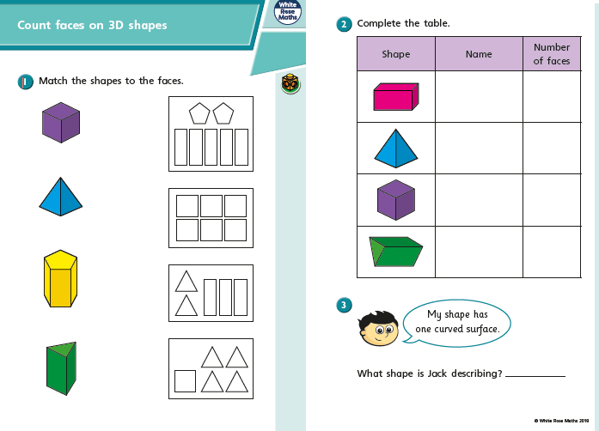

On Thursday and Friday, we are going to look at counting amounts of money in £ and p. In Year 2 we are brilliant at counting in 1s, 2s, 5s and 10s and this is going to help us.
Remember the coins and notes we use are:
Tuesday part 2
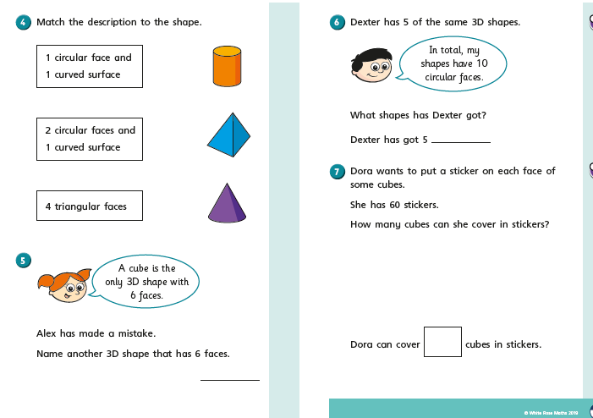

Tuesday part 3
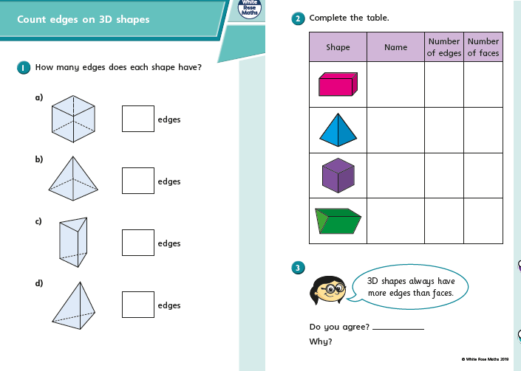

Tuesday part 4
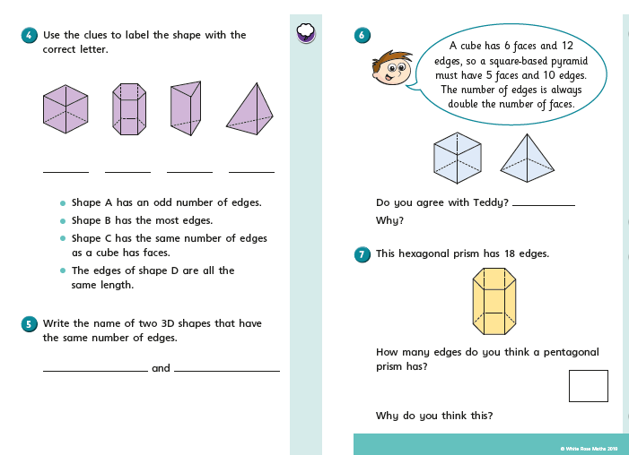

Tuesday part 5
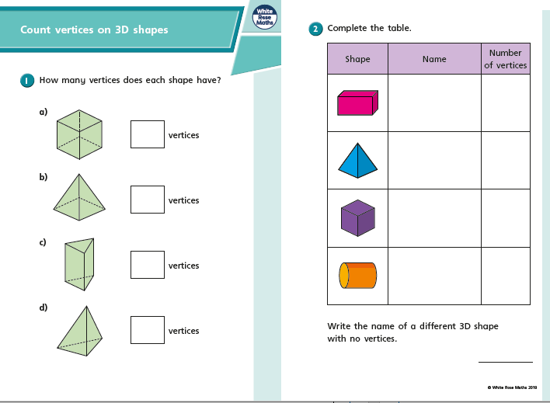

Tuesday part 6
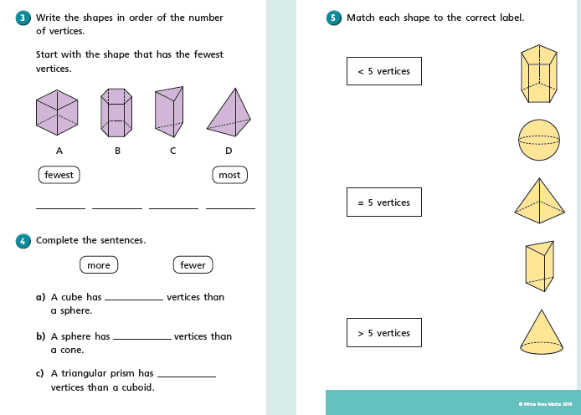

Wednesday part 1
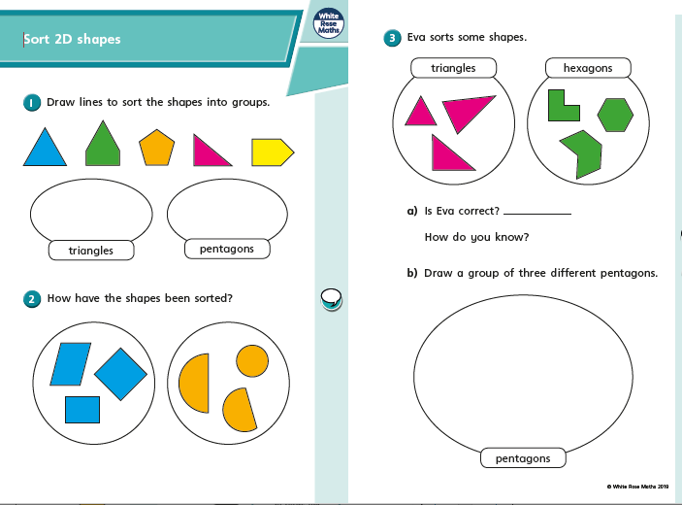

Wednesday part 2
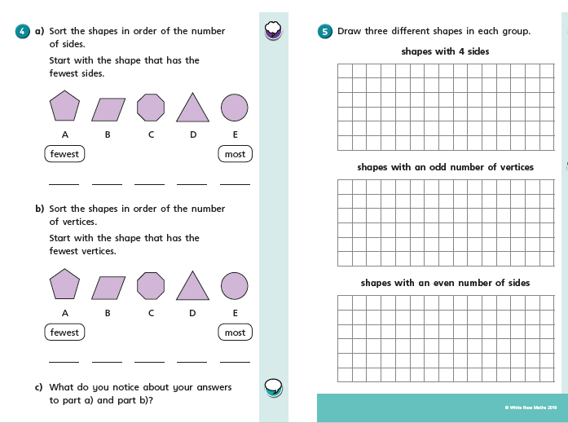

Wednesday part 3
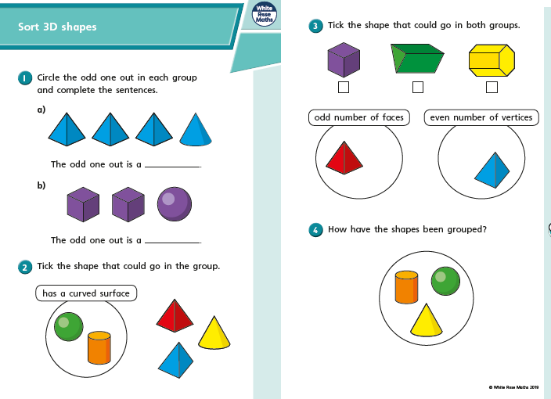

Wednesday part 4
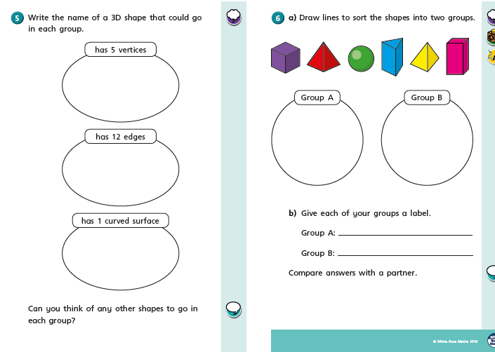

Thursday part 1
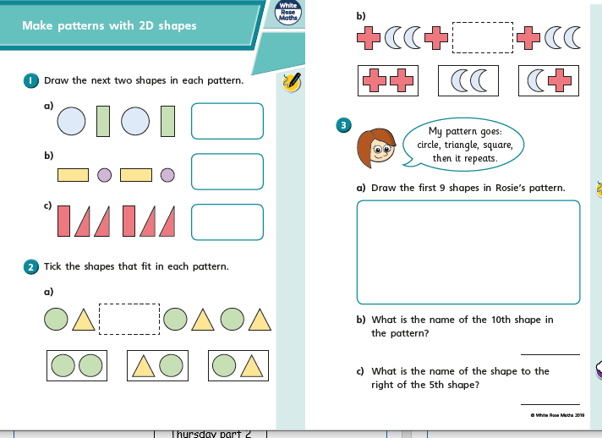

Thursday part 2
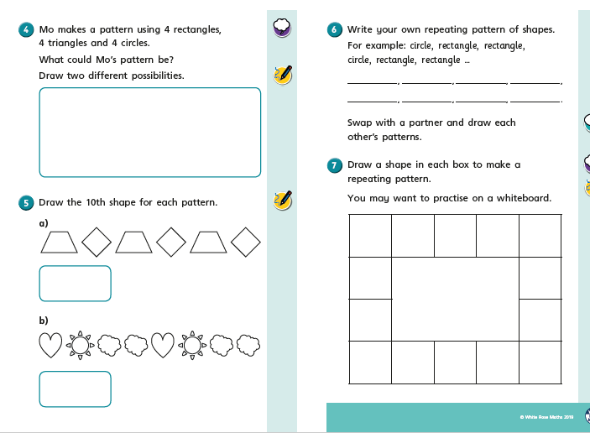

Friday
Friday
Thursday part 3
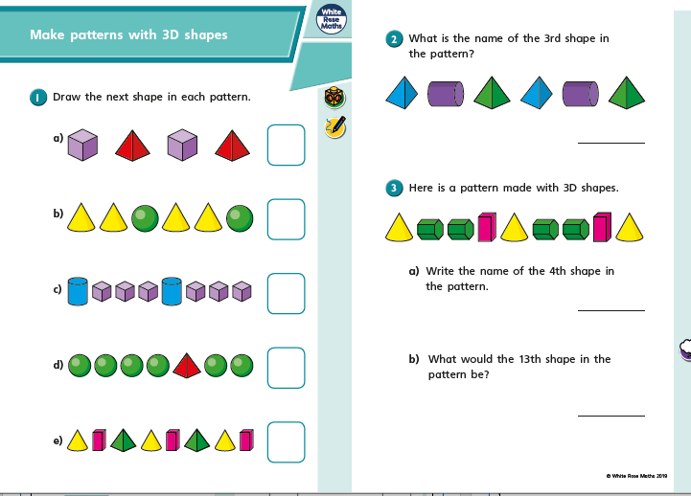

Thursday part 4
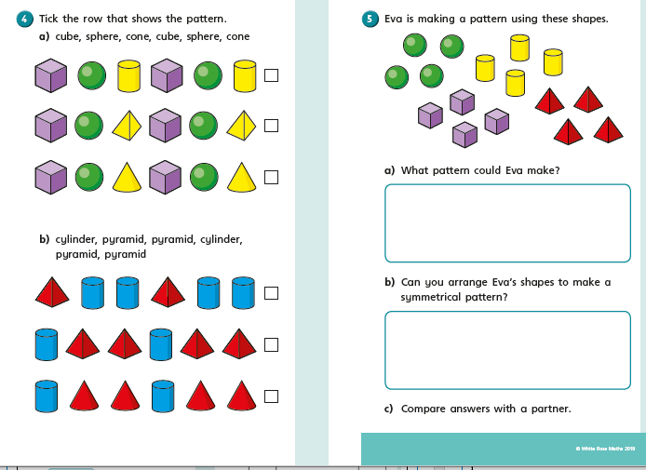

Friday

Shape Hunt

- Go on a shape hunt at home! Or you can go on a shape hunt whilst out walking.

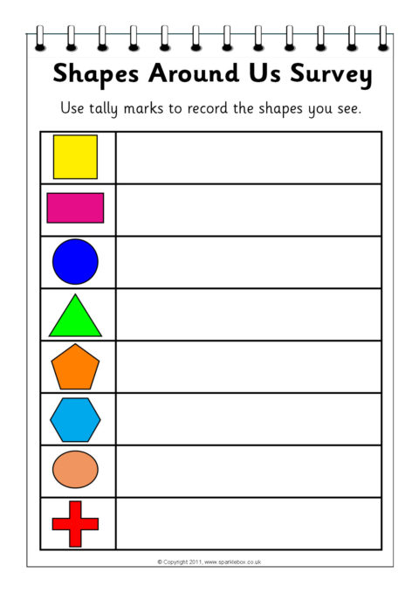
- Decide if you are going to hunt for 2D or 3D shapes.

- What different shapes can you find? I have put some scavenger sheets in your pack to help you.

- Try and take photos of the different shapes.

- How many different shapes in nature can you find?

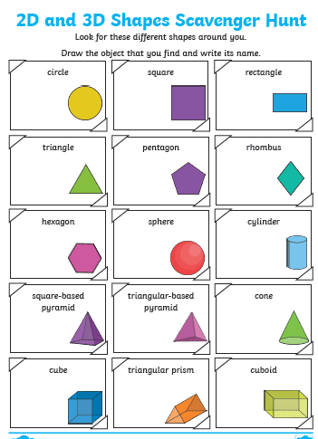
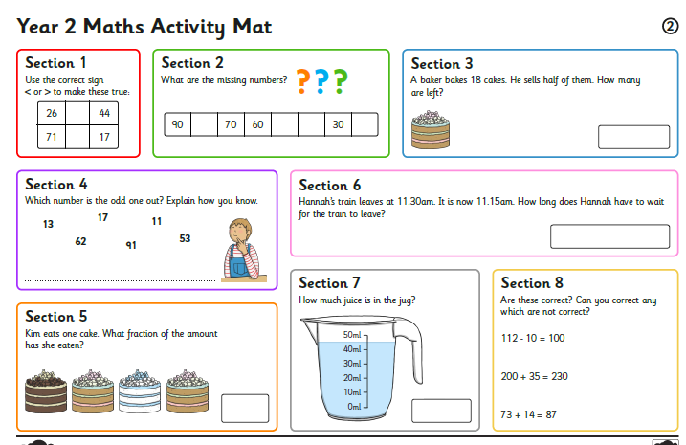

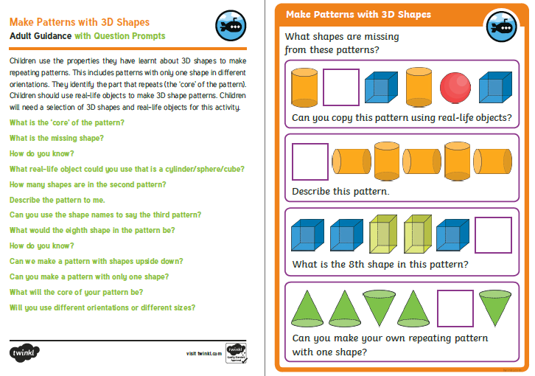

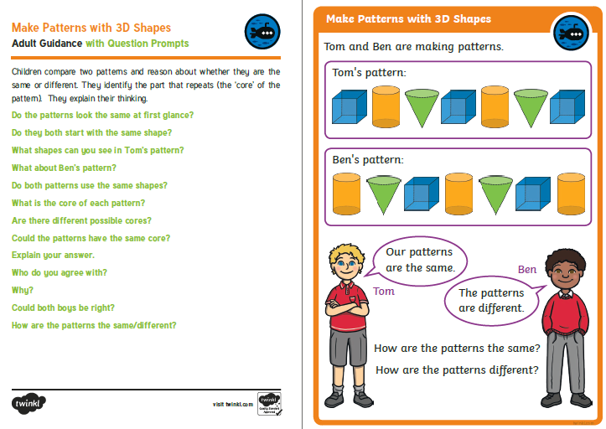

I am looking forward to seeing all your exciting learning!
Take Care,
Mrs Burland

