Year 2 Home Learning for 8.6.20
Maths
Your maths this week is all about the 10 times table, sharing, grouping and odd and even numbers. Start each day by watching the videos on the White Rose website (Summer Term Week 6, 25th May). Then complete the sheets in your pack.
https://whiterosemaths.com/homelearning/year-2/
Here are some games on Classroom Secrets Kids which match our learning this week.
https://kids.classroomsecrets.co.uk/resource/10-times-table-memory-card-game/ (10 x table)
https://kids.classroomsecrets.co.uk/resource/year-2-make-equal-groups-sharing/ (sharing)
https://kids.classroomsecrets.co.uk/resource/year-2-make-equal-groups-grouping-game/ (grouping)
https://kids.classroomsecrets.co.uk/resource/year-2-odd-and-even-numbers-game/ (odd and even)
Monday – The 10 times table.

Tuesday – Making equal groups - sharing.

Wednesday – Making equal groups – grouping.

Thursday – Odd and even numbers.

Friday – I have put a selection of grouping games in your pack. Remember to keep playing on ‘Times Tables Rockstars,’ as this will really help you.

Monday part 1
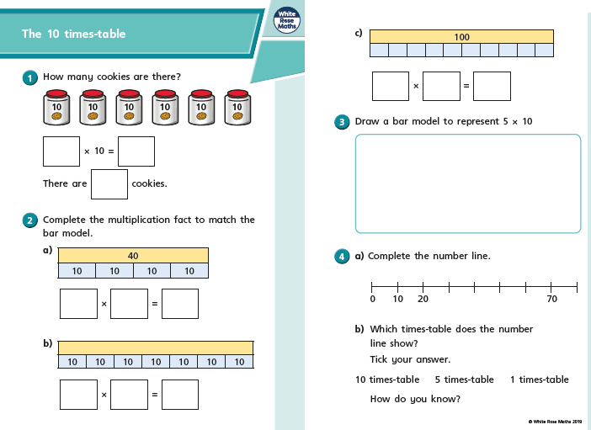

Monday part 2
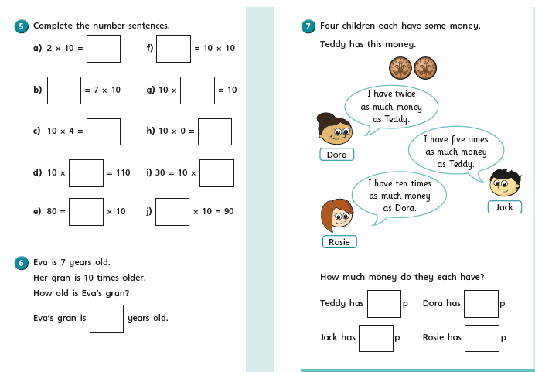

Tuesday part 1
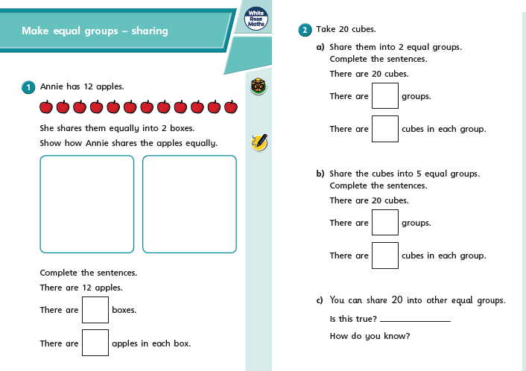

On Thursday and Friday, we are going to look at counting amounts of money in £ and p. In Year 2 we are brilliant at counting in 1s, 2s, 5s and 10s and this is going to help us.
Remember the coins and notes we use are:
Tuesday part 2
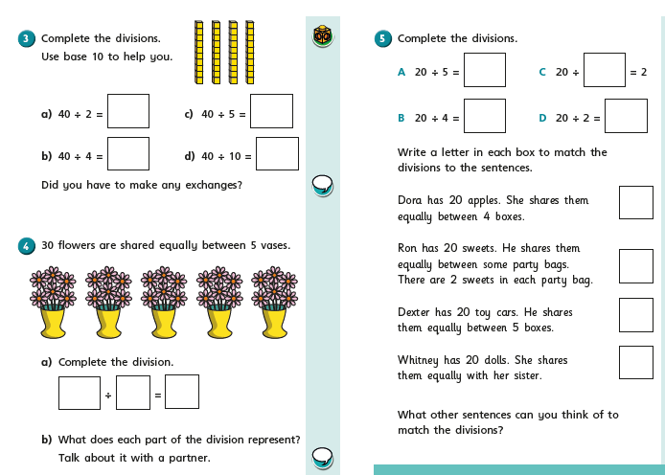

Wednesday part 1
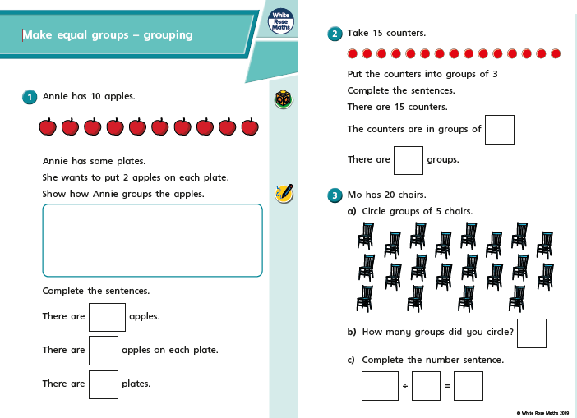

Wednesday part 2
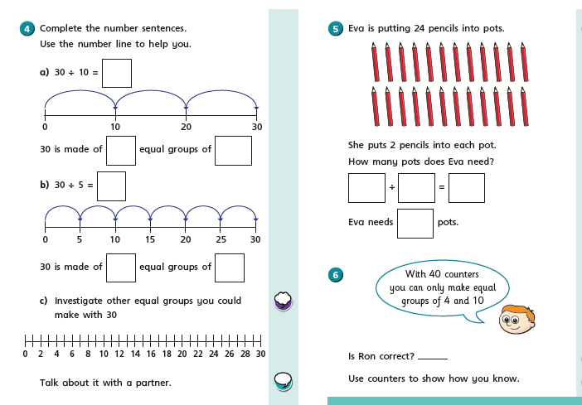

Thursday part 1
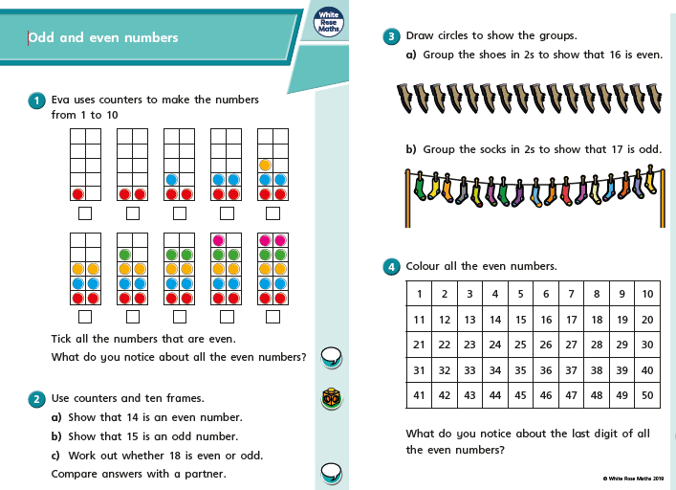

Thursday part 2
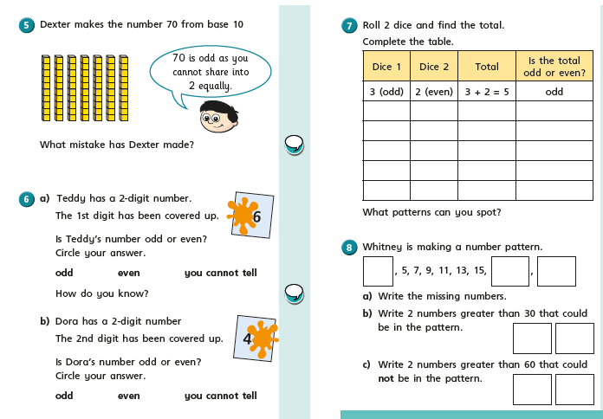

Friday
Friday
Friday
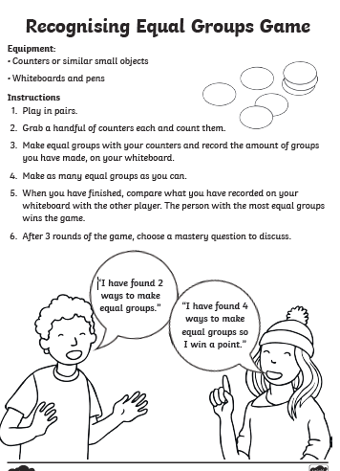

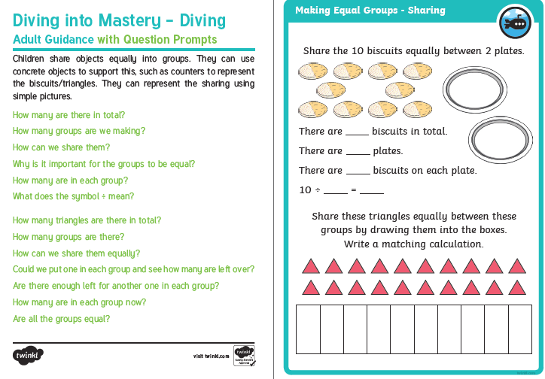

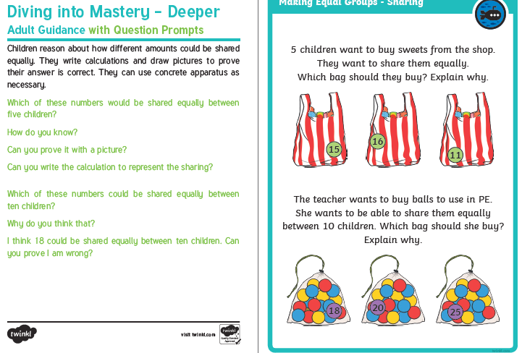

I am looking forward to seeing all your exciting learning!
Take Care,
Mrs Burland

