Year 3 Writing
You are going to write an adventure story suitable for a year 2 child. This will be based on the story ‘The Tunnel’ by Anthony Browne.
Monday
SPAG – Possessive apostrophes
A possessive apostrophe shows that something belongs to or is connected to something else.
Watch the first clip on this webpage to learn how to use possessive apostrophes:
https://www.bbc.co.uk/bitesize/articles/zmt2mfr
Singular nouns
A singular noun is a noun referring to just one person or thing.
For example: Cat
When you want to show that something belongs to that person or thing, you add a possessive apostrophe and an s
For example: The cat 's tail was fluffy.
's shows that the tail belongs to the cat.
Top tip
If a singular noun already ends in s, you don't need to add another s . You can just add an apostrophe at the end.
For example: Charles' cat was naughty.

Plural nouns ending in s
Plural nouns refer to more than one person or thing.
For example: Brothers
To show possession when the noun is plural and already ends in s, you just add an apostrophe to the end of the word. You don't need to add an extra s.
For example:
The brother s' feet were muddy.
The girl s' bathroom was a mess.
Watch the second video now on the web page to revise apostrophes for possession. Focus on the words that are highlighted in pink.
https://www.bbc.co.uk/bitesize/articles/zmt2mfr
You could try the short quiz at the bottom of the webpage too to check what you have remembered.
Now, have a go at completing the possessive apostrophes challenge on page 3, copying the sentences into your book.

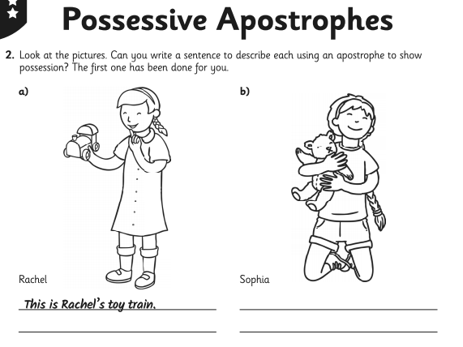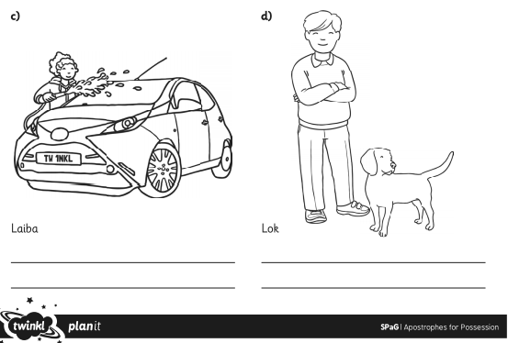

Tuesday
The Tunnel – by Anthony Browne
Listen to the clip of the story being read and stop it when you get to 1min 53seconds.
https://www.youtube.com/watch?v=ps2E5yoRsMk
You are going to pretend that a friend of yours / or a brother or sister have gone through the tunnel and they have not returned so you decide to follow them into the tunnel…
On the following page, write down adjectives and descriptive phrases to describe how you feel and also what you can see, smell, hear and feel.

Tuesday
I can think of descriptive words and phrases to use in my writing
The word bank on page 11 may help you to complete this!
How do you feel that you have been left alone and don’t know where the other person has disappeared to?

As you crawl through the tunnel, describe what it is like. What can you hear, see, smell, feel?

Describe what is at the other end of the tunnel – is it a wonderful place or a scary place?

Tuesday picture prompts to help!

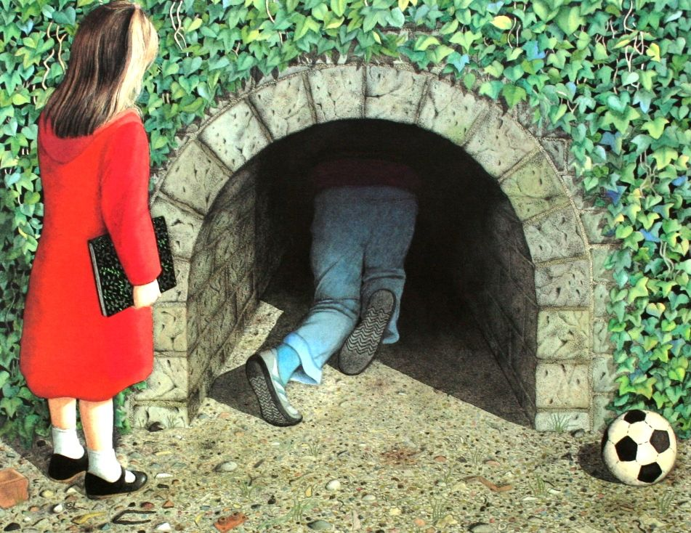
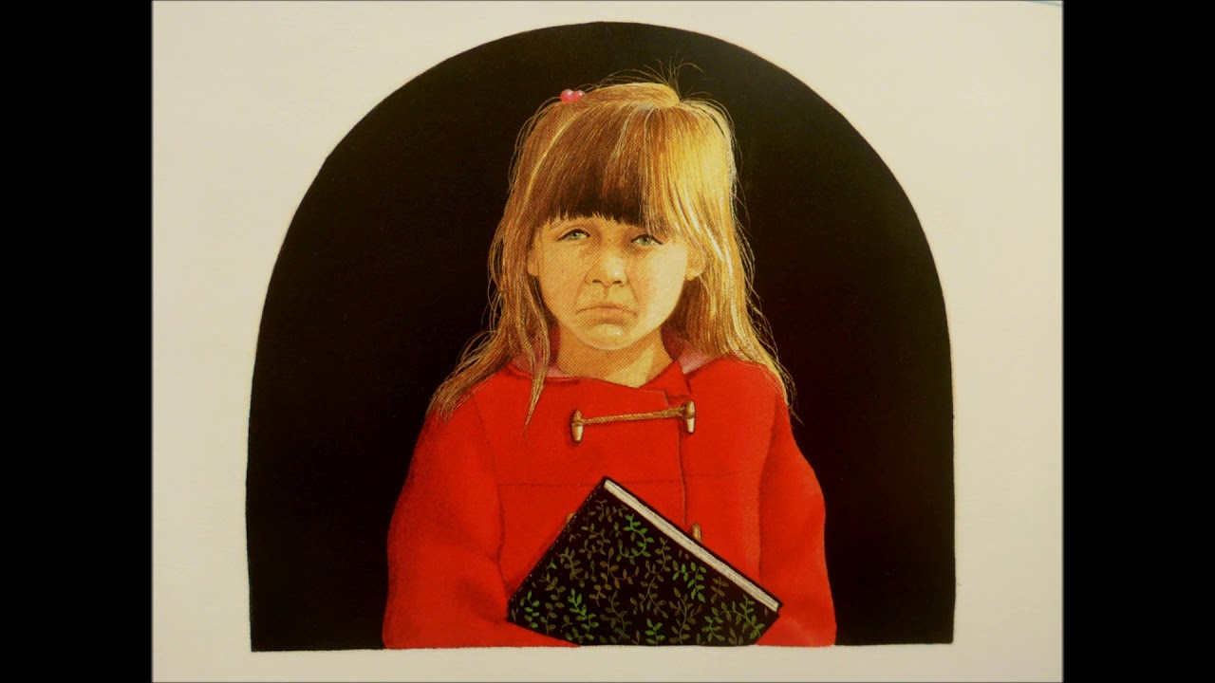

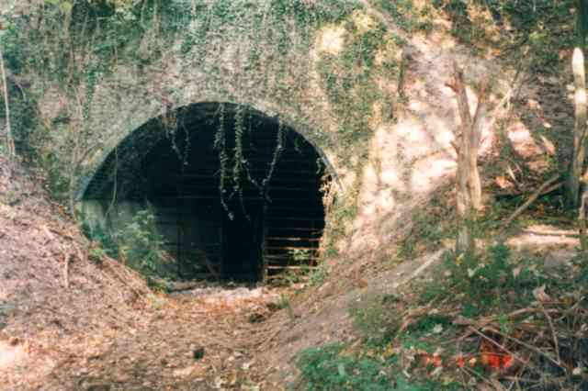

Wednesday
Watch the clip again (this time you can watch all of it!)
https://www.youtube.com/watch?v=ps2E5yoRsMk

Like Rose, you are going to follow your friend or sibling into the tunnel and enter a different world – it is up to you if this is a pleasant or not so pleasant experience!

Use the planning sheet on page 8 to help you create a plan for your adventure story.

Wednesday Planning sheet

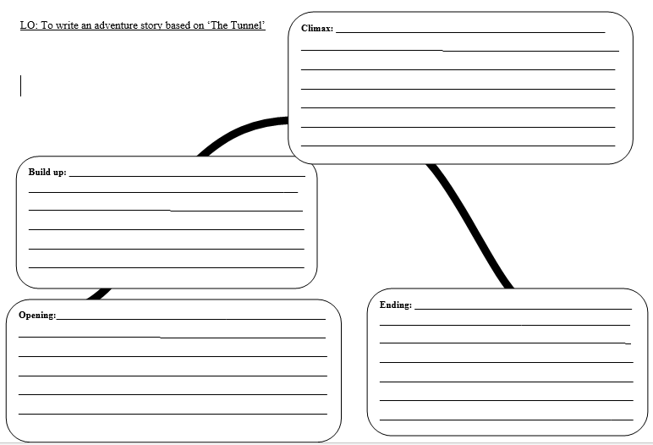
Thursday
Writing
Have a read through the model below, which is the start of an adventure story and see if you can spot any of the following:
- Adjectives (describing words)
- Possessive apostrophes
- Conjunctions (words which join ideas together. For example, and, so, but, because)

Now, have a go at writing your own adventure story in your book about following someone through a tunnel and rescuing them, remembering to use the ideas from your plan. You may like to use the word bank on page 11 to help you too! Remember, try to include at least 3 examples of possessive apostrophes!
The Tunnel
“Don’t go Edward!” I screeched, but it was too late. He had disappeared into the deep, dark tunnel. Tears started to fill my eyes, I had no idea where he had gone. Terror ran through my body as time continued to pass, then a decision had to be made. I was going to follow him and crawl through the tunnel.
I got down onto all fours and started to crawl through. It was pitch black, I had no idea what I was crawling through. But all I did know was that it was squelchy and wet. The smell was making my eyes water and I could hear the noise of creatures scurrying around on top of the tunnel. All of a sudden, a rat’s tail came into view. I screamed ‘ARRGGHHH!’ and it soon darted away. Thankfully, the light at the end of the tunnel was coming closer.
I had finally reached the end of the tunnel. As I scrambled to my feet, piercing eyes were staring down at me. I looked up and I could see Edward’s red coat caught in a thorny bush, “Where could he be?” I thought to myself.
Friday
Have a go at re-reading through the story you wrote yesterday. Are there any parts which you could improve? Have you used a lot of ‘and’ or not included any possessive apostrophes?

Also, please check your spellings!

Once you have done this, you can write up your story onto the bordered paper at the end of this pack.

Have fun year 3!

Mr Price.

