Maths Year 5
Converting between units of time w/c 08.06.20

The objective we are working on this week is:
- To solve problems involving converting between units of time
Monday 8th June
Use the links below to find out about converting between analogue and digital times as well as solving problems involving different units of time.
https://www.bbc.co.uk/bitesize/topics/zkfycdm/articles/zcrmqty
https://www.bbc.co.uk/bitesize/clips/zq7xn39

Use these step by step guides to help you.

Now try these questions. If you are still struggling, look back at the videos and the step by step guide to help you.

1. How many minutes are there in 2 hours?
2. How many seconds are there in half an hour?
3. How many hours are there in a week?
4. If you arrive at school at 8:50am and leave at 3:20pm, how long are you in school?
5. If you go to bed at 8:15pm and wake up at 7:30am, how long are you in bed?

Tuesday 9th June

Wednesday 10th June
1. What is 513 minutes in hours and minutes?
2. What is 3 hours and 14 minutes in minutes?
3. How many seconds are there in 5 minutes and 37 seconds?
4. Rewrite three hundred and eighty-six minutes in hours and minutes.
5. How many years and months are there in 65 months?
6. What is seven years and eleven months in months?
7. Convert 86 days into weeks and days.
8. How many days are there in 18 weeks and 5 days?
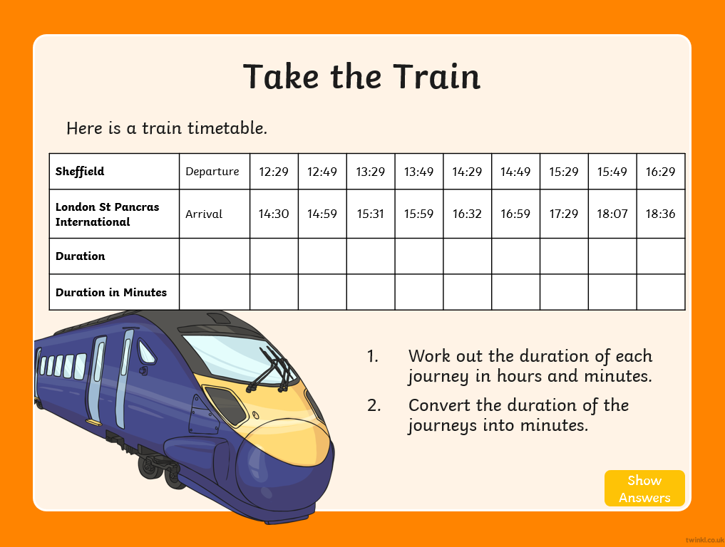

Thursday 11th June
Solve these word problems. Remember to read the question and underline the important information.

1. Isabella swims 4 lengths of a swimming pool. Her target is to swim the lengths in under 5 minutes. It takes her 319 seconds. Explain why Isabella did not achieve her target.
First convert 5 minutes into seconds. I know that 5 x 6 = 30 so 5 x 60 = 300. I know there are 300 seconds in 5 minutes and it took Isabella 319 seconds, therefore I know she did not reach her target as she was 19 seconds slower.
2. A child’s school year has 38 weeks and 5 days. In a non-leap year, how many days does each child not have to go to school?
3. A year 6 class has 5 maths lessons during the week. Each lesson lasts 1 hour and 15 minutes. How many hours and minutes will they have maths lessons in a week? How many hours and minutes will they have maths lessons in a seven-week half term?
4. Aisha is 10 years and 5 months old. Her brother Amit is 6 years and 11 months old. How much older is Aisha in years and months?
5. Daniella saves 10p a day. Her target is to save £4.50. How many weeks and days will it take?
6. A family has lived in a house for 12 years and 7 months. They want to have a party to celebrate 20 years of living in the house. How many months will they have to wait until the party?
Friday 5th June
To finish off your work on converting between units of time I thought you could make a fortune teller to play with your family.

