Maths Year 5
Converting between units of time w/c 08.06.20
Answers

The objectives we are working on this week are:
- solve problems involving converting between units of time

Now try these questions. If you are still struggling look back at the videos and the step by step guide to help you.

- How many minutes are there in 2 hours?
2 x 60 = 120 minutes
- How many seconds are there in half an hour?
60 x 30= 1,800 seconds
- How many hours are there in a week?
24 x 7 = 168 hours
4. If you arrive at school at 8:50am and leave at 3:20pm, how long are you in school? 6 ½ hours
5. If you go to bed at 8:15pm and wake up at 7:30am, how long are you in bed? 10 hours and 45 minutes

Tuesday 9th June
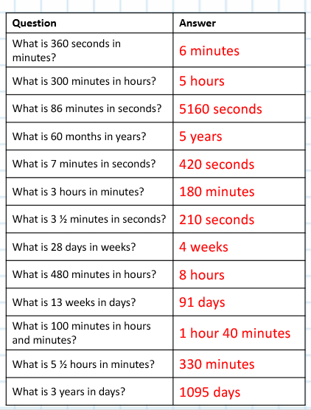

Wednesday 10th June
1. What is 513 minutes in hours and minutes? 8 hours and 33 minutes
2. What is 3 hours and 14 minutes in minutes? 194 minutes
3. How many seconds are there in 5 minutes and 37 seconds? 337 seconds
4. Rewrite three hundred and eighty-six minutes in hours and minutes. 6 hours and 26 seconds
5. How many years and months are there in 65 months? 5 years and 5 months
6. What is seven years and eleven months in months?
95 months
7. Convert 86 days into weeks and days. 12 weeks and 2 days
8. How many days are there in 18 weeks and 5 days?
131 days
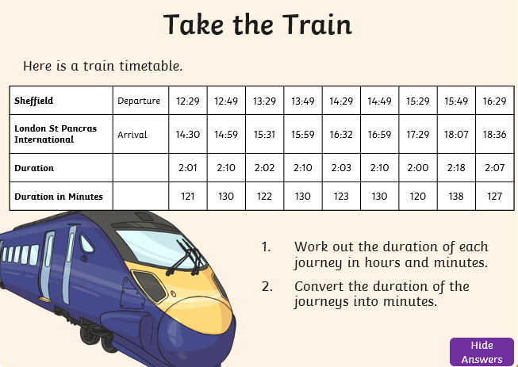

Thursday 11th June
Solve these word problems. Remember to read the question and underline the important information.

1. Isabella swims 4 lengths of a swimming pool. Her target is to swim the lengths in under 5 minutes. It takes her 319 seconds. Explain why Isabella did not achieve her target.
First convert 5 minutes into seconds. I know that 5 x 6 = 30 so 5 x 60 = 300. I know there are 300 seconds in 5 minutes and it took Isabella 319 seconds, therefore I know she did not reach her target as she was 19 seconds slower.
2. A child’s school year has 38 weeks and 5 days. In a non-leap year, how many days does each child not have to go to school? 175 days
3. A year 6 class has 5 maths lessons during the week. Each lesson lasts 1 hour and 15 minutes. How many hours and minutes will they have maths lessons in a week? How many hours and minutes will they have maths lessons in a seven-week half term? 43 hours and 45 minutes
4. Aisha is 10 years and 5 months old. Her brother Amit is 6 years and 11 months old. How much older is Aisha in years and months? 3 years and 6 months
5. Daniella saves 10p a day. Her target is to save £4.50. How many weeks and days will it take? 6 weeks and 3 days
6. A family has lived in a house for 12 years and 7 months. They want to have a party to celebrate 20 years of living in the house. How many months will they have to wait until the party? 89 months
Friday 5th June
To finish off your work on converting between units of time I thought you could make a fortune teller to play with your family.

