Maths Year 5
Revision – multiplication and division w/c 01.06.20

The objectives we are working on this week are:
- multiply numbers up to 4 digits by a 1-digit no. using a formal written method.

- divide numbers up to 4 digits by a one-digit number using the formal written method of short division and interpret remainders appropriately for the context.

Monday 1st June
Use the link to help you remember how to do short division.
https://www.bbc.co.uk/bitesize/topics/z36tyrd/articles/zgxdfcw

Use these step by step guides to help you remember how to do short multiplication and short division.
Tuesday 2nd June

Answers
1. 920 x 4 = 3,680 4. 224 ÷ 4 = 56
2. 618 x 6 = 3,708 5. 288 ÷ 6 = 48
3. 762 x 9 = 6,858 6. 608 ÷ 8 = 76

Once you have completed these have a go at doing the inverse (÷) to check you got the answers right.

Inverse calculations
- 3680 ÷ 4 = 920 4. 56 x 4 = 224
- 3708 ÷ 6 = 618 5. 48 x 6 = 288
- 6858 ÷ 9 = 762 6. 76 x 8 = 608
Wednesday 3rd June
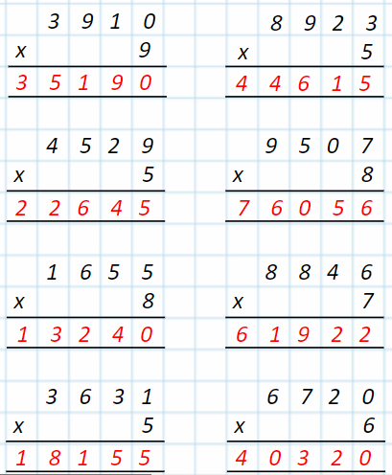

Thursday 4th June
Have a go at these missing number calculations.
887
2661 / 3 = 887
2661 ÷ 3 = 887
_____________ x 3 = 2661
You are looking for the number that when multiplied by 3 will give you 2661. To work it out you need to do the inverse. So in this case you need to divide 2661 by 3.
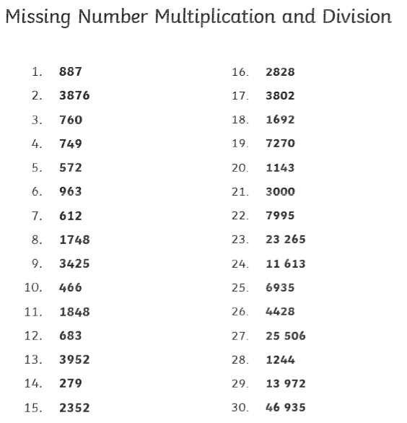

Friday 5th June
- A teacher asks children to arrange some chairs into 12 rows of 8 chairs. How many chairs will be laid out?
12 x 8 = 96
- In the garden there is space for 8 rows of 324 seeds in a flower bed. How many seeds are in the flower bed?
324 ÷ 8 = 40 seeds in each row and 4 seeds left over
3. Each glass of fresh apple juice made at the café requires the juice of four apples. If they have 388 apples, how many full glasses of juice can they make? 388 ÷ 4 = 97
4. There are 25 rows of 9 stickers on a sheet. How many are there on a sheet? How many would there be on 10 sheets? 25 x 9 = 225 225 x 10 = 2250
5. There are 138 boxes of cereal on a shelf. How many boxes on 5 shelves? 138 x 5 = 690
6. 256 marbles are sorted into boxes of 7. How many boxes are needed? 256 ÷ 7 = 36 boxes and 4 marbles left over so in total 37 boxes are needed
7. 315 people are sorted into teams of 9 for a competition. How many teams are there? 35 teams
8. There are 549 stickers in a box. How many stickers are there in 7 boxes? 549 x 7 = 3,843
9. A factory produces 3361 chocolate cookies per day. If there are nine cookies in each packet, how many full packets will they be able to make? 3361 ÷ 9 = 373 packets and 4 biscuits left over
10. There are 1426 seats in one area of the stadium. How many seats are there in the whole stadium made up of 9 areas? 1426 x 9 = 12834

