Maths Year 5
Angles w/c 29.06.20

The objective we are working on this week is:
- know angles are measured in degrees: estimate and compare acute, obtuse and reflex angles.
- identify angles at a point and one whole turn (total 360°)
- identify angles at a point on a straight line and ½ a turn (total 180°)

Monday 29th June
Now have a go at labelling these angles
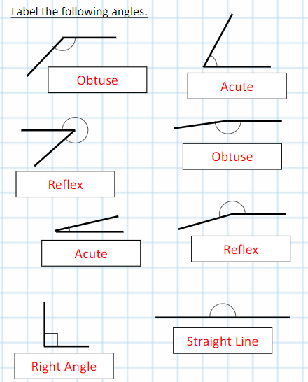

Tuesday 30th June

Remember that these angles are estimates so a couple of degrees either way is fine. E.g. 132ᵒ for the first one – your answer could be between 130ᵒ and 135ᵒ
These two angles should be exact
180ᵒ
90ᵒ
161ᵒ
18ᵒ
172ᵒ
140ᵒ
62ᵒ
132ᵒ

Wednesday 1st July

- What do angles on a line add up to?
- What do angles around a point add up to?
Now use what you have learnt to find the missing angles.

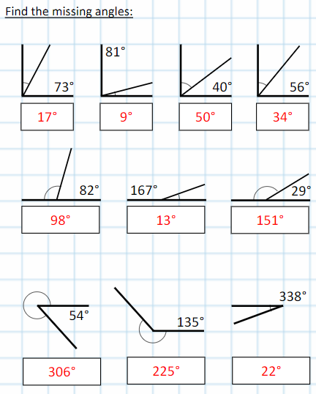

Thursday 2nd July
Write some top tips for finding the missing angle on a line and use them to help you with the activity below.
Here are some angles on a line, can you find the missing angle?

180 – 84 = 96ᵒ
180 – 110 =70ᵒ
180 – 95 = 85ᵒ
180 – 17 = 163ᵒ

180 – 119 = 61ᵒ
180 – 150 = 30ᵒ
180 – 126 = 54ᵒ
180 – 170 = 10ᵒ
180 – 90 = 90ᵒ
180 – 36 = 144ᵒ

Friday 3rd July
