Maths Year 5
Answers – long multiplication w/c 22.06.20

The objectives we are working on this week are:
- multiply numbers up to 4 digits by a 2-digit no. using a formal written method.

Monday 22nd June

1. 920 x 14 = 12, 880 4. 1224 x 41 = 50, 184
2. 618 x 62 = 38,316 5. 2188 x 26 = 56, 888
3. 762 x 29 = 22,098 6. 6108 x 28 = 171,024

Tuesday 23rd June

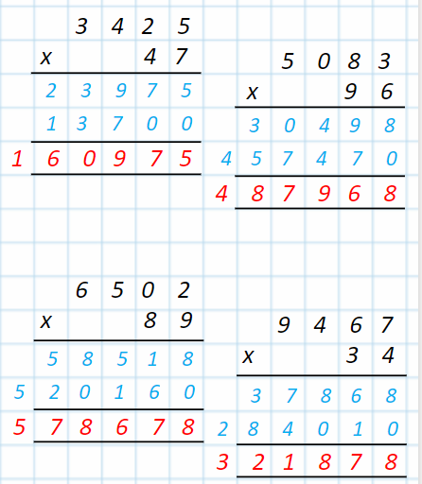

Wednesday 24th June
Using the top tips you wrote yesterday complete these long multiplication calculations.
1. 161 x 23 = 3, 703
2. 232 x 26 = 6,032
3. 614 x 18 = 11,052
4. 969 x 95 = 92,055
5. 740 x 96 = 71, 040
6. 362 x 58 = 20,996
7. 305 x 71 = 21,655
8. 370 x 64 = 23,680
9. 2190 x 69 = 151,110
10. 1342 x 52 = 69,784
11. 1521 x 73 = 111,033
12. 1143 x 34 = 38,862
13. 2468 x 27 = 66,636
14. 1895 x 46 = 87,170
15. 1462 x 70 = 102,340
16. 2127 x 48 = 102,096

Thursday 25th June
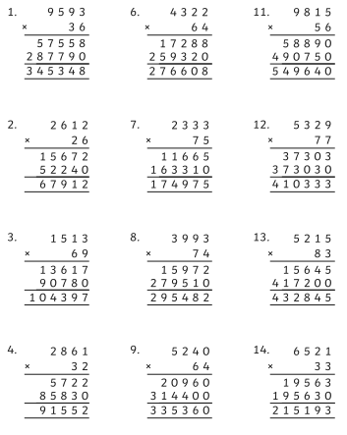
Have a go at these missing number calculations.

To check your answers, you can do the calculation with the missing number you have added to check if the answer is the same.

Friday 26th June
To finish off your work on long multiplication have a go at these word problems. Read carefully!
1. There are 15 biscuits in a packet. A shop orders 156 packets. How many biscuits will be in the 156 packets? 2,340
2. A school buys 172 boxes of pencils. Each box has 12 pencils. How many pencils has the school bought? 2,064
3. A wholesaler sells apples for 17p each. A grocer buys 197 apples. How much will they cost? £33.49
4. A cinema has 21 screens. Each screen has 297 seats. How many seats are there in the cinema? 6,237
5. A bag of nails contains 613 nails. A hardware store has 23 bags. How many nails are in the 23 bags? 14,099
6. It takes 78 hours for a satellite to go around the Earth. How many hours will it take for the satellite to go around the Earth 9859 times? 769,002
7. A rugby club has an average attendance of 6962 people to each match. What is the total attendance for the 39 matches played in a season? 271,518
8. Sacks of potatoes contain an average of 95 potatoes. In a year, a farmer sells 4911 sacks. How many potatoes does she sell in one year? 466,545
9. A machine makes 8521 dice in a week. In a 52-week working year, how many dice are made? 443,092
10. There are 43 children in year 6. Each child pays £75.60 for a school trip. How much do they pay altogether? £3,250.80

