Maths Year 5 - Area and perimeter w/c 15.06.20

The objectives we are working on this week are:
- measure and calculate the perimeter of shapes in cm and m.
- calculate and compare the area of rectangles, using standard units, square centimetres (cm²) and square metres (m²).
Monday 15th June
Now try these questions. If you are still struggling look back at the videos and the step by step guide to help you.

Calculate the perimeter and area of these rectangles
1. 10cm 2. 3cm

4cm 6cm

Perimeter = 28 cm Area = 40 cm
Perimeter =18cm Area= 18cm
3. 12cm 4. 11cm

6cm 7cm

Perimeter =36cm Area = 72cm Perimeter = 36cm Area =77cm
5. 8cm 6. 9cm
Perimeter = 32cm
Area = 64cm
Perimeter = 42cm
Area = 108cm
8cm
12cm

Tuesday 16th June

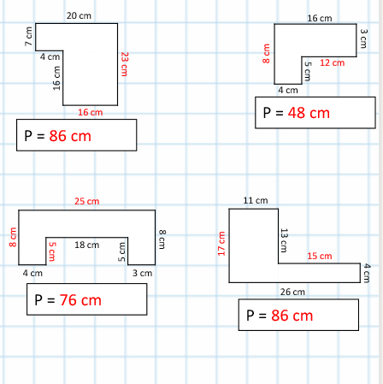

Wednesday 17th June

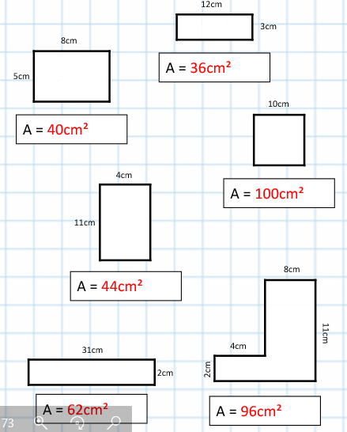

Thursday 18th June
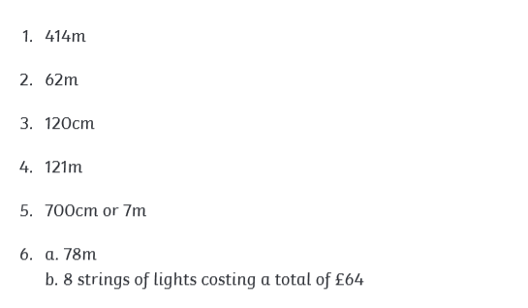

Friday 19th June
Find the area of these compound shapes. Use your top tips to help you!
