Year 2 Writing for 8.6.20
Monday
Phonics – This week we are going to look at adding suffixes. We will start by adding ‘ing.’ Can you remember the rule? Follow the link on ‘Spelling Play’ below and click on ‘demonstration to remind yourself of the rules, then you can play the games on the right hand side of the screen: https://www.spellingplay.co.uk/y2_member/violets_vowel_suffixes.htmll
Below are some verbs and verbs with the ‘ing’ suffix. Cut them out and try to match them.
Play the spelling game on https://kids.classroomsecrets.co.uk/resource/year-2-spelling-game-4/
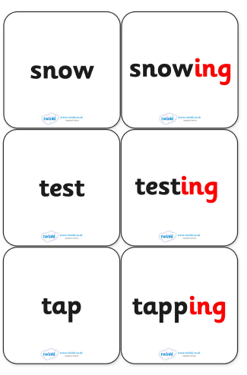
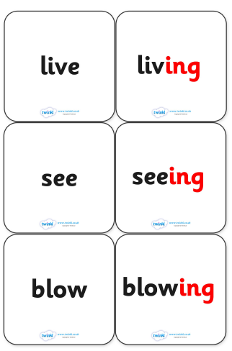

Reading – Complete a Reading Eggs lesson.

Reading – Complete a Reading Eggs lesson.

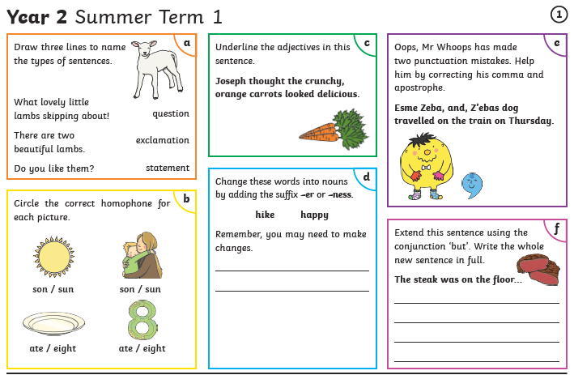

Tuesday

Complete the following comprehension about ‘Captain Tom Moore’

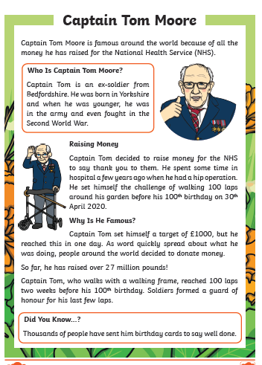

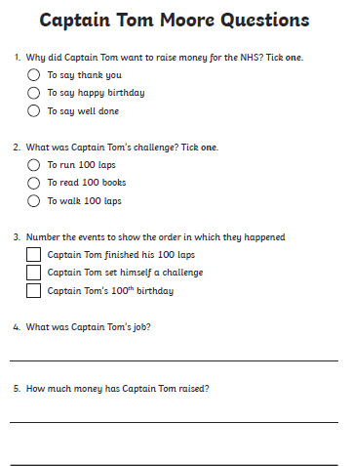

Complete the word search

Complete ‘ing’ suffix crossword

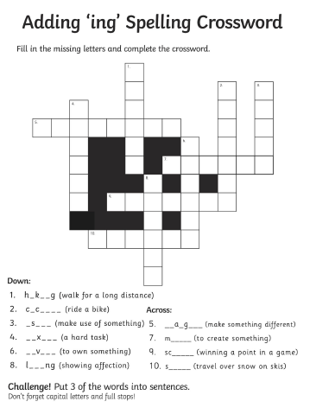

Wednesday

This week and next we are going to be working on the story ‘The Owl who was Afraid of the Dark’ by Jill Tomlinson. You can watch and listen to the story on You Tube https://www.youtube.com/watch?v=y1iST5Bdir8
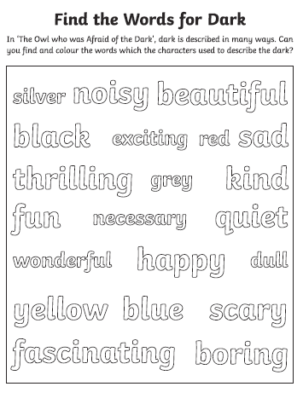
Or you can look on our school Facebook page. You may remember I read this story! Now find these exciting words!
Watch the following clip to understand what alliteration is, then complete the sheet below:
https://www.bbc.co.uk/bitesize/topics/zfkk7ty/articles/zq4c7p3
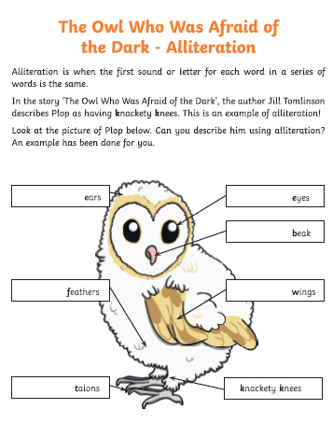
Thursday
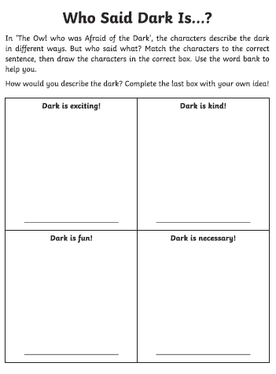
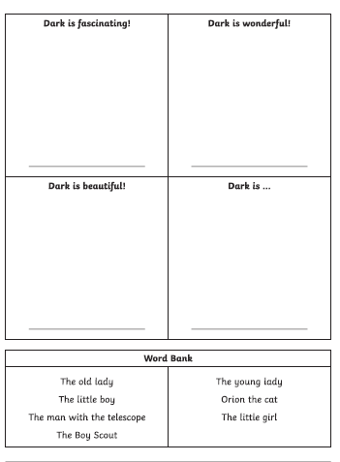

Friday
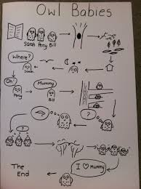
Create a story map of ‘The Owl who was Afraid of the Dark.’

Here is an example of a story map drawn for the ‘Owl Babies.’

You should be able to retell the story just by looking at what you have drawn.

Draw your story map the next page.
We will be using your story map in our writing next week.

My Story Map

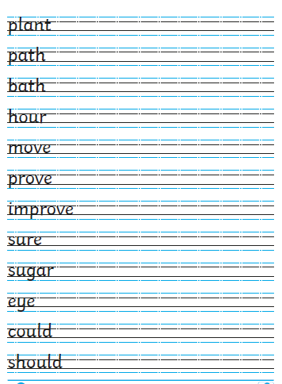

I’ve also included a handwriting sheet with the common exception words on to help you work towards a pen license!

Happy Learning,

Mrs Burland

