Year 2 Writing for 29.6.20
Monday
Phonics – This week we will look at different ways to say the ‘c’ sound. ‘C’ can make a hard or soft sound. Can you remember the rule?
Rule - It makes a soft sound when followed by the letters ‘e, i or y.’ For example, ‘ice, December, city, race, cycle.’
When ‘c’ is in front of any other letter, it is hard and says ‘k’. For example, ‘cat, cage, cuddle, camp.’

Cut the pictures out on page 3 and stick them into the correct boxes on pages 5 and 6.

Read the following sentences to a grown up:

The city is cold and icy in December.
The cat chased the mice into the cinema.
We will celebrate winning the race with a cake.
Rice and corn are nice to eat with coffee.
There is a pencil on the carpet in the caravan.

Can you make your own sentences up? Write them in your home learning book.

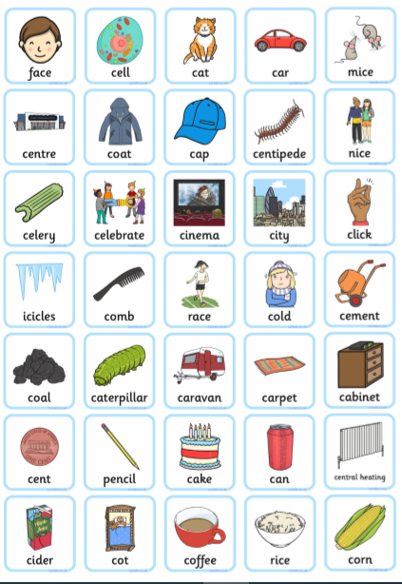

Then complete this spelling game on Classroom Secrets Kids:
https://kids.classroomsecrets.co.uk/resource/year-2-spelling-game-6/

Reading - Don’t forget to complete a reading eggs lesson.

Read a book at home or online and complete a book review.
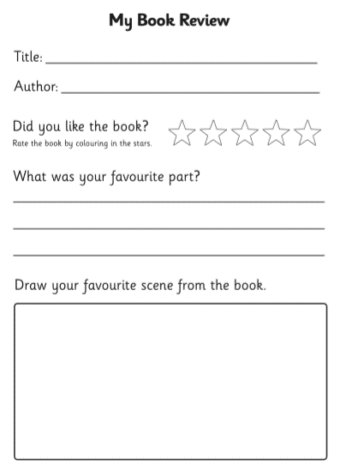

Tuesday

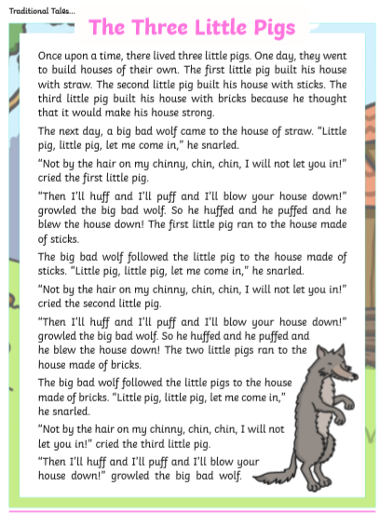
Complete the following comprehension about ‘The Three Little Pigs.’
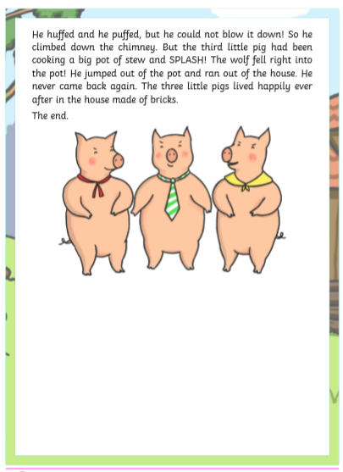
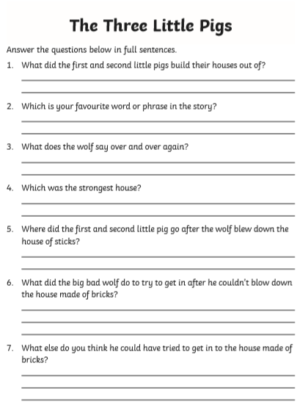
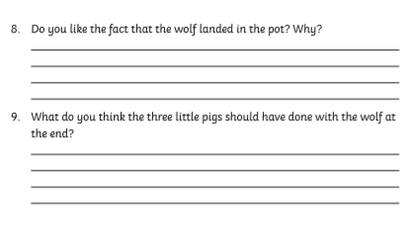

Now complete the SPAG mat on page 13

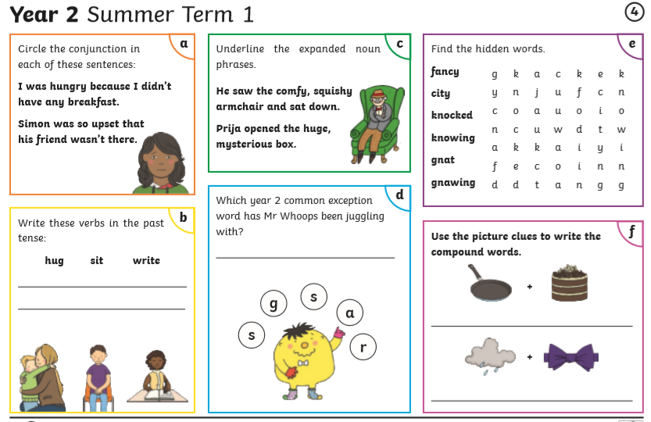
Complete the word search
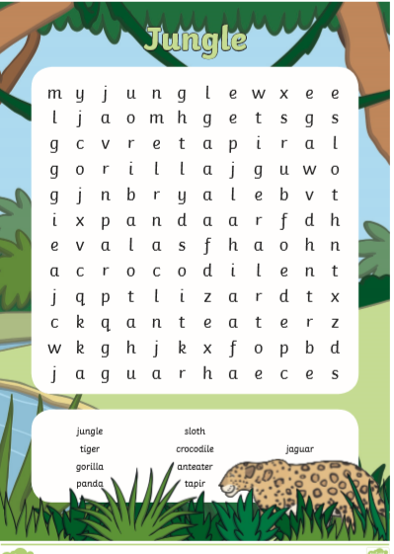

Wednesday

This week we are looking at two stories. One is called
‘The True Story of the 3 Little Pigs’ by Jon Scieska. We will be comparing this story to the Fairy Tale we all know and love, ‘The Three Little Pigs.’
You can watch and listen to the stories on You Tube: https://www.youtube.com/watch?v=m75aEhm-BYw
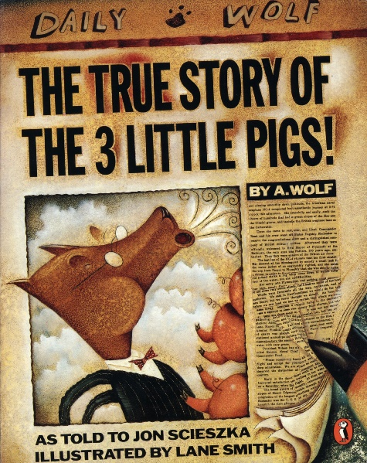

https://www.youtube.com/watch?v=-gdcgnSrUvU
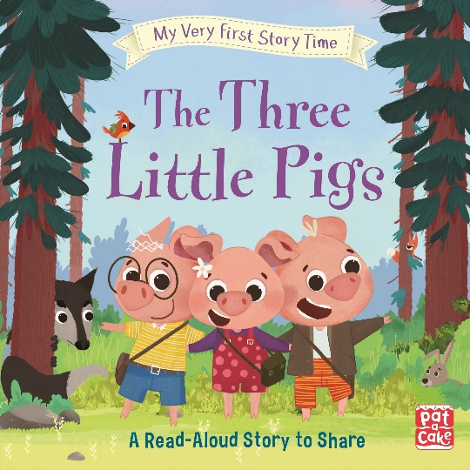

When you have watched the two stories I want you to think about what is the same and what is different. Fill in the grid below:

What is the same in both stories? | What is different about the two stories?
You might want to use some of the words on the next page to help you.

Alexander T. Wolf

straw sticks bricks

friendly wolf houses wolf goes to jail

wolf needed sugar sneezed fault

wolf ate the pigs cake for Grandma

Thursday

Who is telling the truth in the two stories? Do you believe the Three Pigs or do you believe Mr Alexander T. Wolf?

On the next page, write down your opinion and try to give three reasons why to support your answer.

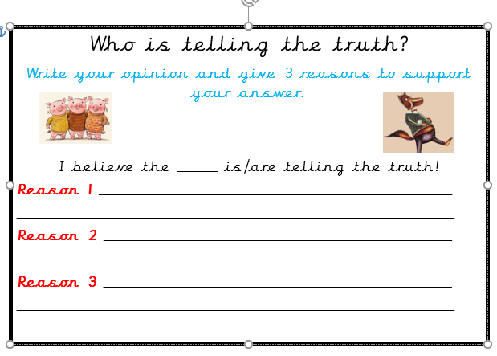
Friday – Quiz time!

Have another look at the story:
‘The True Story of The 3 Little Pigs’
https://www.youtube.com/watch?v=m75aEhm-BYw
Today you are going to make your own quiz about the story and give it to a grown up at home to see how well they do!
You need to make up 10 questions (remember, you need to know the answers!) and set your questions out on the next page.
The following words will help you to start your questions.

What Why Who When How

Remember, when you are writing questions you need to finish with a question mark
?
Here are a couple of questions to help you:
Who was the wolf baking a cake for?
Where did the wolf go after he ran out of sugar?
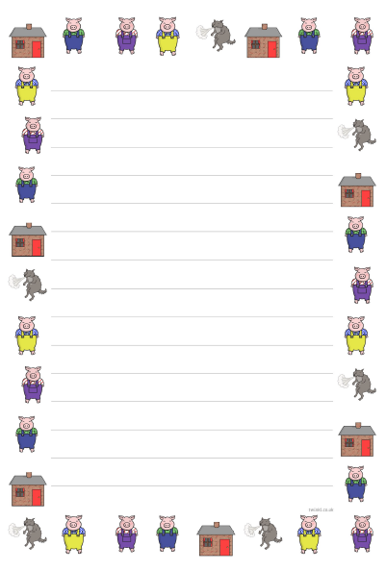
Handwriting
The handwriting sheet I am including each week will be recapping spellings we have already covered in Year 2. They will help you work towards a pen license!
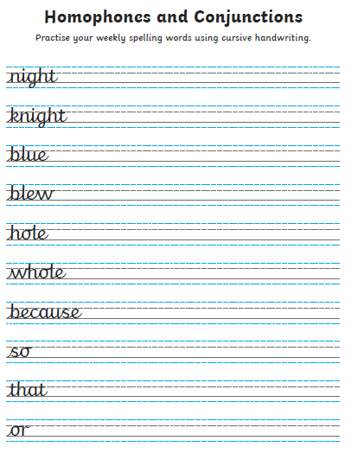
I can’t wait to hear all about Mr Wolf and your quiz questions!
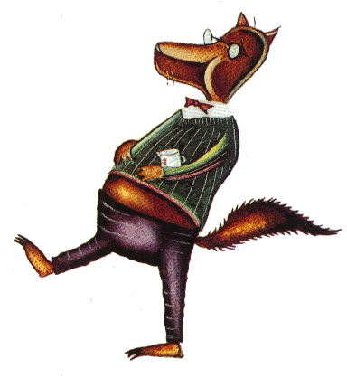

Happy Learning,

Mrs Burland

