Year 4 Writing
This week, we will be looking at SPAG exercises and writing activities that link with our topic mat on Transition. Your writing task on Friday, is to write a letter to your new teacher...How exciting!

Monday. Task 1. SPAG.
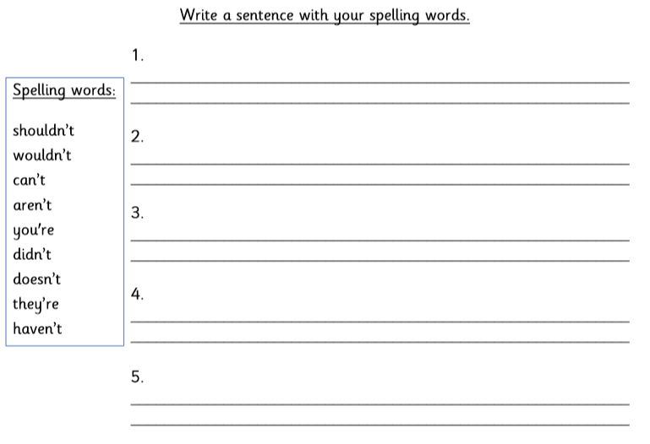

Monday: Task 2.
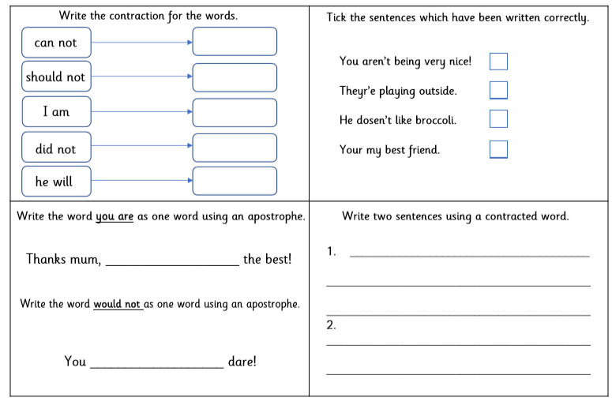

Monday Task 3.
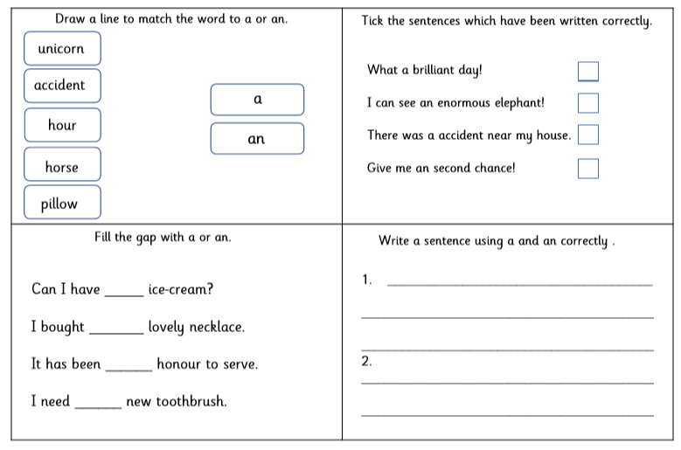
Tuesday Task 1.
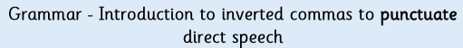
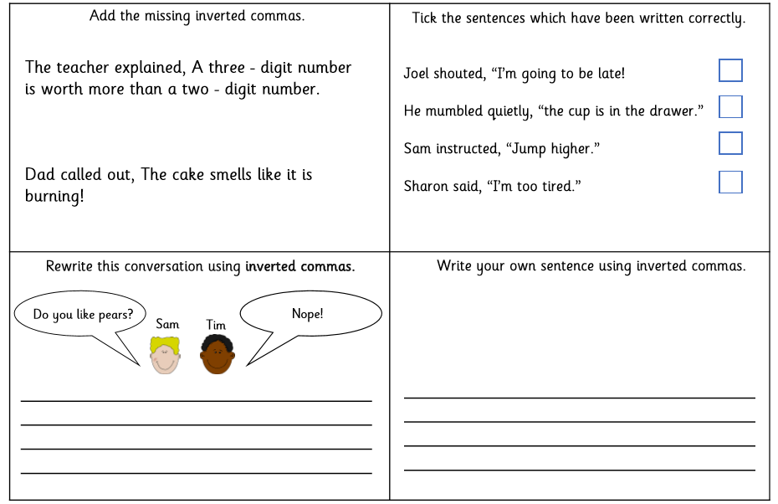
Tuesday Task 2.
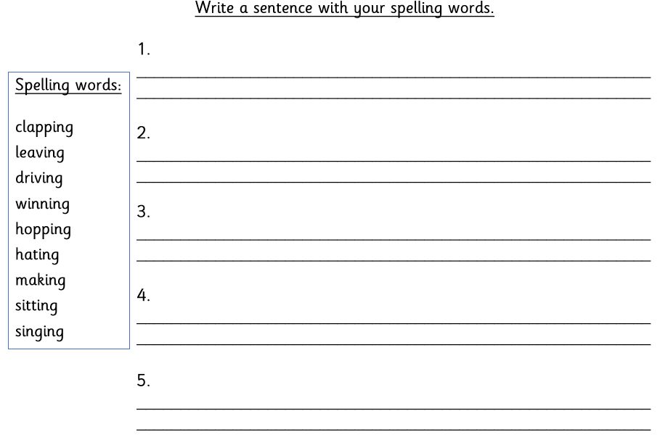
Wednesday. Task 1.
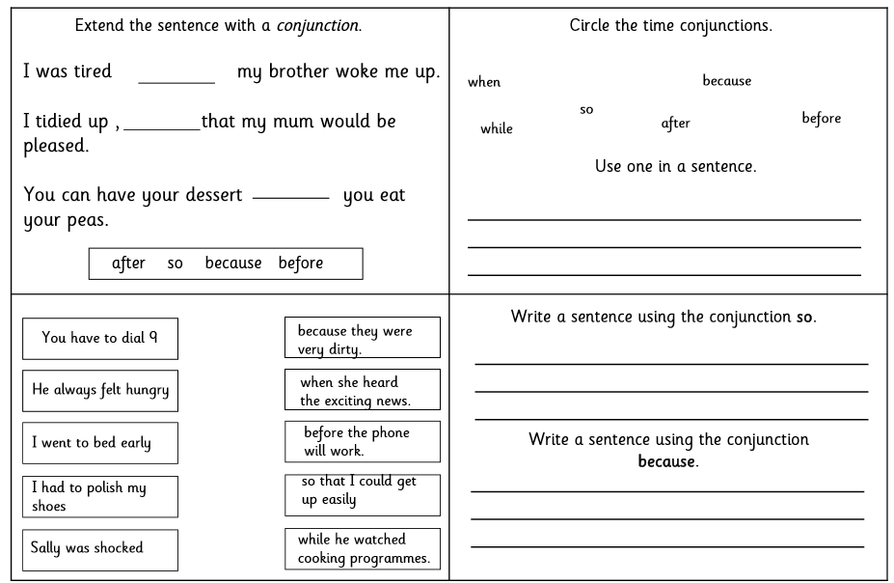
Wednesday Task 2.
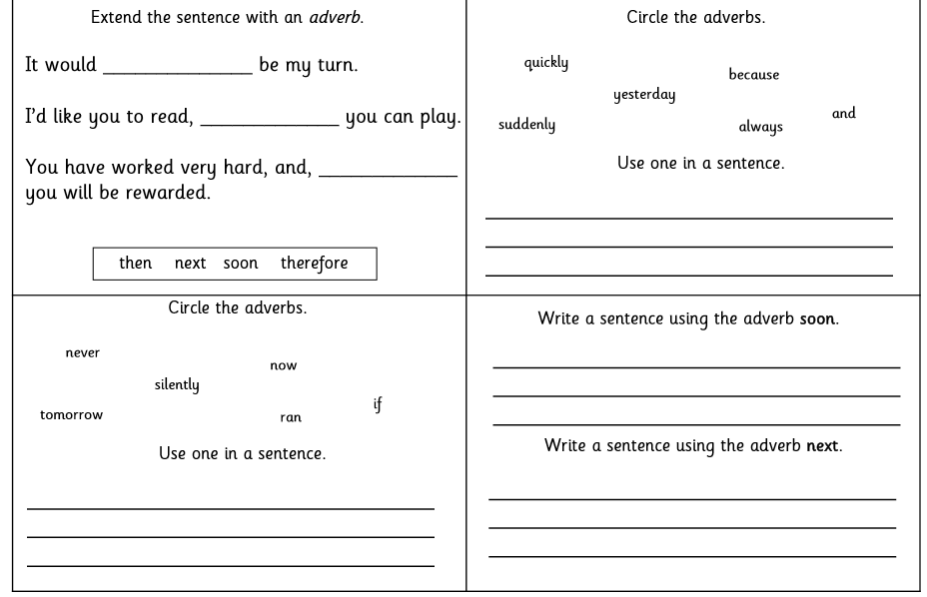
Thursday. Task 1.
From your topic mat, you are to complete Task 3. You need to write a note to yourself. Use the template in your pack.

Friday
Your job is to write a letter to your new teacher. Tell them all about you and what you like doing in school and at home. Have you got a talent? Use the template on page 9 to write your letter.

