Year 3 Writing
This week, we will be looking at SPAG exercises and writing activities that link with our topic mat activities on Transition. Your writing task on Friday is to write a letter to your new teacher...How exciting!

Monday. Task 1. SPAG.
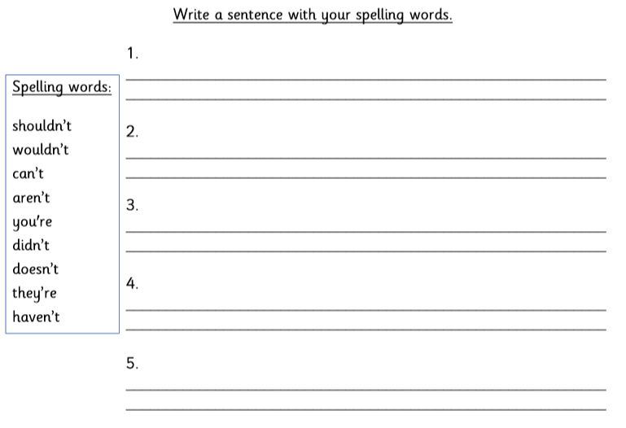

Monday: Task 2.
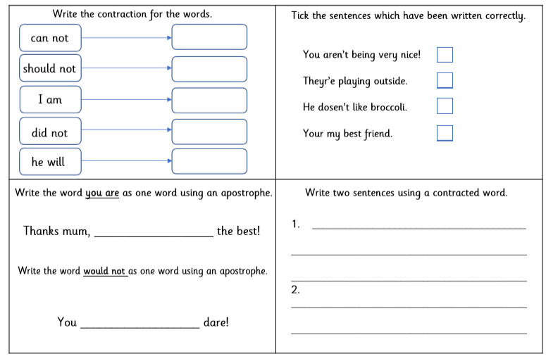

Monday Task 3.
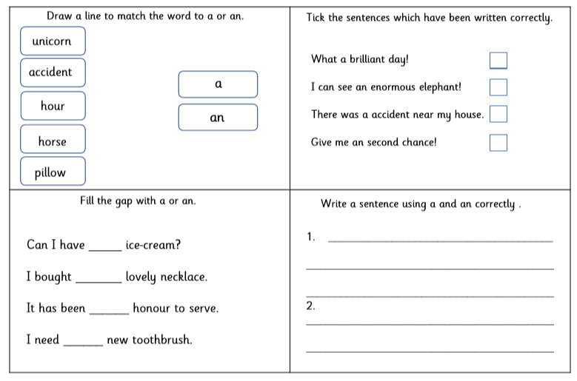
Tuesday Task 1.
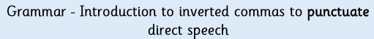
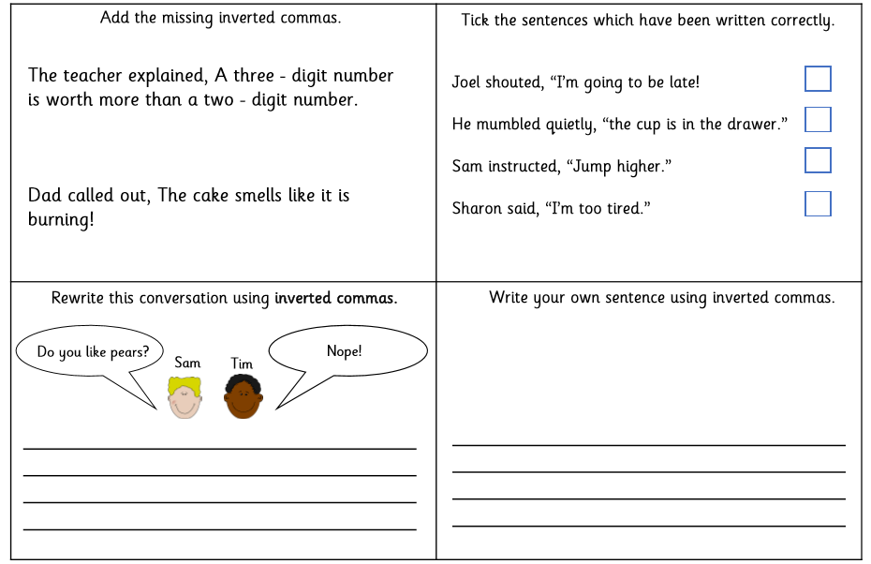
Tuesday Task 2.
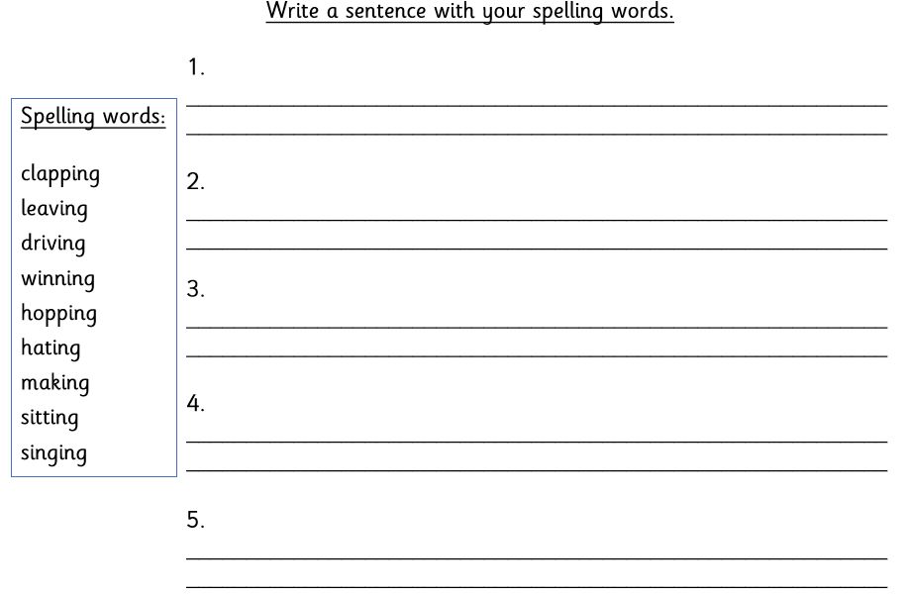
Wednesday. Task 1.
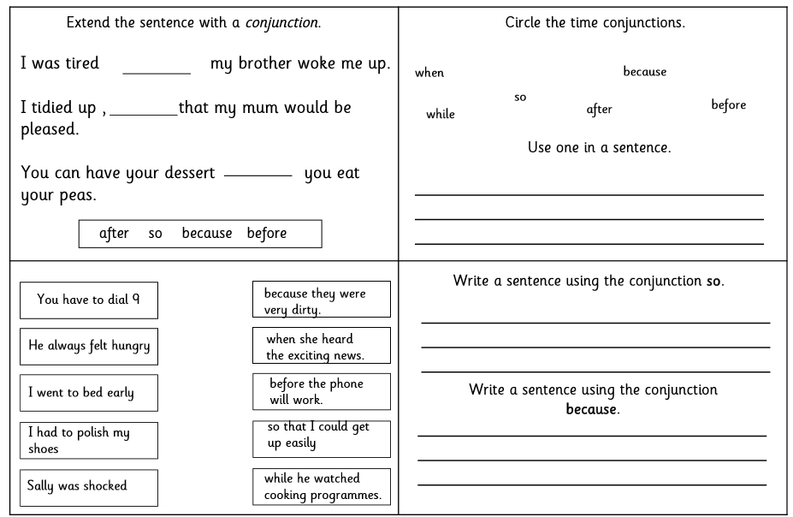
Wednesday Task 2.
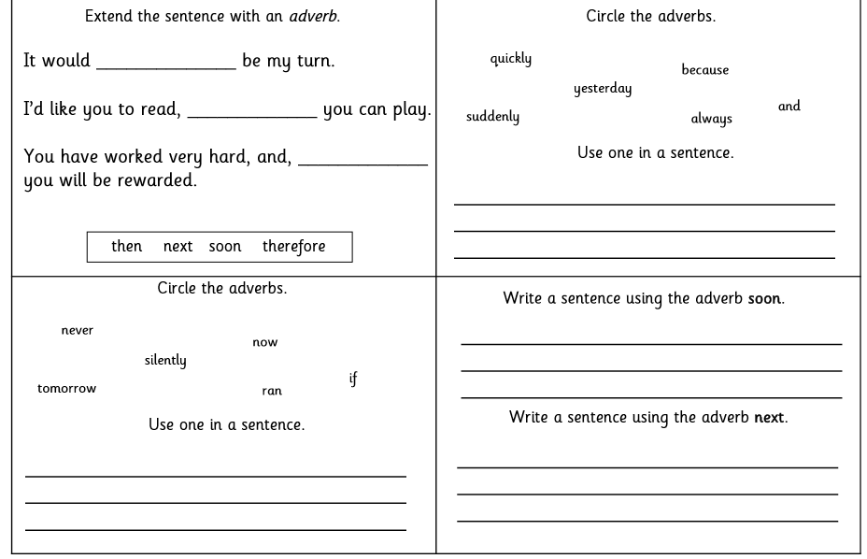
Thursday. Task 1.
Complete Task 3 from your topic mat. You need to write a note to yourself. Use the template in your pack.

Friday Task 1.
Your job is to write a letter to your new teacher. Tell them all about you and what you like doing in school and at home. Have you got a talent? Use the template on page 9 to write your letter.

