Year 3 Transition activities moving into Year 4.

Task 1: Transition is all about change.  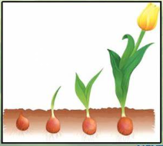  Lots of things change all of the time.  You have changed SO much throughout year 3!  Complete the activity on page 2 to show how you have changed from starting year 3 up to now. What have you got better at? What can you do now that you couldn’t do before? | Task 2: I am Amazing!  It is really important to be able to think positively about yourself and why you are a star!  Complete page 3, where you need to give yourself some compliments. | Task 3: A Positive Note  You are going to have a try at writing a positive note to yourself! Write down all the reasons why you are glad to be you (use page 4). Then, put this note in an envelope and keep it somewhere safe.  When you have had a difficult day or are feeling sad, you can open the envelope and read all the reasons why it is good to be you.
Task 4: 10 Interesting Facts  Even though you have been at Moorside for a while (some of you longer than others), there are still lots of things we don’t know about you!  Have a go at completing the 10 Interesting Facts challenge (page 5). I have completed one for you, so you can find out some things about me!  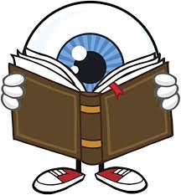 | Task 5: Everybody is somebody…………… and we all fit together  We are all amazing people and we are special in many different ways.  On page 6, is a giant jigsaw piece. Write your name across the middle as large as you can fit it.  Either draw pictures to show how wonderful you are and what things you like or cut pictures out of a magazine to stick on. Then you can show your new teacher how you all ‘fit together.’  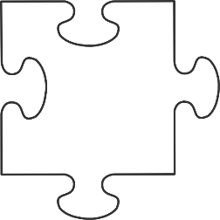 | Task 6: 5 Finger Facts  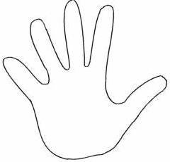  Create 5 Finger Facts all about you: what you are good at, the way you learn best and what you are going to try and get better at (page 7)  Remember to write the facts next to each finger. You can also write a test for your new teacher to see if they can remember all of the facts – just like we do in school!

What I was like at the beginning of Year 3 | How I have improved. What I can do now.

All about change
