Year 2 Transition activities.

Transition is all about change.  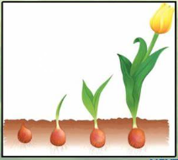  Lots of things change all of the time.  You have changed SO much throughout year 2!  Complete the sheet on page 2 to show how you have changed from starting year 2 up to now. What have you got better at? What can you do now that you couldn’t do before? | Shoe box portrait  Your new teacher will want to know all about you so they can get to know you better!  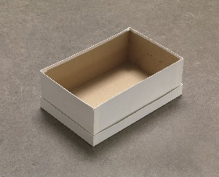  Find an empty shoe box and either fill it with things that are all about you or you could draw things that are important to you.  Decorate the outside of the box to show your personality. | Friendship Garden  Everyone needs friends and your new teacher might want to create a ‘friendship garden’ in your new classroom.  On the flower in your pack, either draw your face in the middle or stick a photo of your lovely face.  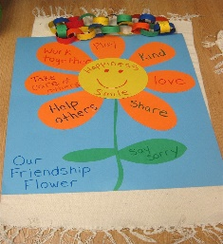  On the petals around the outside, think about the qualities that make you a good friend. Write a different quality on each petal. You can decorate your flower too!
Worries  Some people worry about things changing and some people don’t.  It is completely normal to worry about things changing.  However, once you meet your lovely new teacher and get used to the changes, you will see that there is nothing to worry about!  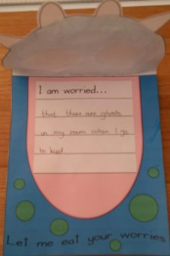  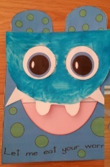  If you have got any worries, make the worry monster on page 4. Once you have written them down, he can eat them up and you will feel better! | Everybody is somebody…………… and we all fit together  We are all amazing people and we are special in many different ways.  On page 5 is a giant jigsaw piece. Write your name across the middle as large as you can fit it.  Either draw pictures to show how wonderful you are and what things you like or cut pictures out of a magazine to stick on. Then you can show your new teacher how you all ‘fit together.’  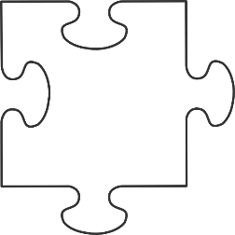 | 5 Finger Facts  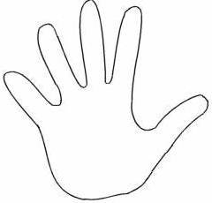  Create 5 Finger Facts all about you: what you are good at, the way you learn best and what you are going to try and get better at (page 7)  Remember to draw around your hand and write the facts next to each finger. You can also write a test your new teacher to see if they can remember all of the facts – just like we do in school!

What I was like at the beginning of Year 3 | How I have improved. What I can do now.
All about change

