Year 1 Transition activities WC 22-6-20

Transition is all about change.  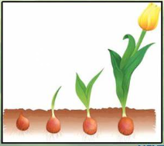  Lots of things change all of the time.  You are changing all of the time too.  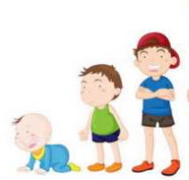  Complete the timeline on page 2 to show how you have grown and changed from being a baby up to now. | All about me!  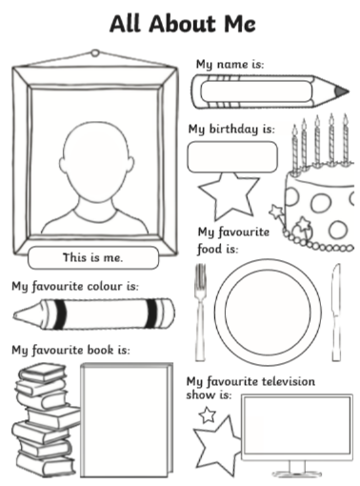  Your new teacher will want to know all about you so they can get to know you better!  Complete the ‘All about me’ worksheet (page 3). Remember to use your neatest handwriting and colouring skills! | Super Hero!  Imagine that you were a super hero – what would your special powers be? What would be your super hero name? Do you have a weakness?  Think carefully about the super hero that you would like to be and complete the activity on page 4.  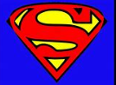
Worries  Some people worry about things changing and some people don’t.  It is completely normal to worry about things changing.  However, once you meet your lovely new teacher and get used to the changes, you will see that there is nothing to worry about!  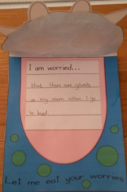  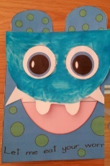  If you have got any worries, make the worry monster on page 5. Once you have written them down, he can eat them up and you will feel better! | Friendship Garden  Everyone needs friends and your new teacher might want to create a ‘friendship garden’ in your new classroom.  On the flower in your pack, either draw your face in the middle or stick a photo of your lovely face.  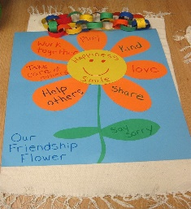  On the petals around the outside, think about the qualities that make you a good friend. Write a different quality on each petal. You can decorate your flower too! | 5 Finger Facts  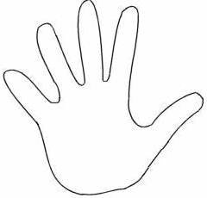  Create 5 Finger Facts all about you: what you are good at, the way you learn best and what you are going to try and get better at (page 7)  Remember to draw around your hand and write the facts next to each finger. You can also write a test your new teacher to see if they can remember all of the facts – just like we do in school!

