Year 4 Writing
This week you have the chance to use your creative minds! There are lots of exciting pictures to describe. Use the brilliant vocabulary that you have used previously but be imaginative with your creations. Have fun with this!
Monday. Task 1. SPAG.
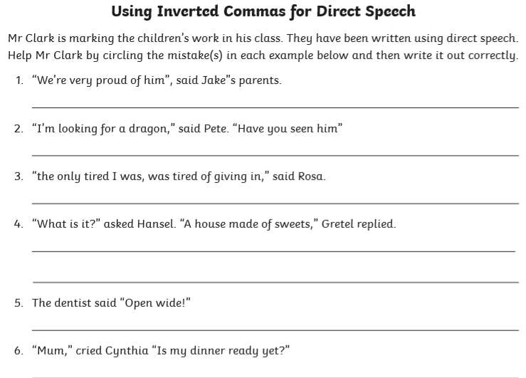

Monday: Task 2.
Have a go at this and write your response below. What would your superpower be? Could you use speech marks as if your character is speaking? Good Luck!
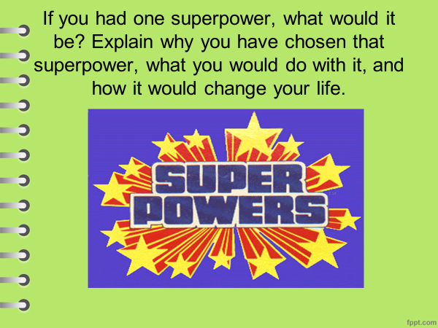

Tuesday Task 1.
How did the girl end up being inside the jar? Can she get out? Why is she so small? Write a short story answering the questions above. Use the planning sheet on page 5 to help you.
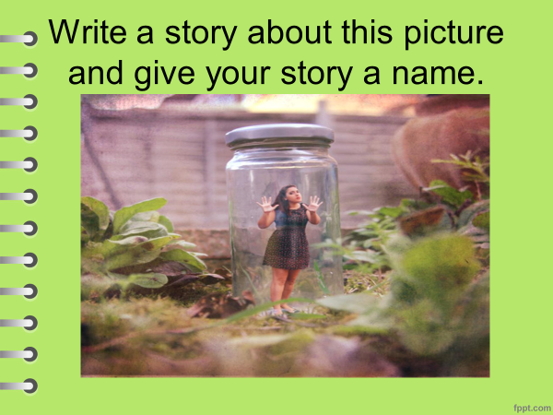

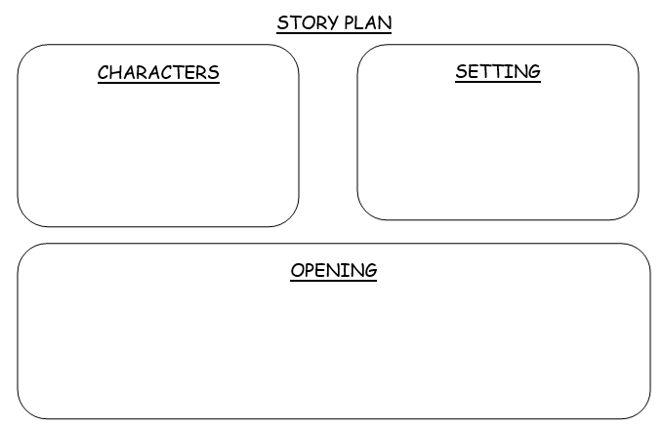
Wednesday. Task 1.
Use your imagination for this task! Use the questions to help you. You can draw the robot if you like also.
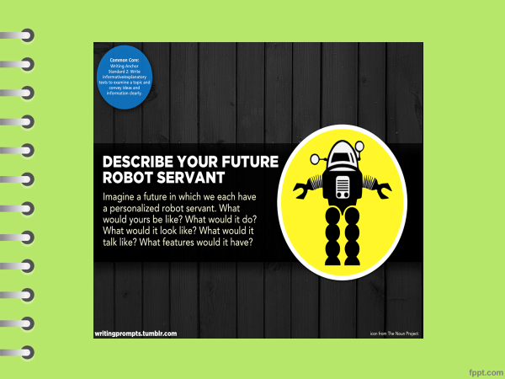

Wednesday Task 2.
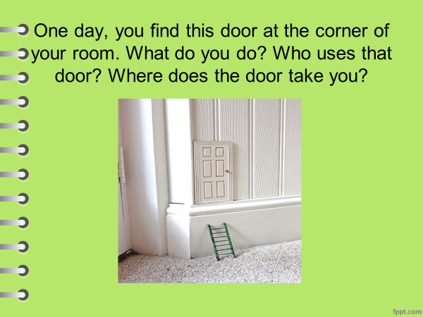

Thursday. Task 1.
Think carefully about what your car might have! Be inventive and imaginative. Draw your finished car on page 11.
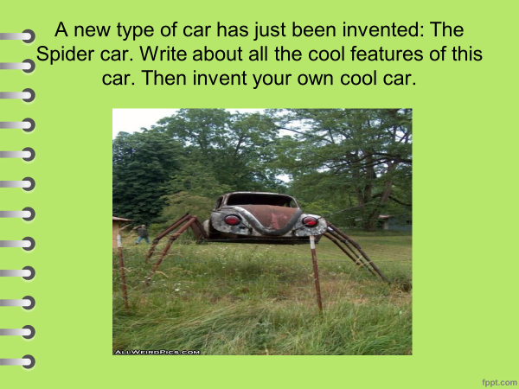

My new Car design.

Friday Task 1.
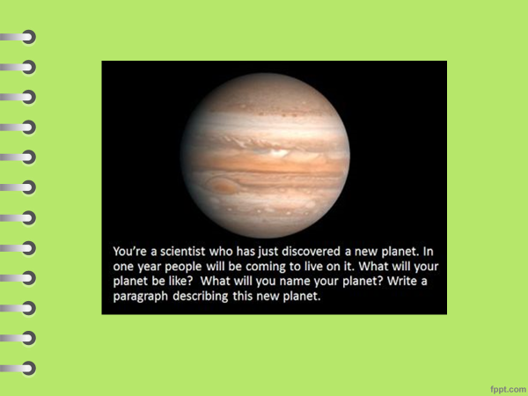

Task 2.
Be creative. Don’t just put Football or Rugby. Create a game and give it a name. You could combine 2 games that you know to make a new one. Maybe we could use your game at Sports Day.
