Reception Home Learning WC 08-06-20

Reading
Read a book with your grown up every day – the more often the better!
We will also be putting a story on YouTube and Facebook every day for you to enjoy at home.
Keep logging onto Reading Eggs – everyday if you can!
Have a go at the Early Reading Comprehension on page 2 – read the sentence and add to the pictures.

Writing
Please continue to practice some ‘one armed robot’ letters this week (page 3). Please watch the handwriting video on https://www.youtube.com/watch?v=1U-oQ78Xdc8 -this should help with questions about how to form the letters. Use the blank handwriting sheet to find and practice writing some words that start with ‘r’ and ‘b’.
If your child is still learning to write their name, remember to practice writing their name every day. Start with the first letter and practice that until they can do it beautifully! Then move onto the second letter etc.

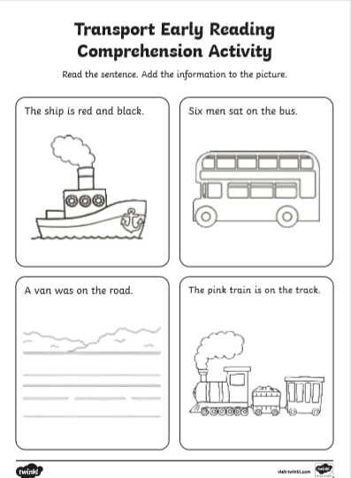

Phonics
Monday
Complete the Phase 3 Tricky word quiz on Purple Mash
Tuesday
Find the missing words in the Seaside picture (page 6). These words include consonant blends.
Wednesday
Practise singing ‘Apples and Bananas’ https://www.youtube.com/watch?v=lNNMknj0PyE. This is all the vowel sounds (long and short)
Thursday
Practise saying initial consonant blends using the Phase 4 (page 8) mats. Can you start to think of other words that start with the same blends. Can you make up some silly words or sentences e.g. crabs cracking crisps etc.
Friday
Practise writing some silly sentences using your Phase 4 mat.

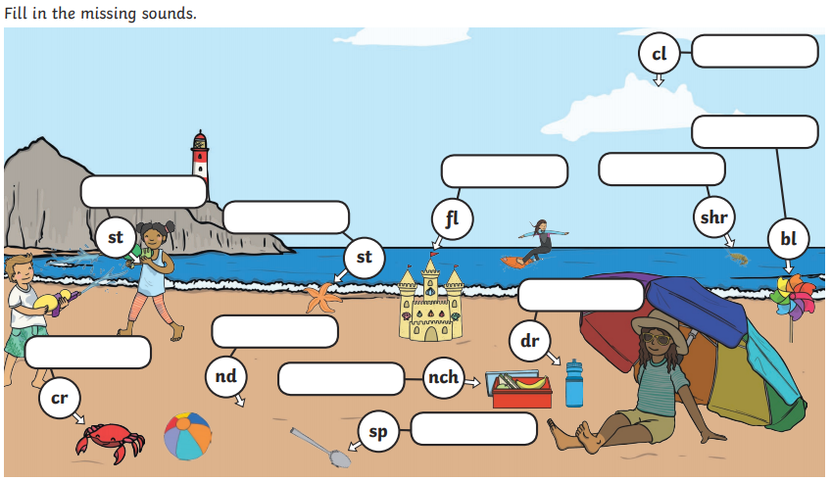
BLANK PAGE
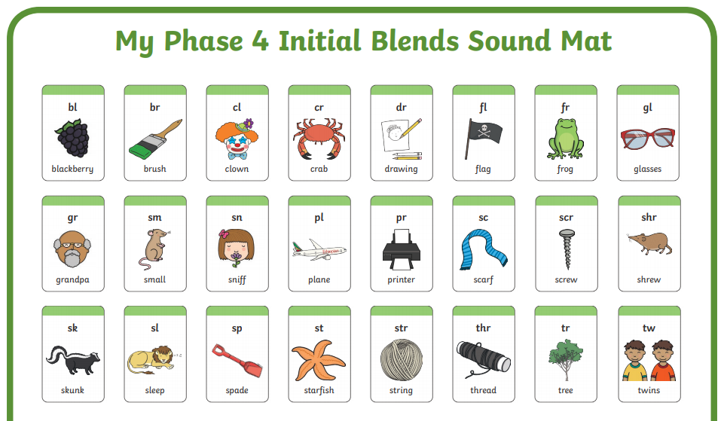
Maths
We will be thinking about weight this week.
Monday
Get your child to be a human balancing scale. Use items and ask them to tip to show which is heavier or lighter. Can they draw a picture to record this? You could even work through several items and try to order them lightest to heaviest.
Tuesday
Watch the story ‘How much does a ladybird weigh?’ https://www.youtube.com/watch?v=cY6-SpJAM4k Can you use this story to draw a picture of the creatures in order from lightest to heaviest?
Wednesday
Watch ‘Who sank the boat’ https://www.youtube.com/watch?v=ZpFWuHSDFtQ. Make your own boat using a plastic container and play about with sinking the boat in water. Can you use this to help you talk about weight?
Thursday
Use a container e.g. a bucket and an elastic bank attached to the handle (or balloon or hair bobble). Fill the container with different objects and observe the stretch on the elastic band. Can you use this to make some direct comparisons?
Friday
Complete the Save the Superhero weighing activity. (page 10)
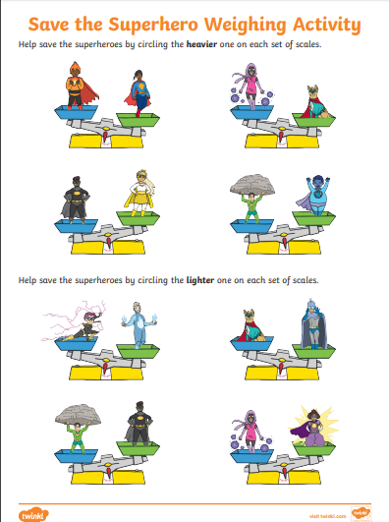

Don’t forget to check on Purple Mash and Abacus for more maths activities!
Topic – PHSCE
Children should know the importance for good health of physical exercise, and a healthy diet, and talk about ways to keep healthy and safe.
Nursery and Reception will be learning about why it is important to be fit and healthy.
Purple Mash tasks
-Design a healthy meal. Paint what you would have as a healthy meal. Can you include different food groups?
-Write about your favourite? What is your favourite food like? Try to use simple sentences to describe it within this 2Do e.g. It is red. It has seeds. etc,
-What happens during exercise? Read the information with an adult. Can you describe in your own words what happens during exercise?

Design your own fitness training
Use the exercises from Joe Wicks or Cosmic Kids to help.
-Think of 5 exercises that you can do many times in a minute.
-Challenge yourself to do these activities daily.
-Can you increase how many you can do in a minute?
Think about
What happens to your body after exercising? (after 1 minute, 5 minutes etc)
Do all exercises have the same effect on your body?
Complete the Being Active worksheet on page 13
Play healthy chef
Using play food, pictures of food cut from magazines or drawings make healthy plates of food for your teddies or family. You could even write a menu for them to choose from.
Your healthy meals
Discuss your family meals with your child. Why are they having the food you are giving them? What food group does it belong to? What job will it do in their body? Use the food groups poster provided (page 12) to support this discussion.

