Year 3 and 4 Refugee Week Home Learning Challenges
Task 1  Design a Welcome Poster.  Imagine that you are welcoming a refugee from Syria.  They don’t speak English and have just arrived at your school.  Your task is to create a poster to welcome them to your school.  Think about some of the things that might make a child feel welcome in a new country.  Also, think about all the brilliant things you do at school.  You can use the template on Page 2. | Task 2.  Famous Refugee Factfile.  Use the famous people on the sheet below (Page 3 and 4) and create a factfile about them. You can find further information on the internet if you like.  You could create one by putting the information in bubbles with the persons name or a picture of them in the middle.  You could use bullet points to show your facts. The choice is yours. | Task 4. Did you know?  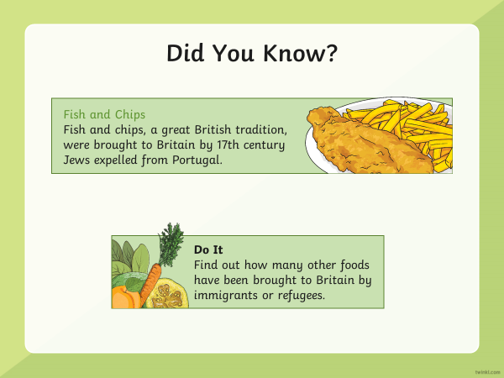
 | Task 3. Refugee Organisations.  Can you find out information about the following charities and organisations? Use the internet to help you if you can. Can you answer the questions on Page 5?  Refugee Council https://www.refugeecouncil.org.uk/  https://www.unhcr.org/. https://www.savethechildren.org.uk/ | Key Vocabulary  Refugee status: A person given refugee status is normally granted leave to remain in the UK for 5 years.  Asylum: The protection granted by a state to someone who has left their home country as a political refugee.  Save the Children: They do whatever it takes for children – every day and in times of crisis – transforming their lives and the future we all share.

