Year 3 and 4 Home Learning Challenges
Task 1  Create a poster of how you have felt whilst being at home and not at school.  Think about your routine at home...Have you missed your friends/teachers?  Are your feelings mixed? You could be happy that you are at home but not happy as you’ve had work to do at home.  You can use words to describe (see sheet attached) and also pictures or photographs of yourself!  Good Luck! | Task 2. What if……..  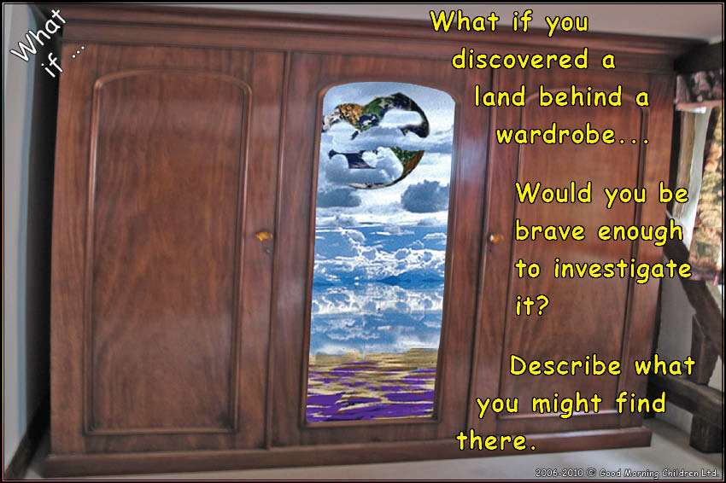 | Task 4. Would you rather……  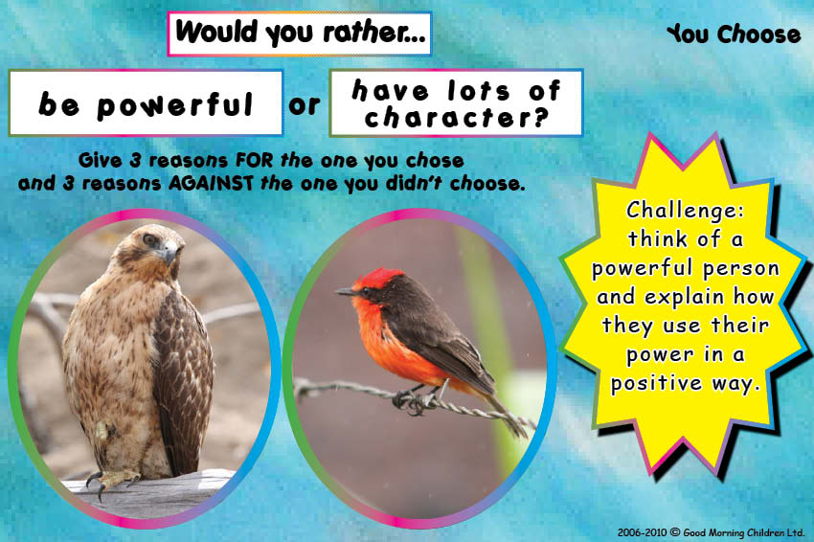
 | Task 3. Worries.  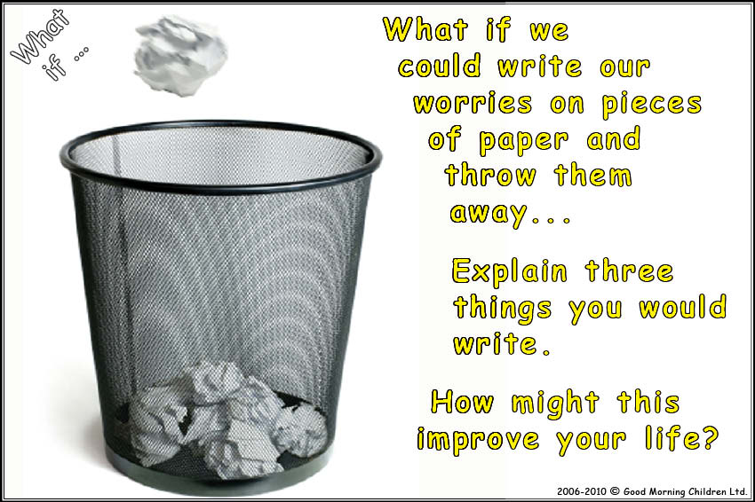 | Key Vocabulary  Powerful: having great strength or power.  Character: the quality of being individual in an interesting or unusual way.  Worries: feel or cause to feel anxious or troubled about actual or potential problems.  Brave: ready to face and endure danger or pain; showing courage.
How do I feel as situations change?
This word bank will help you with all the tasks above. Try using a dictionary if you are unsure of any of the meanings but also a Thesaurus to up level your vocabulary. (If you don’t have these at home, the internet may help!)
