Year 3 Maths
The objectives we are working on are:
- count up and down in tenths; recognise that tenths arise from dividing an object into 10 equal parts and in dividing one-digit numbers or quantities by 10.
- recognise, find and write fractions of a discrete set of objects: unit fractions and non-unit fractions with small denominators.
- recognise and use fractions as numbers: unit fractions and non-unit fractions with small denominators

This week is Fractions week. You can use what we did in school to help but also the work you did a few weeks will help too.

All the lessons can be found on https://whiterosemaths.com/homelearning/year-3/
This week’s learning is dated 18th May.
Monday: Unit and non-unit fractions.

Monday Task 1 . Watch this video first to help you. https://vimeo.com/418151464

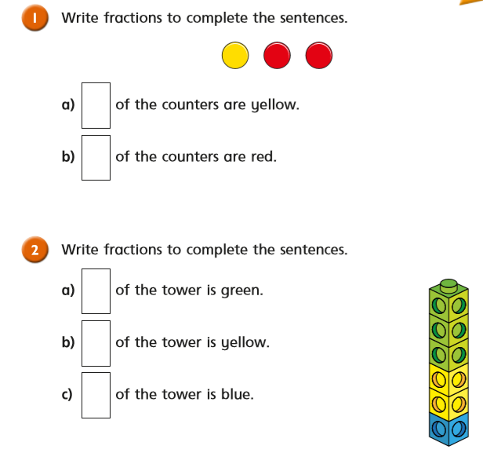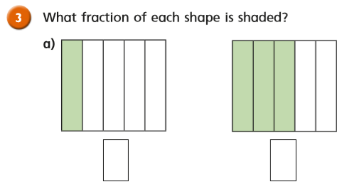
Monday Task 2
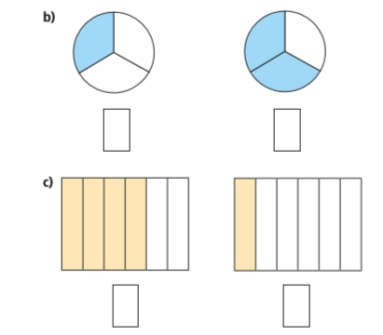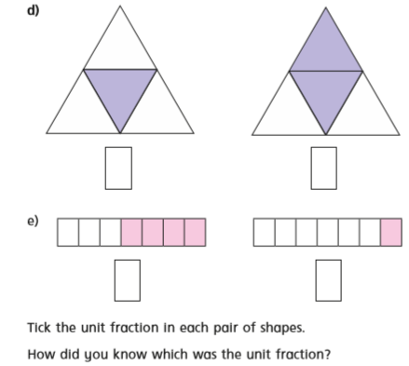

Monday Task 3
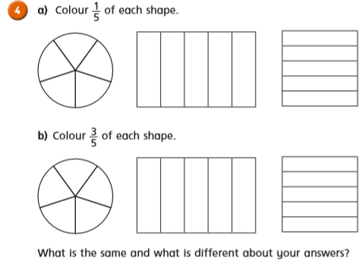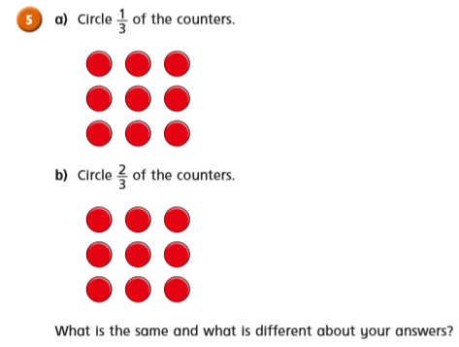

Monday Task 4
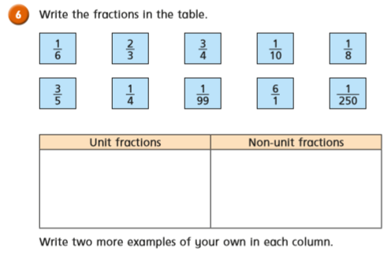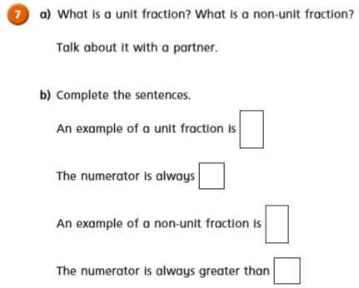
Tuesday Task 1. Making the whole. Watch this first: https://vimeo.com/418151644
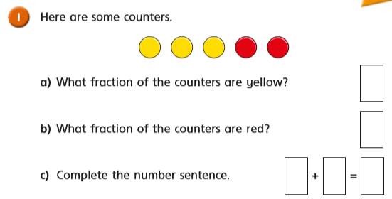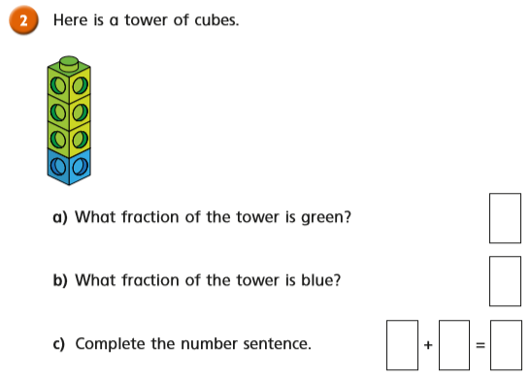

Tuesday Task 2.
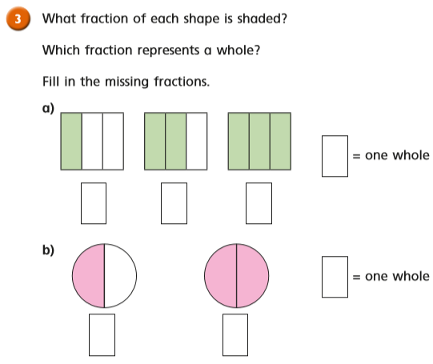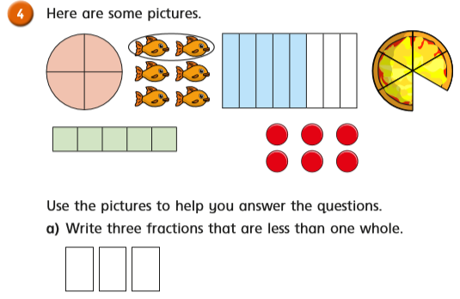
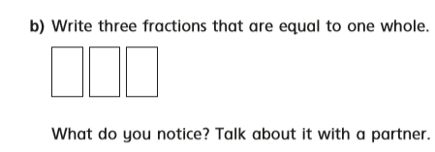
Tuesday Task 3.
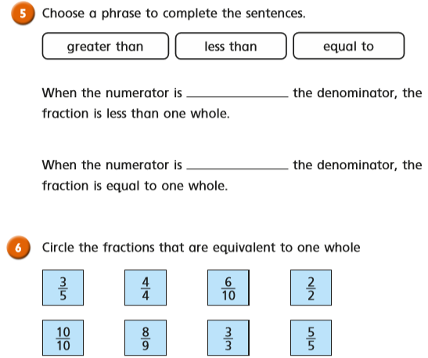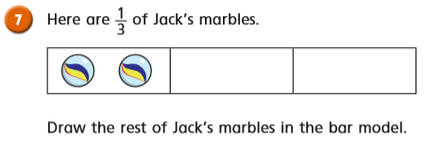

Tuesday Task 4.
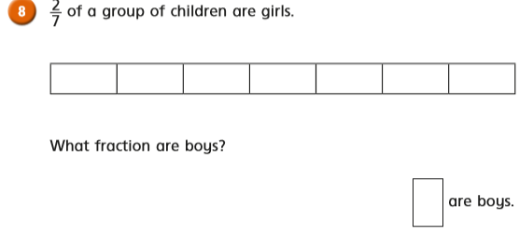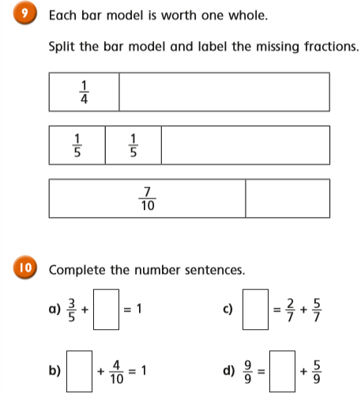

Wednesday Task 1. Tenths. Watch this first: https://vimeo.com/418151919
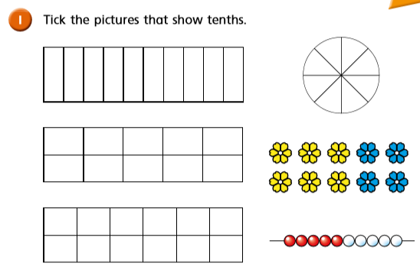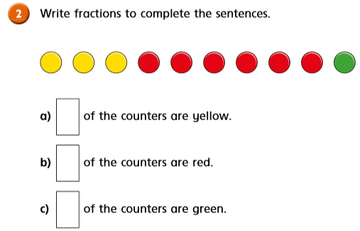

Wednesday Task 2.
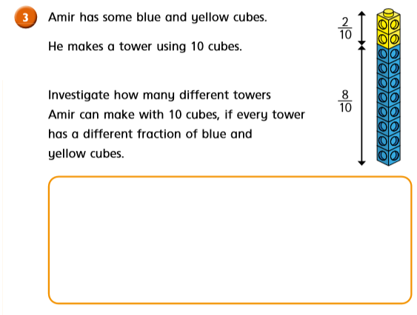
For this, think in patterns. 1/10 yellow would mean 9/10 in blue.2/10 in yellow would mean 8/10 in blue and so on.
Wednesday Task 3.

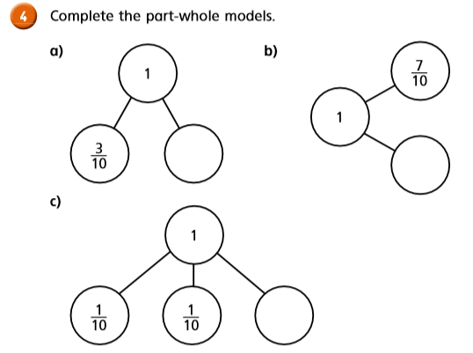

Thursday: Task 1.
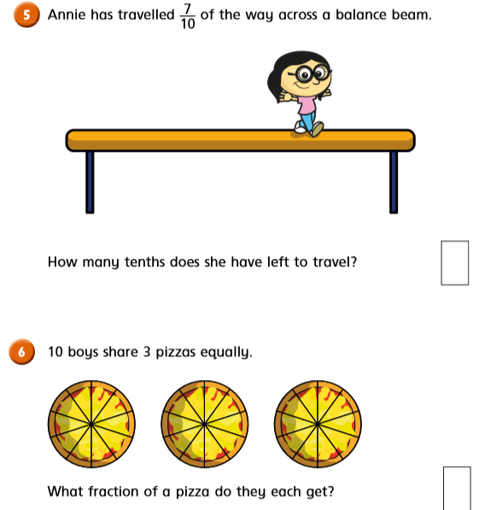

Thursday Task 2.
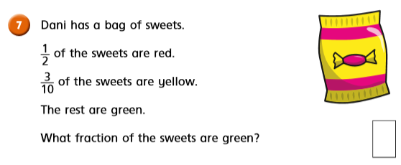
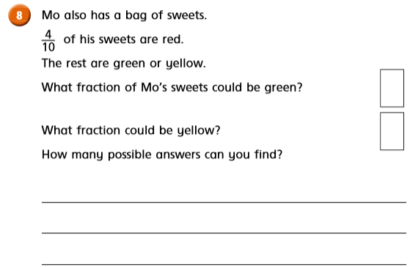
Friday Task 1. Watch the video first https://vimeo.com/418153490
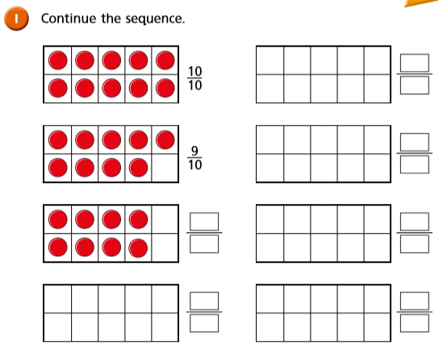

Friday Task 2.
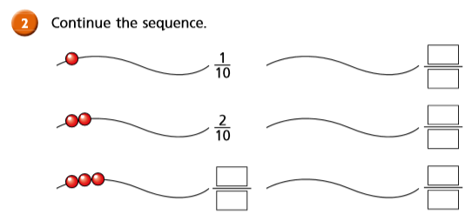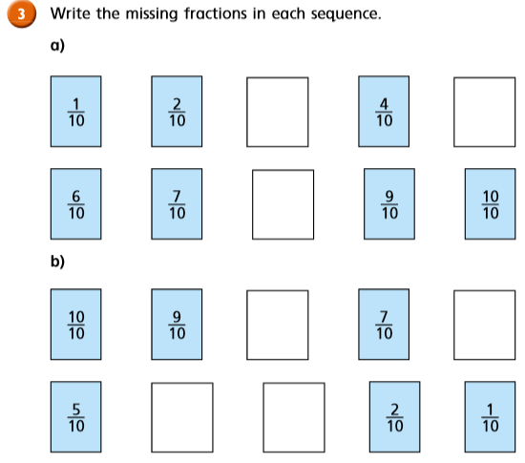

Friday Task 3.
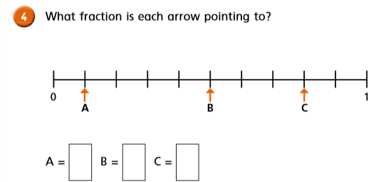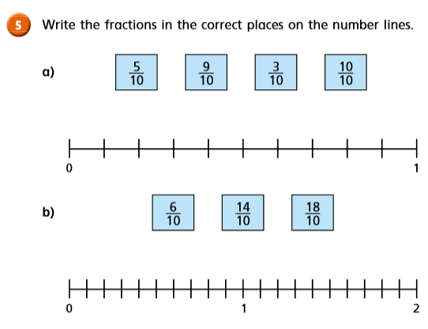

Friday Task 4.
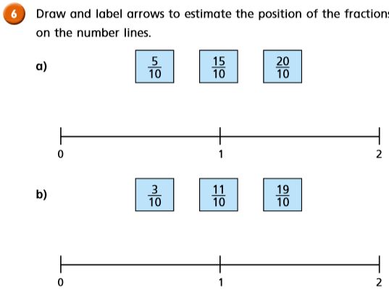

Friday Task 5.
