Maths Year 6
w/c 8.6.2020
The objectives we are working on in this week are:
- To multiply numbers by 10, 100 and 1,000, giving answers up to 3 decimal places
- To multiply decimals by integers (whole numbers)
- To divide decimals by integers (whole numbers)
- To associate a fraction with division and calculate decimal fraction equivalents for simple fractions
This week’s learning will be a recap of more learning we carried out in school during the Spring term. On Monday, you will start by revisiting how to multiply numbers by 10, 100 and 1000; then on Tuesday, you will revisit multiplying decimals by whole numbers; on Wednesday, you will be revisiting dividing decimals by whole numbers; on Thursday, you will be finding decimal equivalents for simple fractions and finally, on Friday, you can practise what you have learnt this week using activities on Classroom Secrets Kids.
Using the link below, click on Summer Term – Week 5 and each day (Monday – Thursday) watch the video and complete the accompanying task (these are printed in your pack). Lesson 1 – Monday, Lesson 2 – Tuesday, Lesson 3 – Wednesday, Lesson 4 – Thursday.
https://whiterosemaths.com/homelearning/year-6/
On Friday, use the following links to continue practising what you have learnt this week:

https://kids.classroomsecrets.co.uk/resource/multiply-by-10-100-and-1000-video-tutorial-2/

https://kids.classroomsecrets.co.uk/resource/year-6-multiply-decimals-by-integers-reasoning-practice/

https://kids.classroomsecrets.co.uk/resource/year-6-multiply-by-10-100-and-1000/

https://kids.classroomsecrets.co.uk/resource/year-6-decimals-as-fractions/

Monday (Part 1)
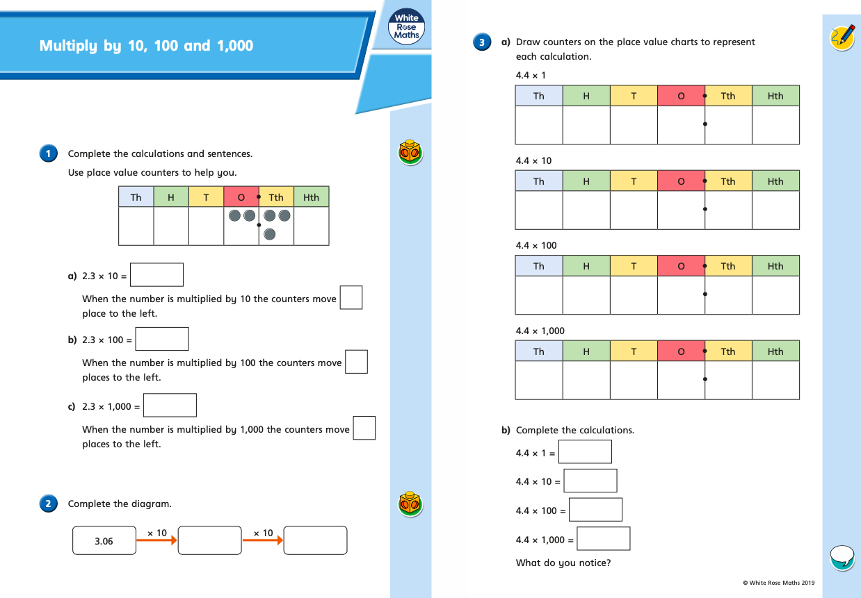

Monday (part 2)
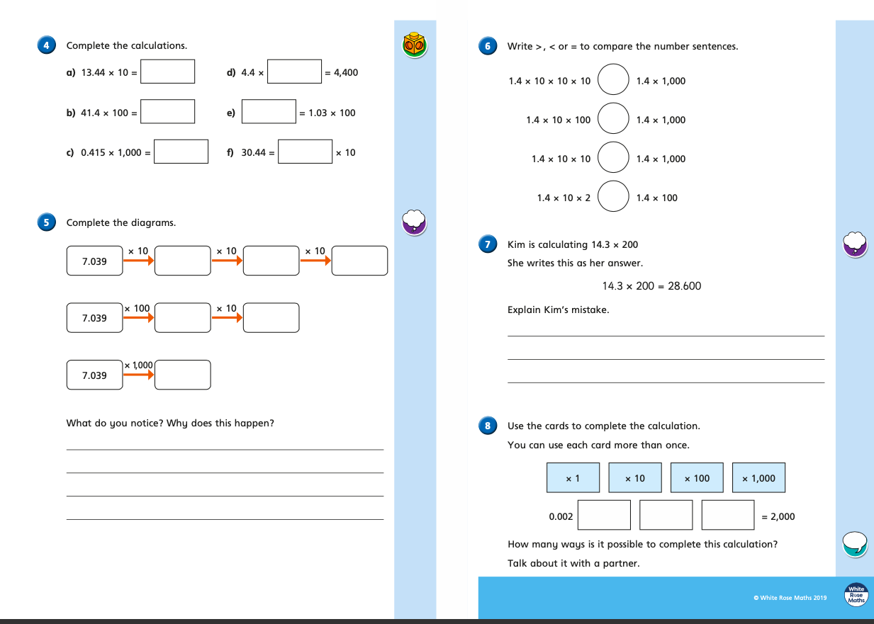
Tuesday (part 1)
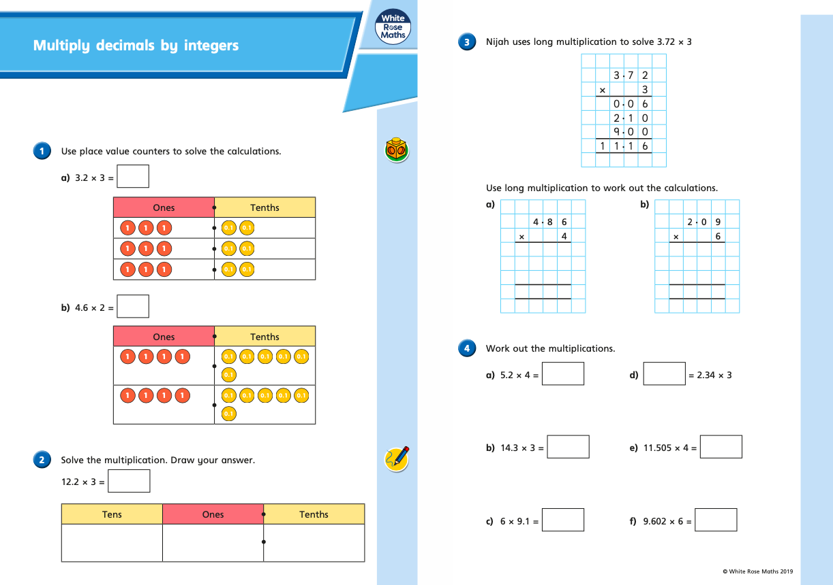
Tuesday (part 2)
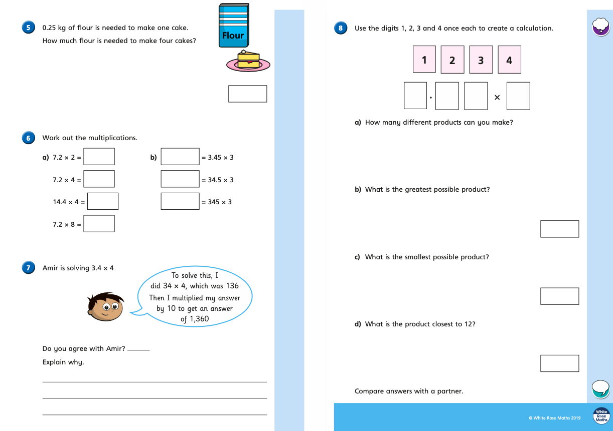
Wednesday (part 1)
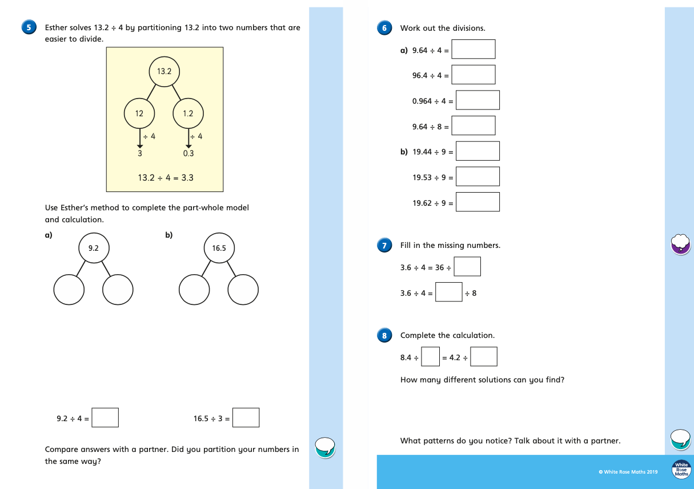

Thursday (part 1)
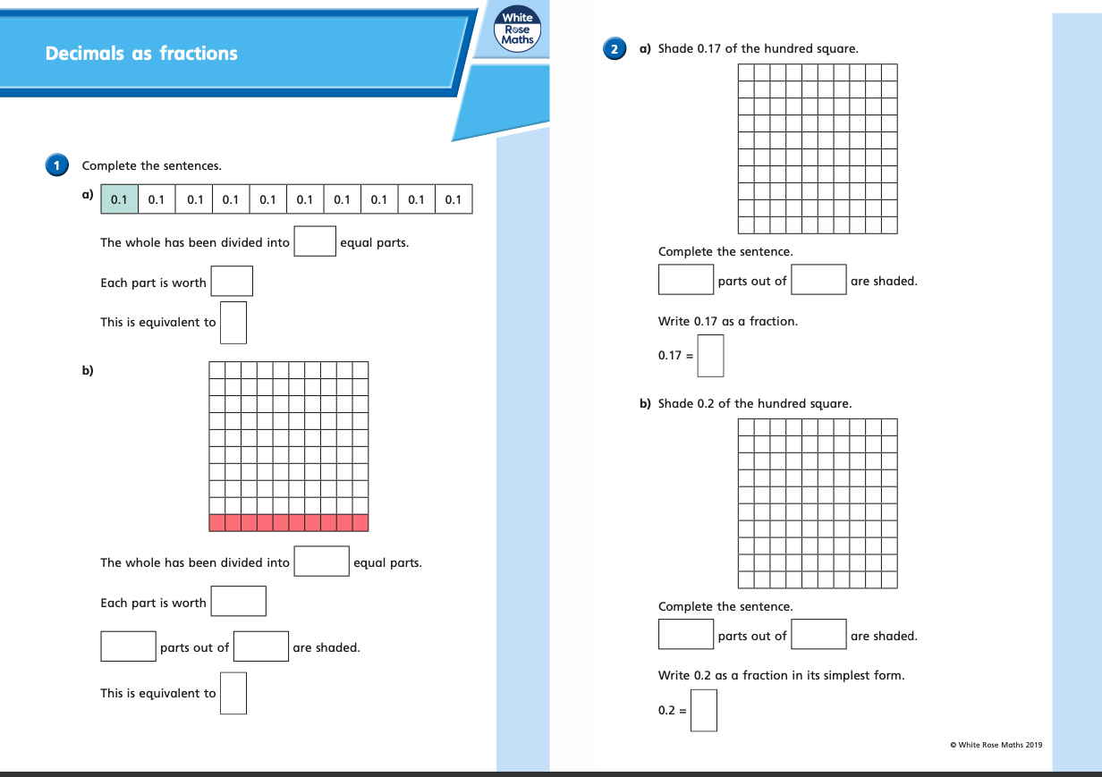
Thursday (part 2)
