Year 3 Maths
This week is Fractions week. You can use what we did in school to help but also the work you did a few weeks will help too.
The objectives we are working on are:

- To add and subtract fractions with the same denominator within one whole.
- To compare and order unit fractions, and fractions with the same denominators.

All the lessons can be found on https://whiterosemaths.com/homelearning/year-3/
Monday: Equivalent Fractions.

Monday Task 1 . Watch this video first to help you. https://vimeo.com/427992995
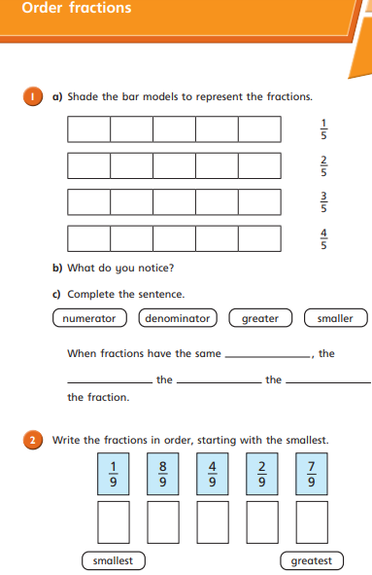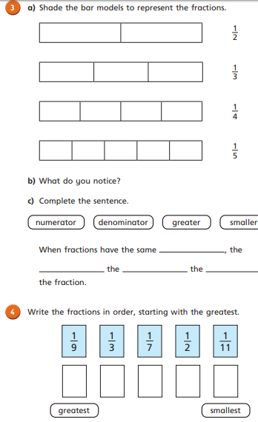

Monday Task 2
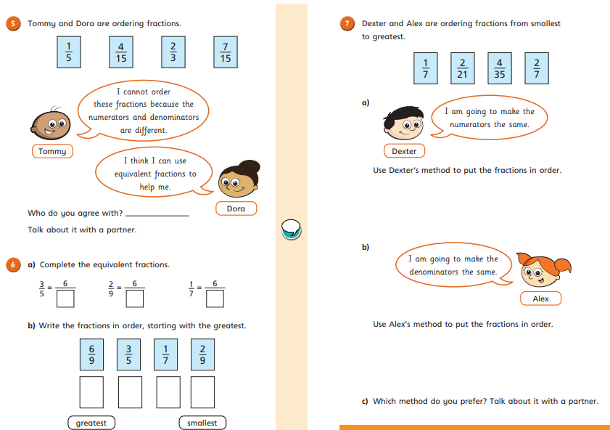
Tuesday Task 1. Watch this first: https://vimeo.com/427993095
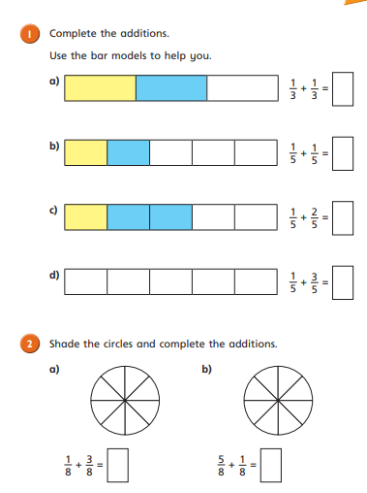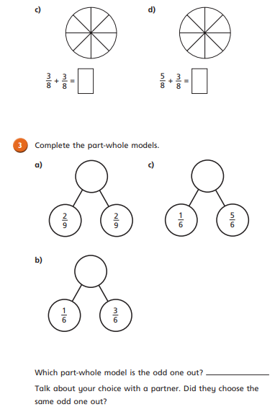
Tuesday Task 2.
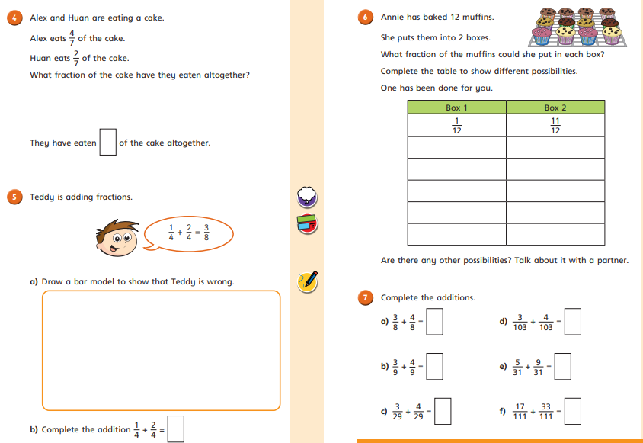
Wednesday Task 1. Watch this first: https://vimeo.com/427993504
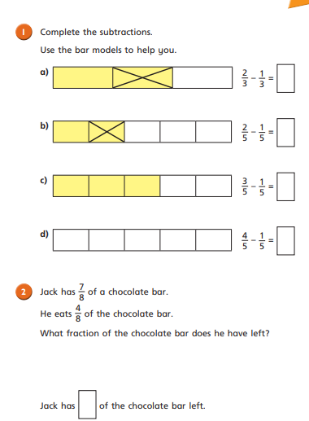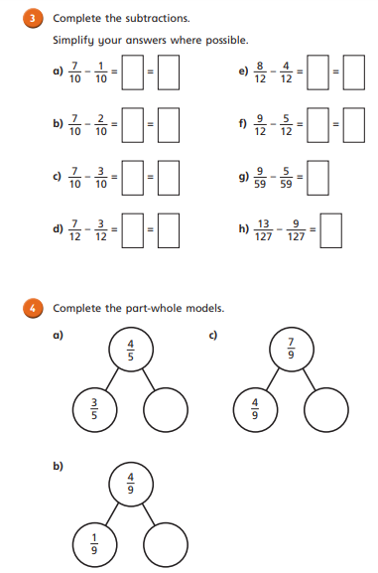

Wednesday Task 2.
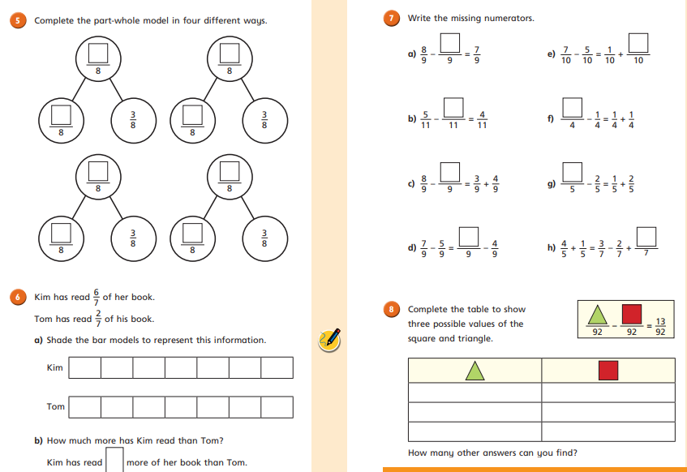
Thursday Task 1. https://vimeo.com/427993581
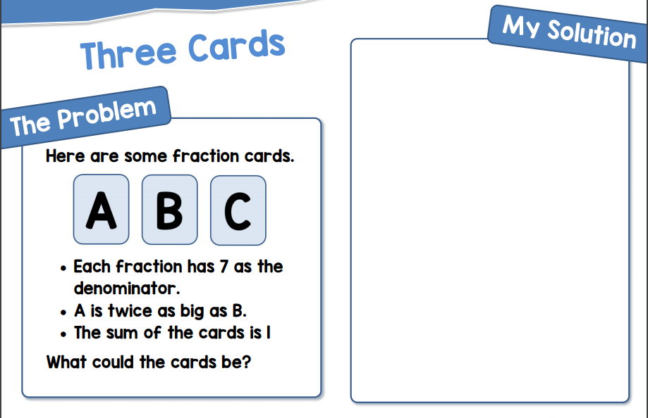
Thursday Task 2.
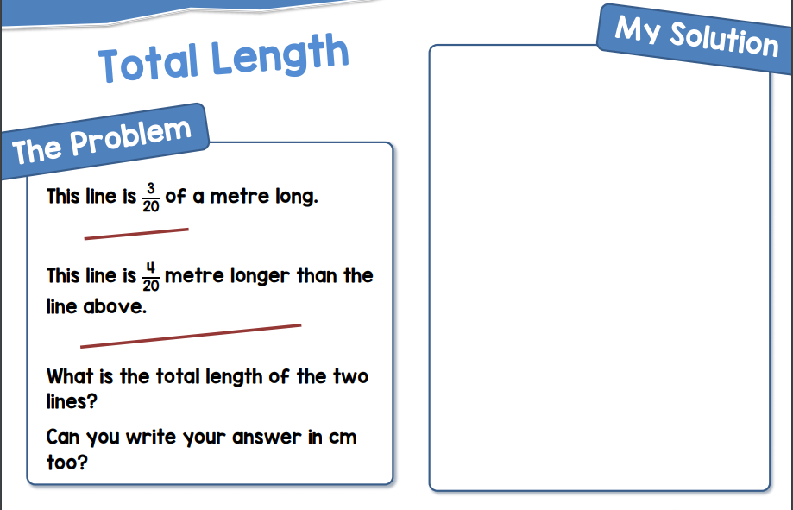
Friday Task 1.
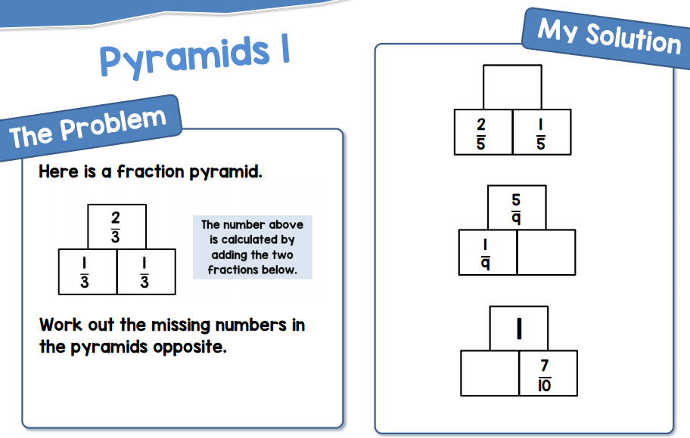
Friday Task 2.
