Maths Year 6
w/c 29.6.2020
The objectives we are working on in this week are:
- To express missing number problems algebraically
- To find pairs of numbers that satisfy an equation with two unknowns
- To use, read, write and convert between standard units of measure
- To convert between miles and kilometres
This week you will be continuing some of the algebra learning from last week then moving on to look at measurements. On Monday, you will be solving two-step equations; then on Tuesday, you will be finding pairs of values to solve equations; on Wednesday, you will begin to convert units of measure; on Thursday, you will be converting between miles and kilometres and finally, on Friday, you can practise some of the skills you have learnt using Classroom Secrets Kids.
Using the link below, click on Summer Term – Week 8 and each day (Monday – Thursday) watch the video and complete the accompanying task (these are printed in your pack). Lesson 1 – Monday, Lesson 2 – Tuesday, Lesson 3 – Wednesday, Lesson 4 – Thursday.

https://whiterosemaths.com/homelearning/year-6/

Monday (Part 1)
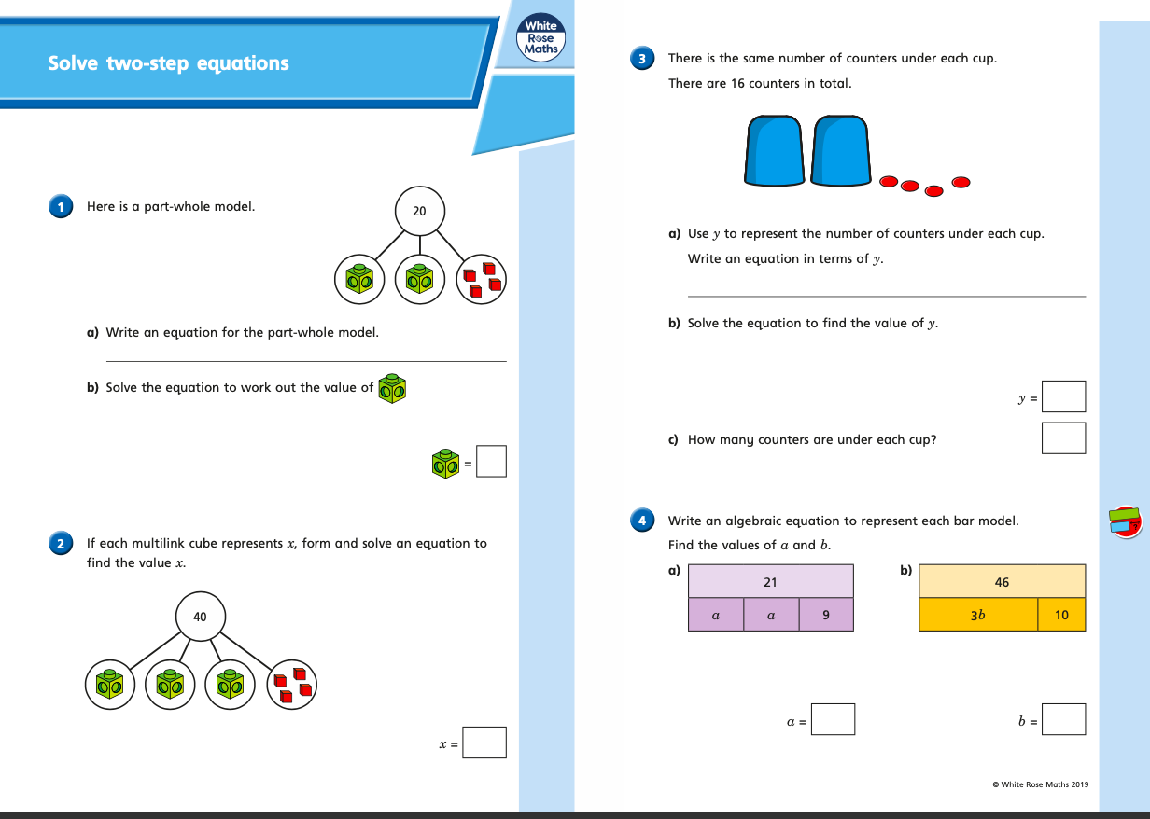

Monday (part 2)
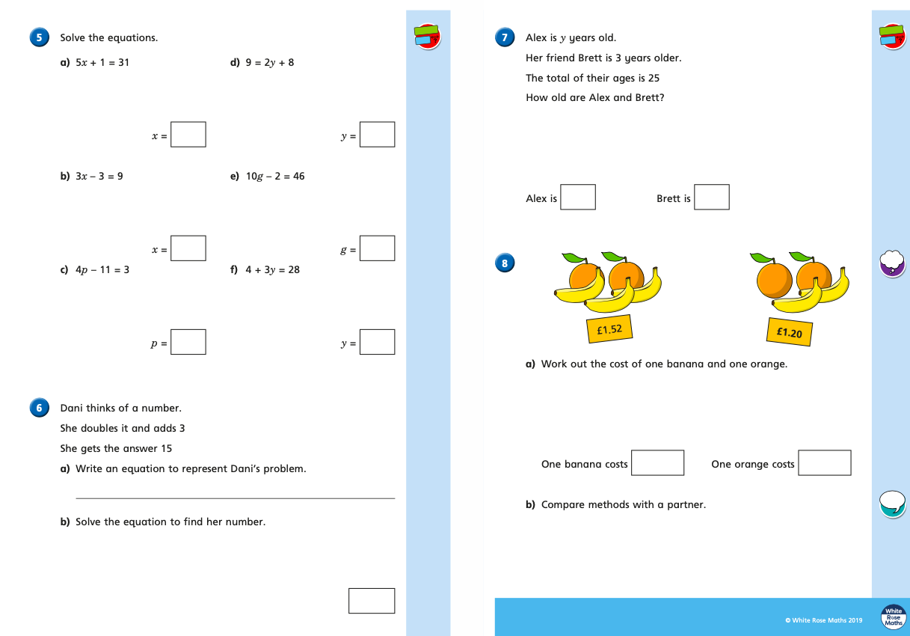

Tuesday (part 1)
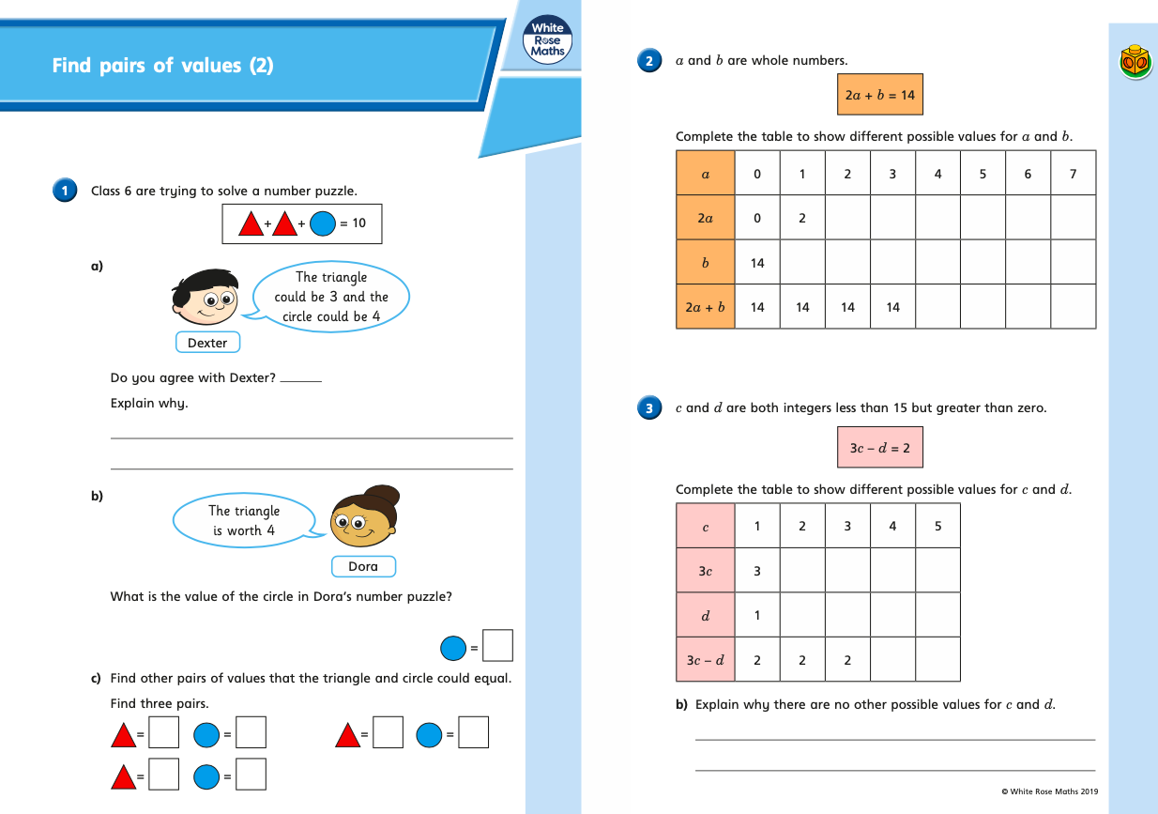

Tuesday (part 2)
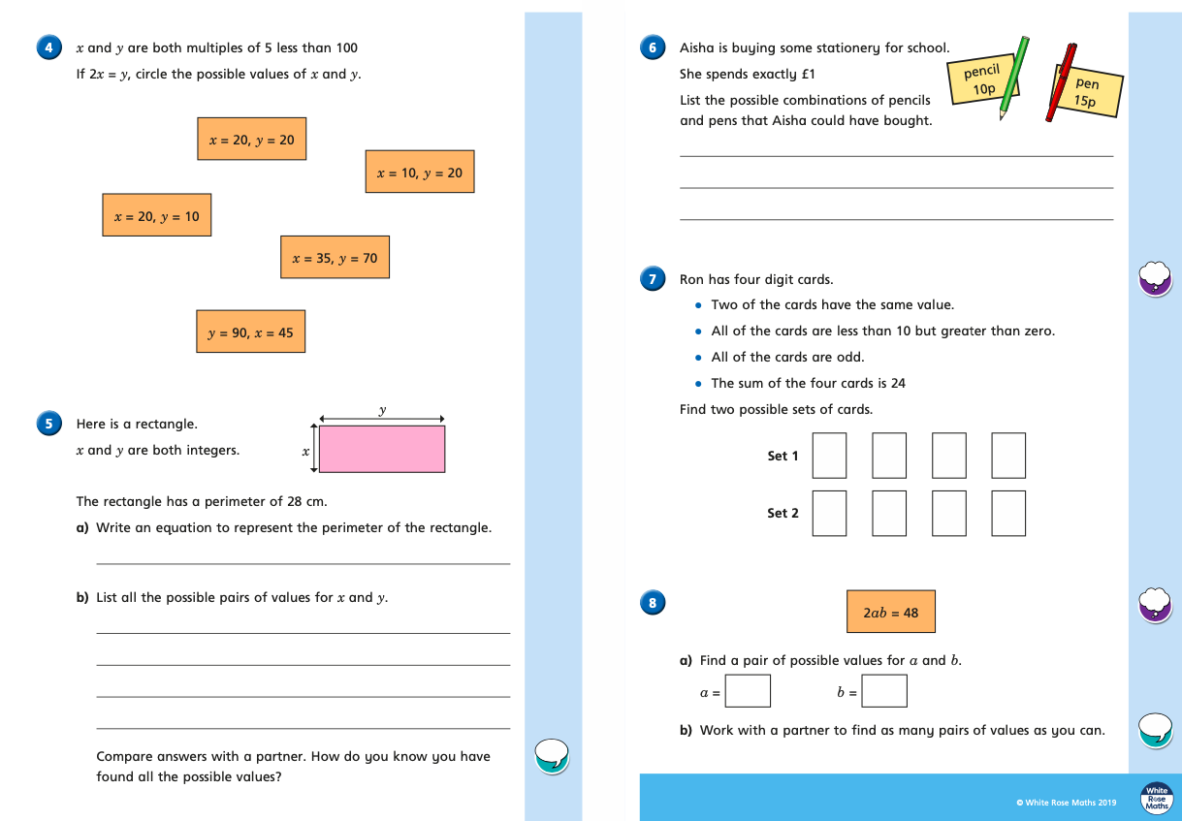
Wednesday (part 1)
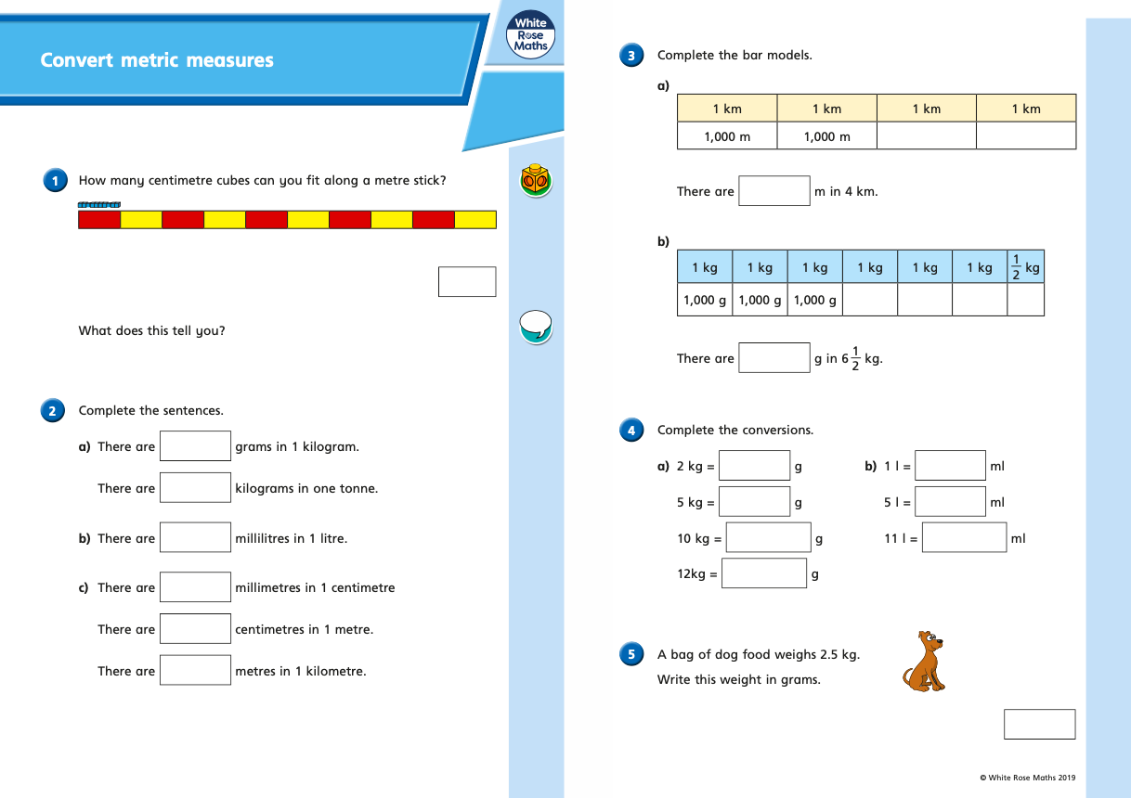

Wednesday (part 2)
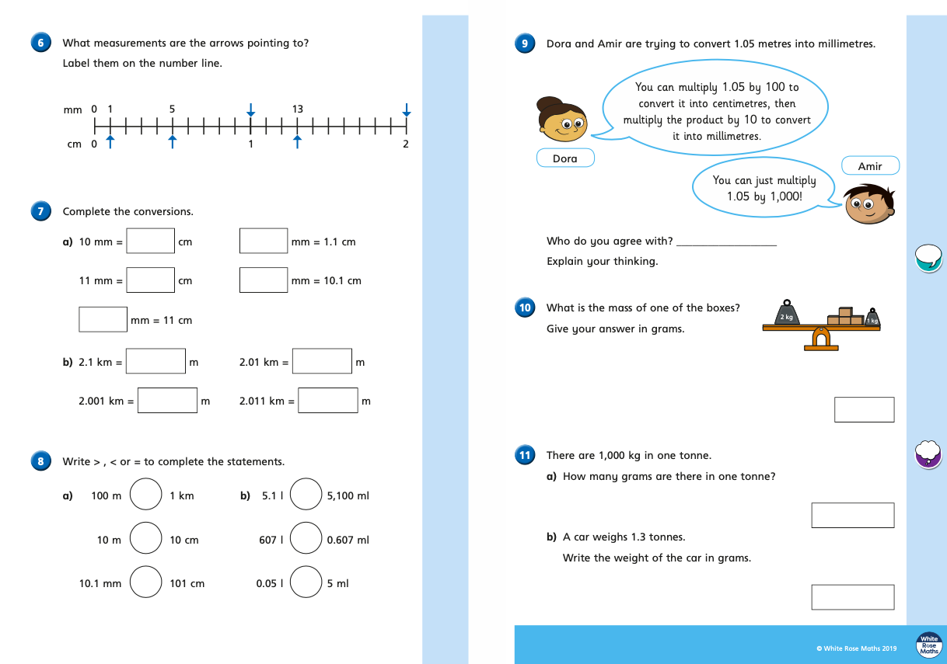
Thursday (part 1)
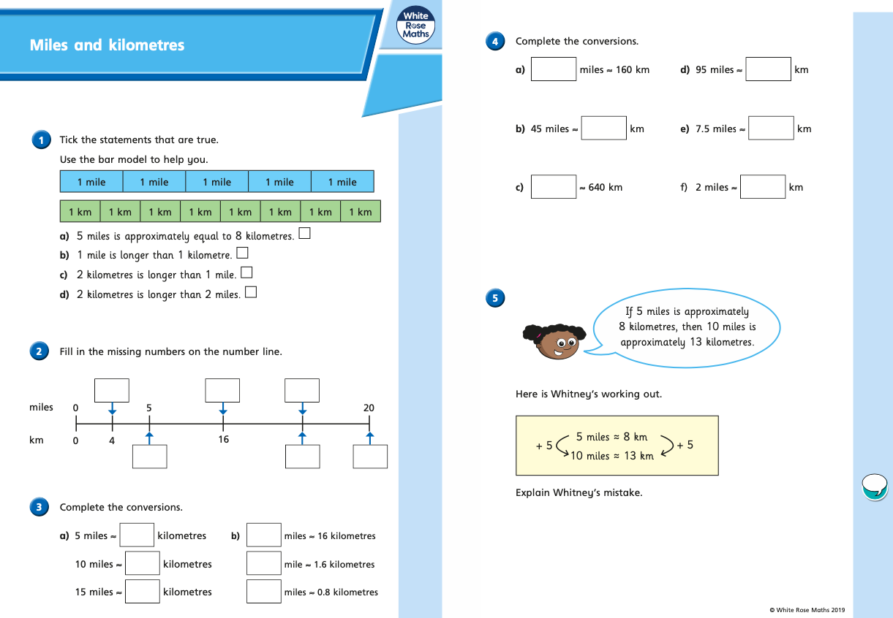
Thursday (part 2)
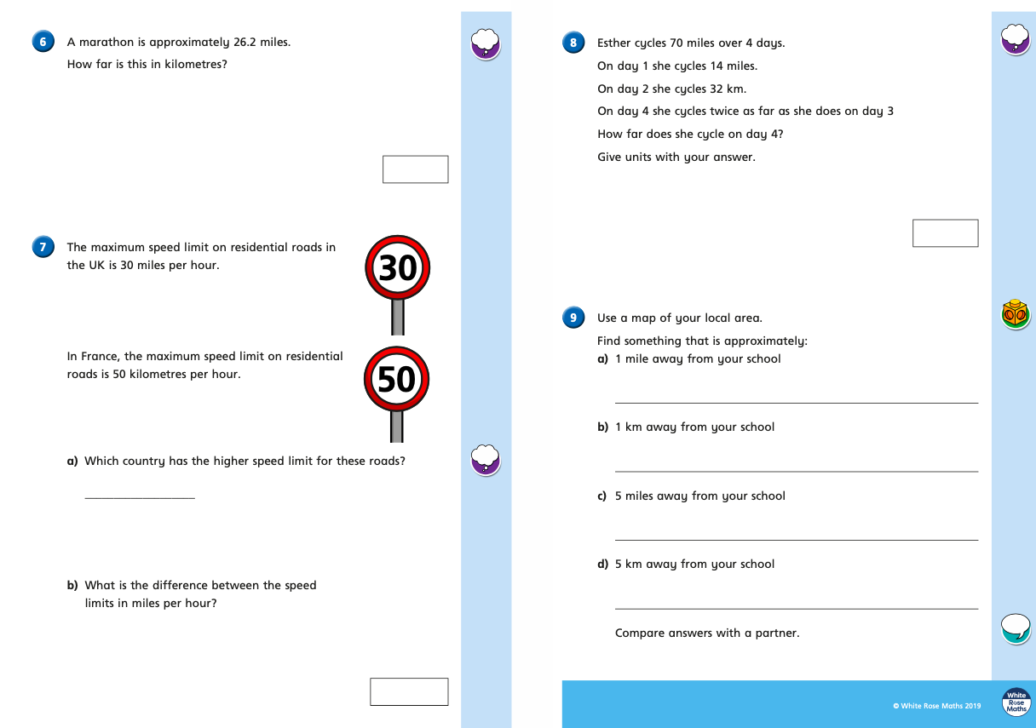

Friday
Have a go at the following Classroom Secrets Kids games to practise some of your maths skills.

https://kids.classroomsecrets.co.uk/resource/year-6-forming-equations-game/

https://kids.classroomsecrets.co.uk/resource/year-6-forming-expressions-game/

https://kids.classroomsecrets.co.uk/resource/year-6-word-problems-measure-1/

