Year 3 Maths
This week is Fractions week. You can use what we did in school to help but also the work you did a few weeks will help too.
The objectives we are working on are:

- To recognise and show, using diagrams, equivalent fractions with small denominators.
- To add and subtract fractions with the same denominator within one whole.
- To compare and order unit fractions, and fractions with the same denominators.

All the lessons can be found on https://whiterosemaths.com/homelearning/year-3/
Monday: Equivalent Fractions.

Monday Task 1 . Watch this video first to help you. https://vimeo.com/425556607
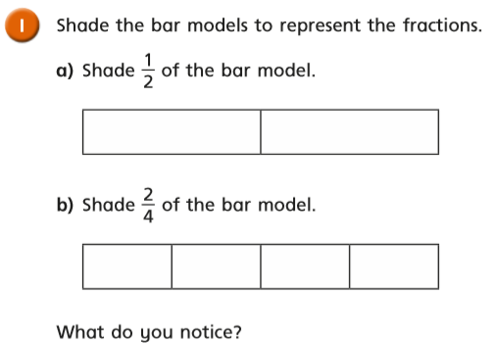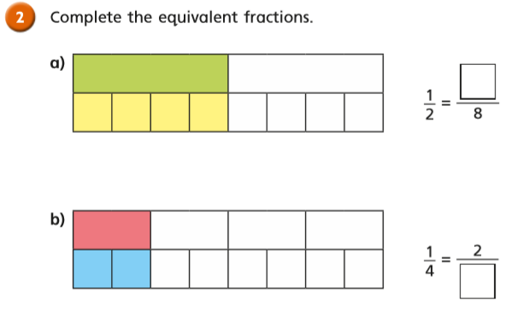

Monday Task 2
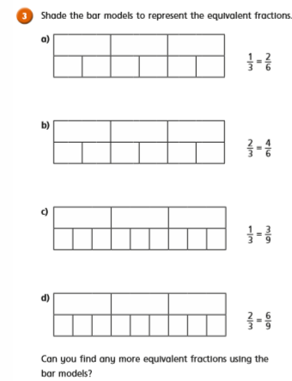
Monday Task 3
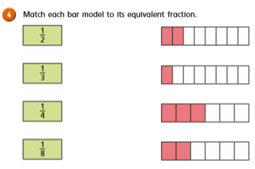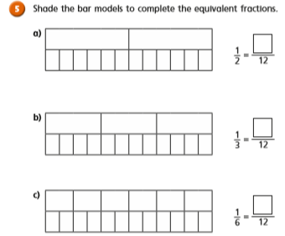

Monday Task 4
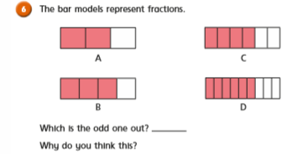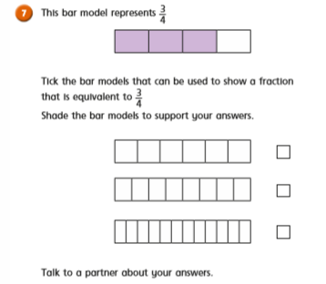
Tuesday Task 1. Making the whole. Watch this first:
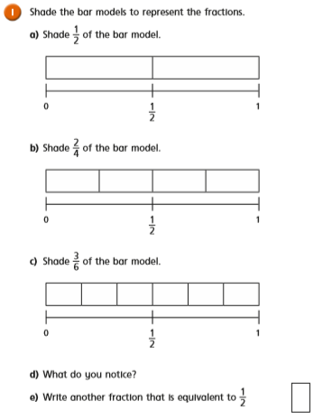

Tuesday Task 2. https://vimeo.com/425556750
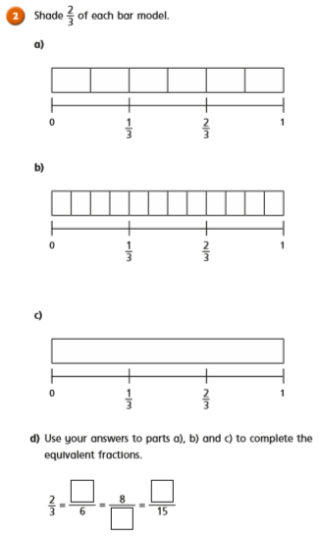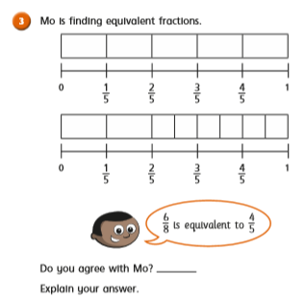
Tuesday Task 3.
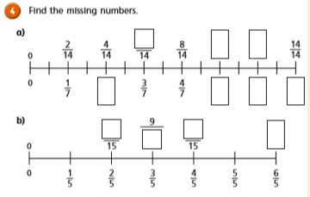

Tuesday Task 4.
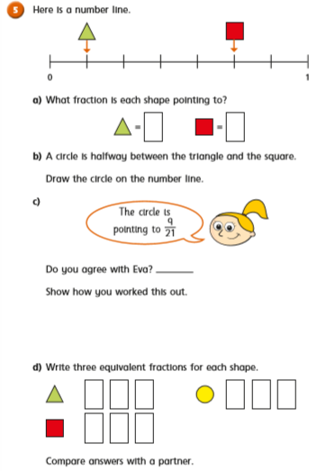

Wednesday Task 1. Tenths. Watch this first: https://vimeo.com/425556923
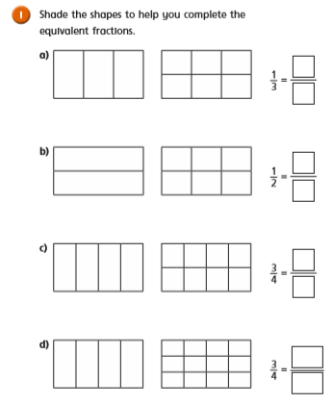

Wednesday Task 2.
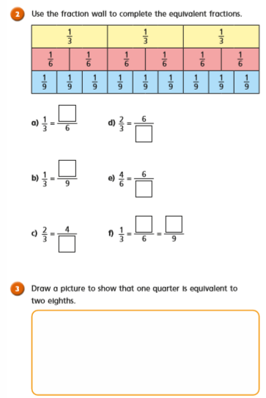

Wednesday Task 3.
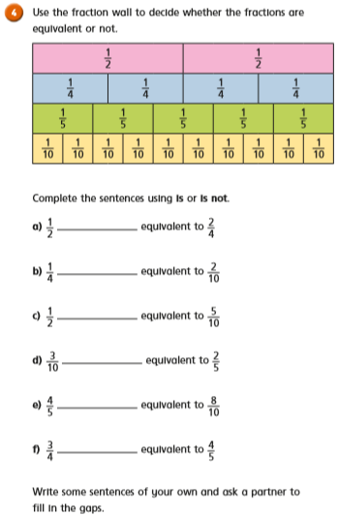

Wednesday Task 4.
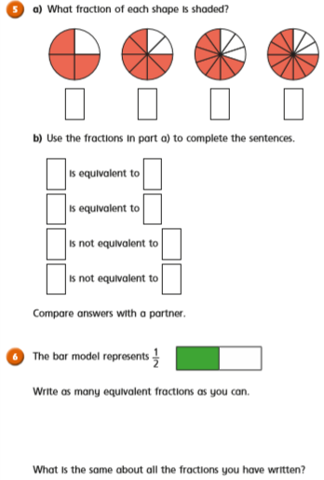

Thursday Task 1. https://vimeo.com/425557120
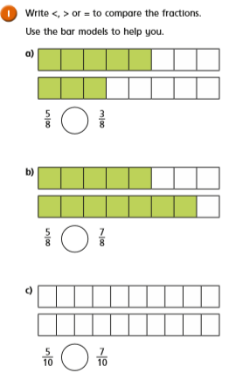

Thursday Task 2.
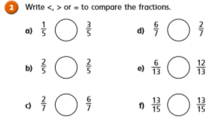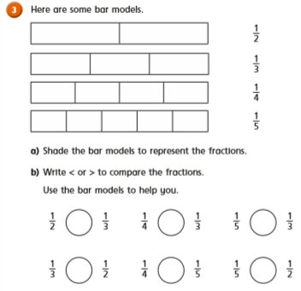

Friday Task 1.
